DOKUMEN LAPORAN PROJECT AKHIR PBO

APLIKASI DIMPRA AUTOCAR 777



Disusun oleh:

Yohanes Dimas Pratama

A11.2021.13254 - A11.442U

FAKULTAS ILMU KOMPUTER

UNIVERSITAS DIAN NUSWANTORO

SEMARANG, 17 JUNI 2023

DAFTAR ISI

Table of Contents

BAB I - PENDAHULUAN 4

1.1 Latar Belakang 4

BAB II – ANALISA DAN DESAIN 5

2.1 Analisa Kebutuhan 5

2.1.1 Kebutuhan Pengguna 5

2.1.2 Kebutuhan Perangkat Keras 5

2.1.3 Kebutuhan Perangkat Lunak 5

2.2 Perancangan 6

2.2.1 Use Case Diagram 6

2.2.2 Class Diagram 7

2.2.3 Activity Diagram 8

2.3 Desain Database dan Tabel 22

2.4 Desain Input dan Output 22

2.4.1 Form Login 22

2.4.2 Form Dashboard 23

2.4.3 Form Pegawai 23

2.4.4 Form Kategori Barang 23

2.4.5 Form Barang 24

2.4.6 Form Distributor 24

2.4.7 Form Pelanggan 24

2.4.8 Form Akun 25

2.4.9 Form Transaksi Barang Masuk 25

2.4.10 Form Transaksi Barang Keluar 25

2.4.11 Form Laporan 26

BAB III – IMPLEMENTASI SISTEM 27

3.1 Halaman Login 27

3.2 Halaman Dashboard 27

3.3 Halaman Pegawai 28

3.4 Halaman Kategori Barang 28

3.5 Halaman Barang 28

3.6 Halaman Distributor 29

3.7 Halaman Pelanggan 29

3.8 Halaman Akun 29

3.9 Halaman Transaksi Barang Masuk 30

3.11 Halaman Laporan 30

BAB IV – PENUTUP 31

4.1 Kesimpulan 31

4.2 Saran 31

BAB V – LAMPIRAN KODE PROGRAM 32

5.1 Form_Akun.java 32

5.2 Form_Barang.java 42

5.3 Form_BarangKeluar.java 69

5.4 Form_BarangMasuk.java 94

5.5 Form_Dashboard.java 119

5.6 Form_Distributor.java 135

5.7 Form_KategoriBarang.java 157

5.8 Form_Laporan.java 177

5.9 Form_Login.java 186

5.10 Form_Pegawai.java 193

5.11 Form_Pelanggan.java 216

5.12 Connection_DB.java 237

5.13 Session_Employee.java 238

5.14 Report.java 240

5.15 report_barang.jrxml 240

5.16 report_barangKeluar.jrxml 246

5.17 report_barangMasuk.jrxml 254

# BAB I - PENDAHULUAN

## 1.1 Latar Belakang

Sebelum adanya teknologi modern dan aplikasi inventaris barang, proses pengelolaan inventaris seringkali dilakukan secara manual. Hal ini memerlukan waktu dan tenaga yang cukup besar, serta meningkatkan risiko kesalahan dan ketidakakuratan data. Selain itu, informasi inventaris yang tidak tersedia secara real-time membuat pengambilan keputusan menjadi lebih sulit.

Dalam era digital, aplikasi inventaris barang telah mengubah cara organisasi melacak, mengelola, dan memantau inventaris mereka. Aplikasi ini memanfaatkan teknologi informasi dan komunikasi untuk menyediakan solusi yang efisien, andal, dan akurat dalam mengelola inventaris barang. Aplikasi ini dapat digunakan untuk mencatat semua detail penting tentang setiap item inventaris, termasuk nomor seri, tanggal pembelian, harga, status, dan lokasi.

Salah satu manfaat utama dari aplikasi inventaris barang adalah kemampuannya untuk menyediakan informasi yang real-time dan terkini tentang status inventaris. Dengan menggunakan aplikasi ini, pengguna dapat dengan mudah melihat berapa banyak barang yang tersedia, berapa banyak yang dipinjam atau digunakan, dan kapan barang tersebut perlu diperbaharui atau digantikan. Informasi ini sangat berharga dalam mengoptimalkan penggunaan inventaris, menghindari kekurangan atau kelebihan persediaan, serta merencanakan anggaran dengan lebih baik.

Tujuan dibuatnya aplikasi inventaris barang supaya menjadi solusi yang sangat berharga dalam pengelolaan inventaris yang efisien dan efektif. Dengan kemampuan untuk menyediakan informasi real-time, mempercepat proses audit, dan meningkatkan efisiensi operasional, aplikasi ini diharapkan dapat membantu perusahaan meningkatkan pengelolaan inventaris mereka.

# BAB II – ANALISA DAN DESAIN

## 2.1 Analisa Kebutuhan

### 2.1.1 Kebutuhan Pengguna

Sistem yang akan dikembangkan pada aplikasi Dimpra Autocar 777 ini meliputi:

1. Pendataan barang
2. Pendataan kategori barang
3. Pendataan distributor
4. Pendataan trasaksi barang masuk
5. Pendataan transaksi barang keluar
6. Pendataan pegawai
7. Pendataan pelanggan
8. Laporan data barang
9. Laporan transaksi barang masuk
10. Laporan transaksi barang keluar

### 2.1.2 Kebutuhan Perangkat Keras

Konfigurasi perangkat keras (hardware):

* Processor Intel i3
* RAM 4 GB
* Harddisk 60GB
* Mouse dan keyboard
* Internet

### 2.1.3 Kebutuhan Perangkat Lunak

Dalam pengembangan aplikasi Dimpra Autocar 777 ini kami menggunakan:

1. Bahasa Pemrograman

Menggunakan bahasa pemrograman Java sebagai bahasa utama.

1. Text Editor

Menggunakan Apache NetBeans IDE 17

1. Aplikasi

Brave

DrawIO

## 2.2 Perancangan

### 2.2.1 Use Case Diagram

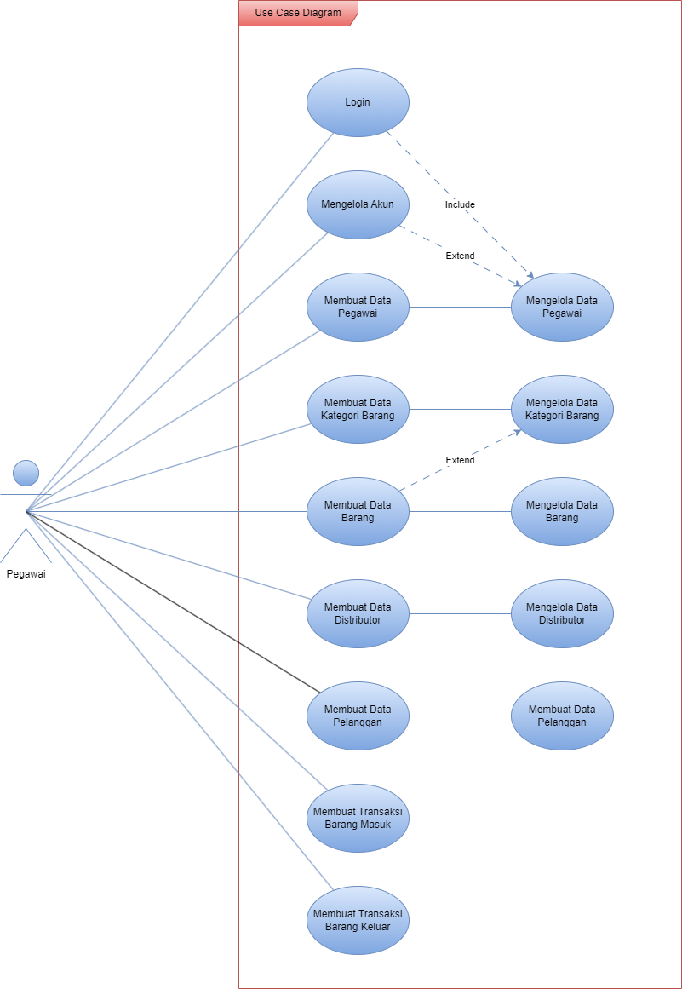

Dalam use case diagram diatas menunjukkan bawah pengguna harus melakukan login admin terlebih dahulu. Selanjutnya sistem akan mengarahkan ke halaman dashboard. Pada halaman dashboard terdapat banyak menu yang dapat diakses oleh mengguna untuk mengelola berbagai fitur yang tersedia dalam aplikasi Dimpra Autocar 777.

### 2.2.2 Class Diagram

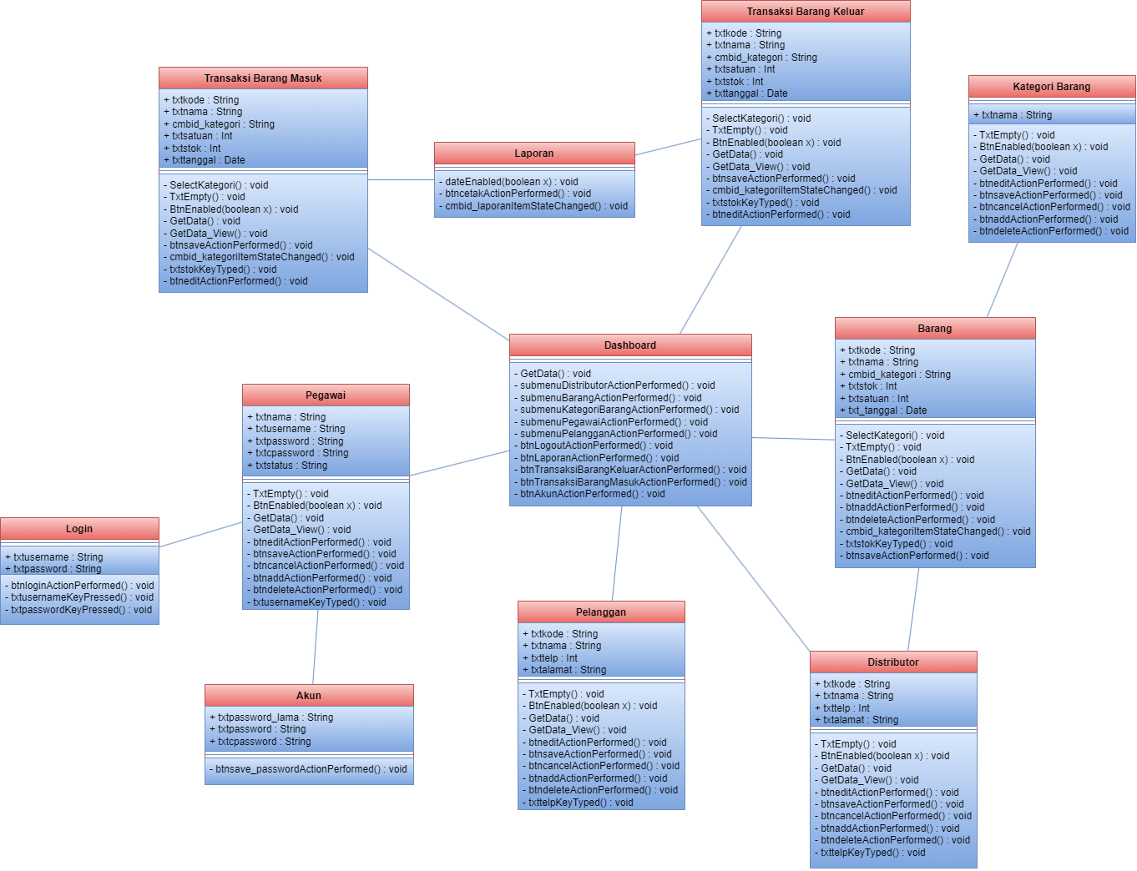

Class diagram diatas menggambarkan struktur statis dari bagian sistem. Diagram tersebut menunjukkan atribut dan method dalam setiap kelas dan hubungan antar kelas pada sistem.

### 2.2.3 Activity Diagram

#### 2.2.3.1 Login

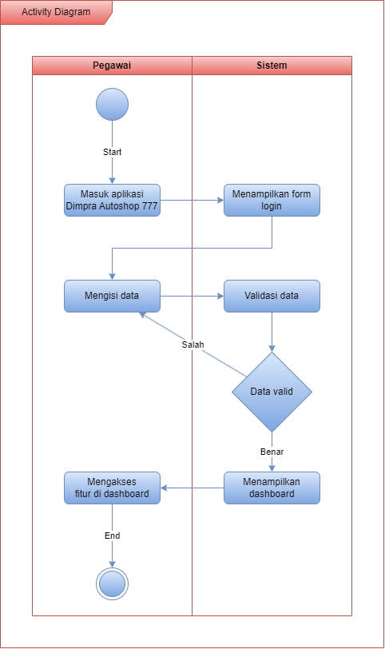

#### 2.2.3.2 Mengelola Akun

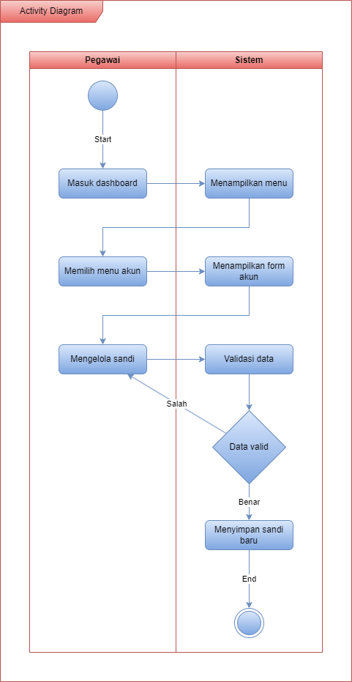

#### 2.2.3.3 Membuat Data Pegawai

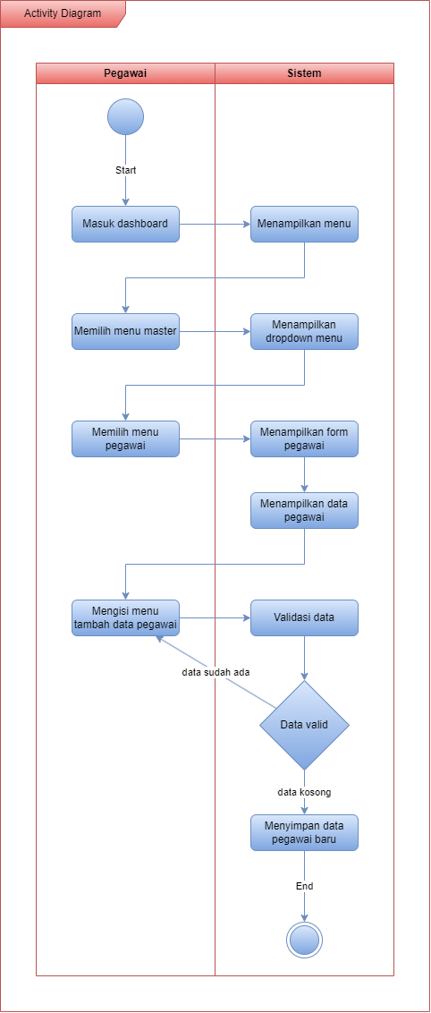

#### 2.2.3.4 Mengelola Data Pegawai

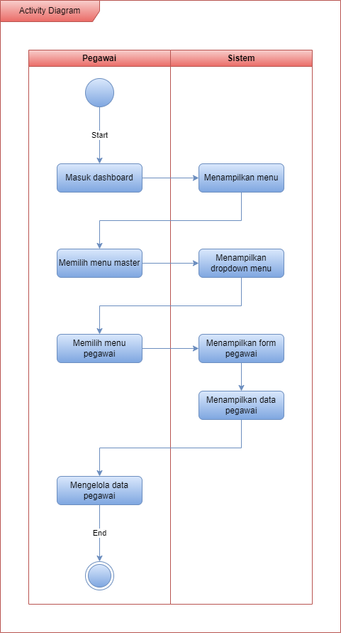

#### 2.2.3.5 Membuat Data Kategori Barang

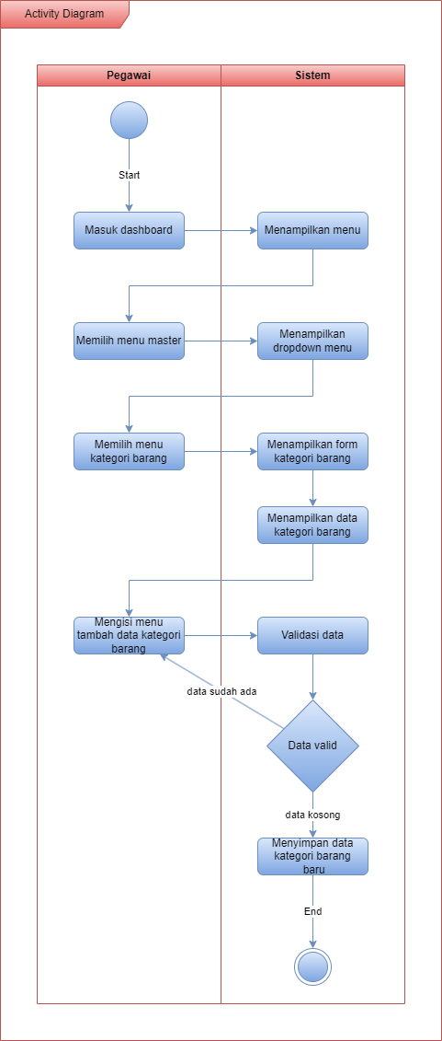

#### 2.2.3.6 Mengelola Data Kategori Barang

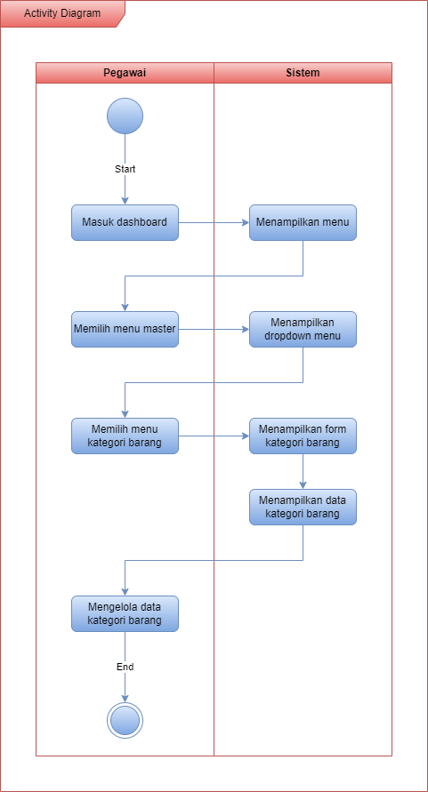

#### 2.2.3.7 Membuat Data Barang

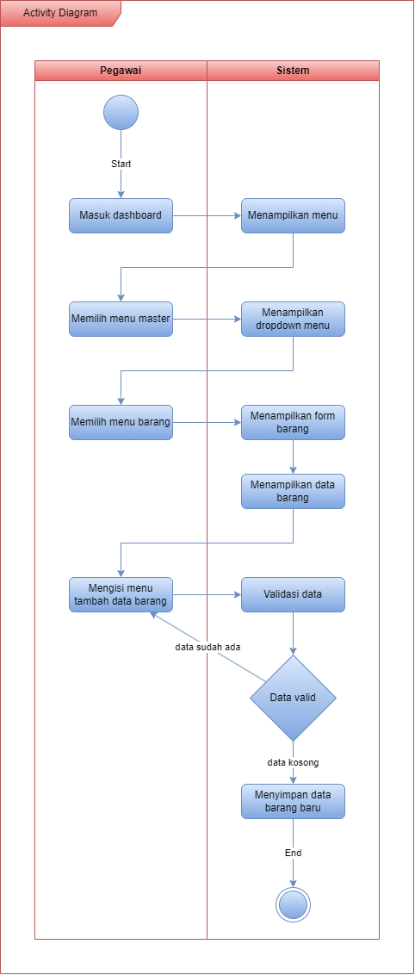

#### 2.2.3.8 Mengelola Data Barang

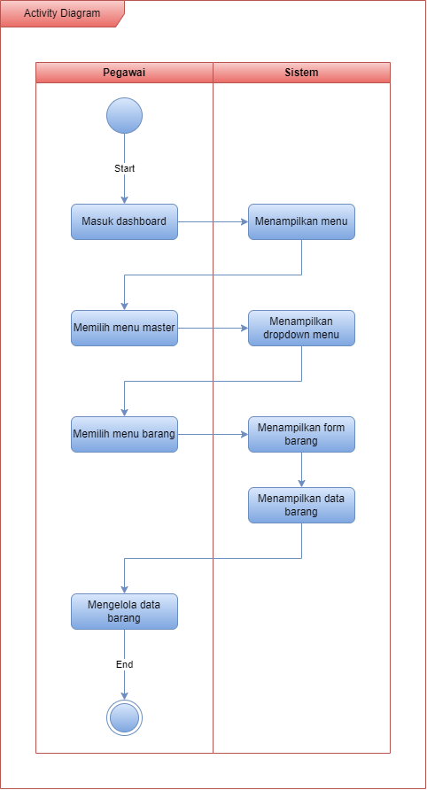

#### 2.2.3.9 Membuat Data Distributor

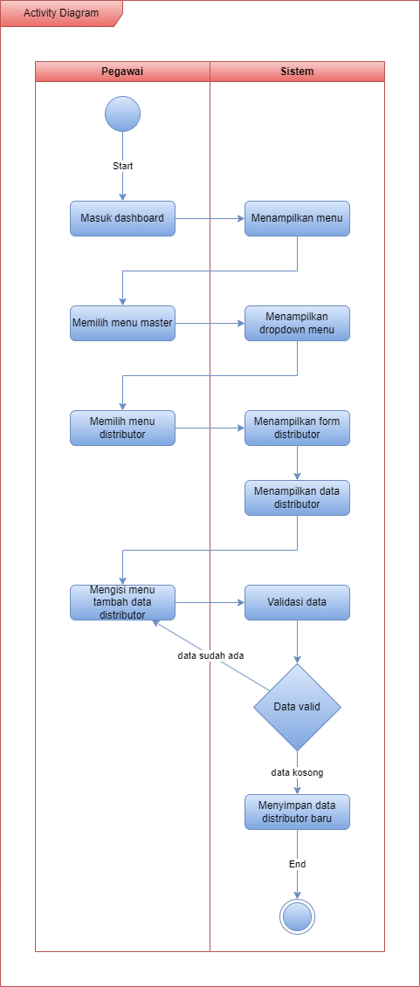

#### 2.2.3.10 Mengelola Data Distributor

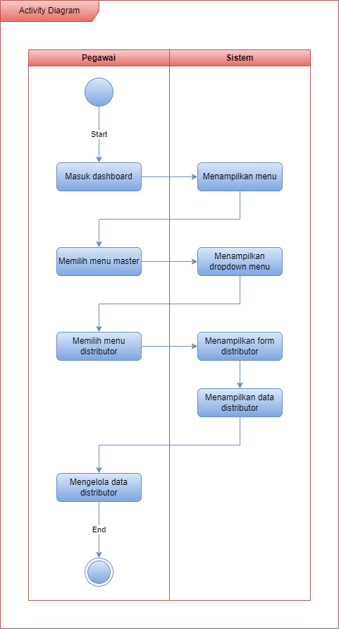

#### 2.2.3.11 Membuat Data Pelanggan

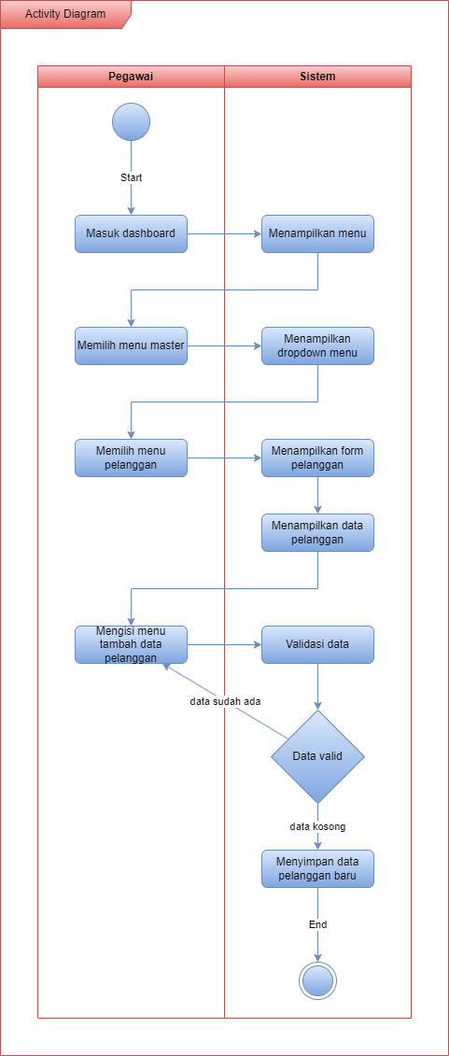

#### 2.2.3.12 Mengelola Data Pelanggan

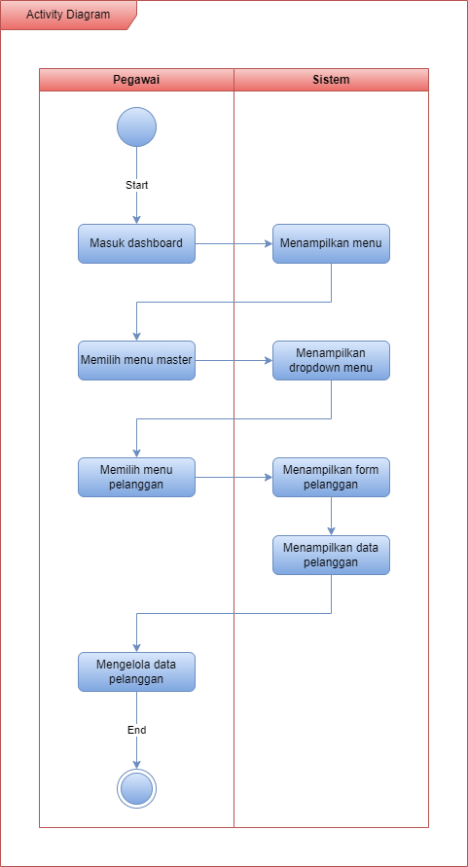

#### 2.2.3.13 Membuat Transaksi Barang Masuk

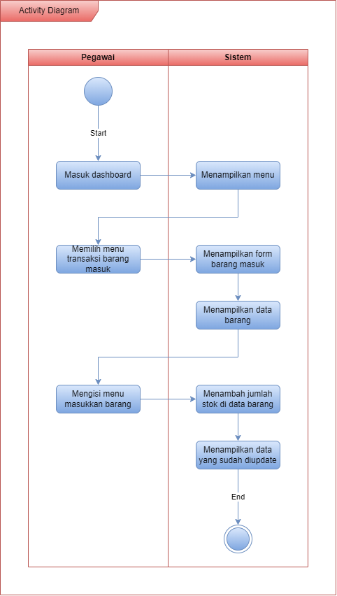

#### 2.2.3.14 Membuat Transaksi Barang Keluar

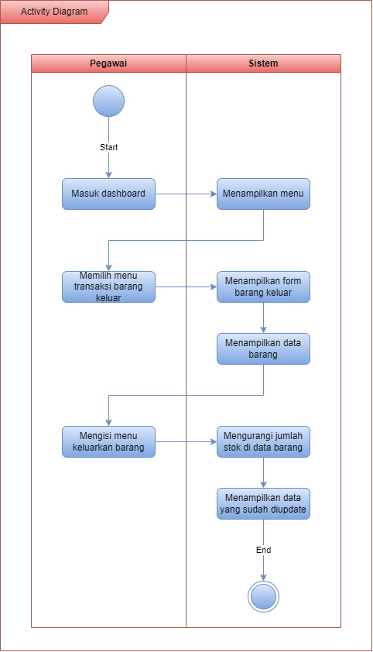

## 2.3 Desain Database dan Tabel

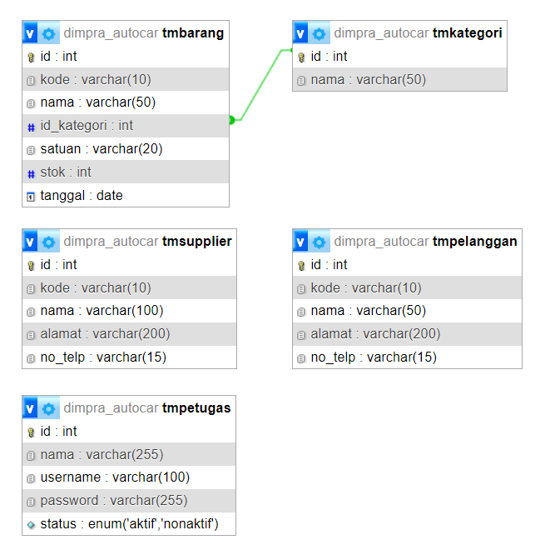

## 2.4 Desain Input dan Output

### 2.4.1 Form Login

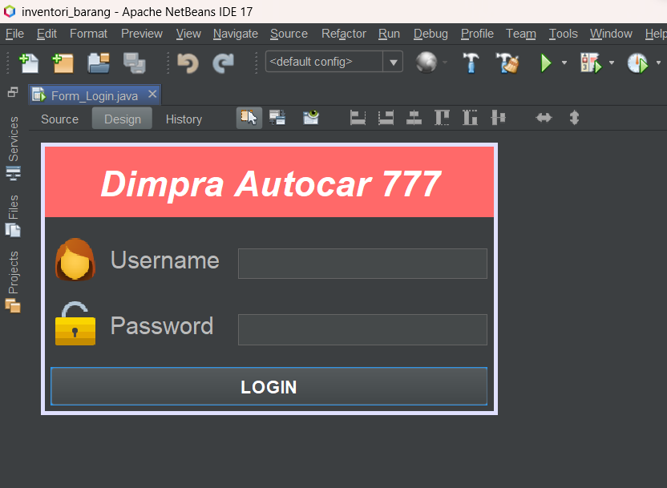

### 2.4.2 Form Dashboard

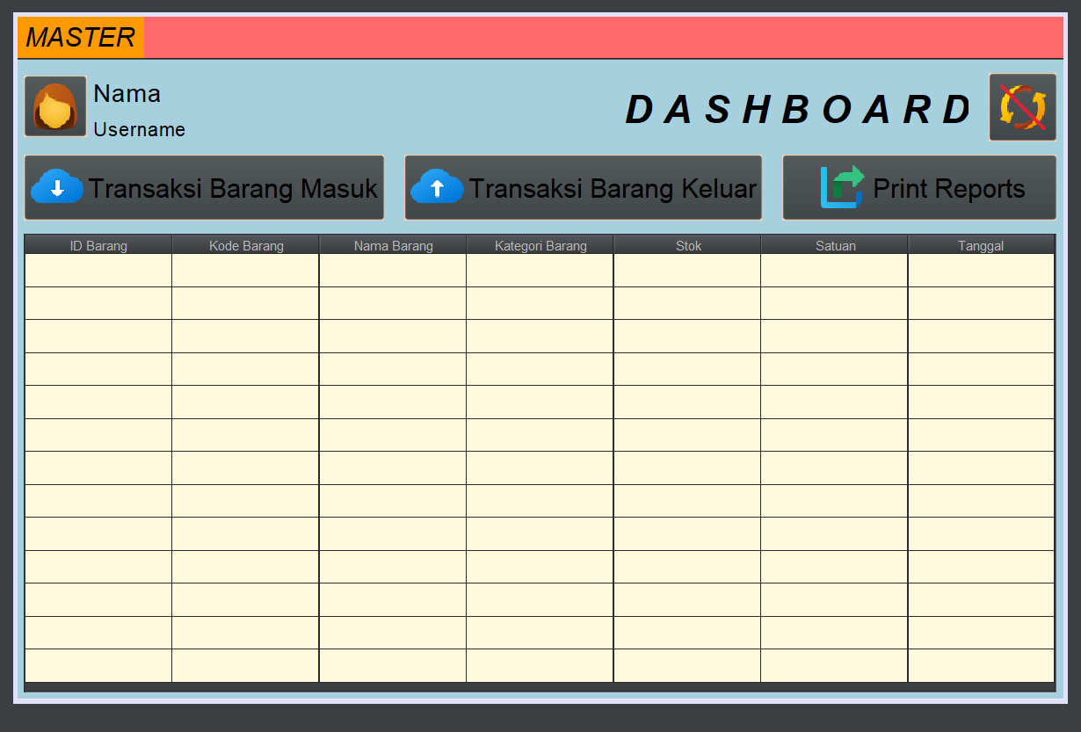

### 2.4.3 Form Pegawai

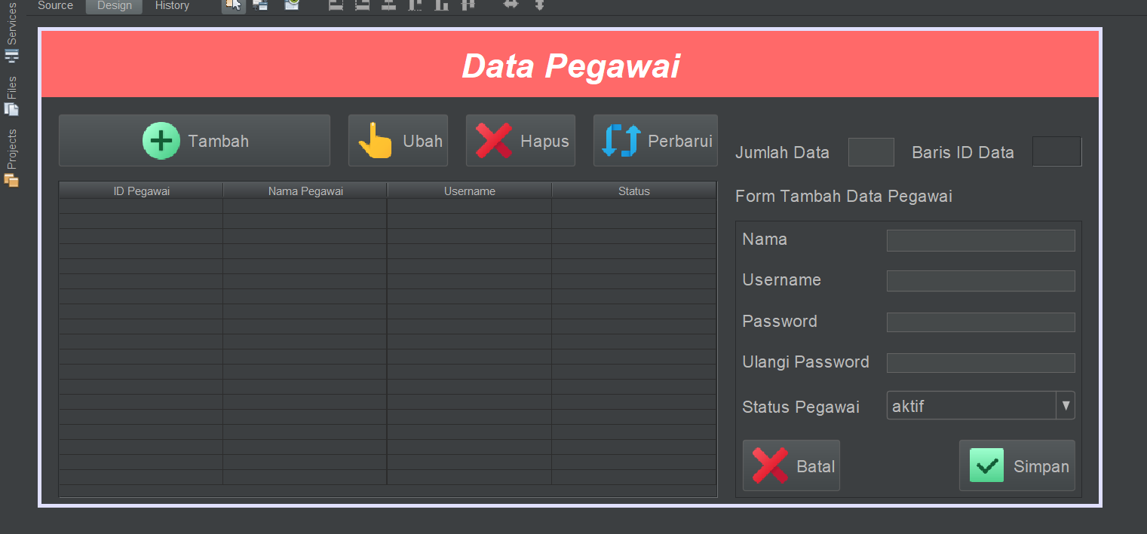

### 2.4.4 Form Kategori Barang

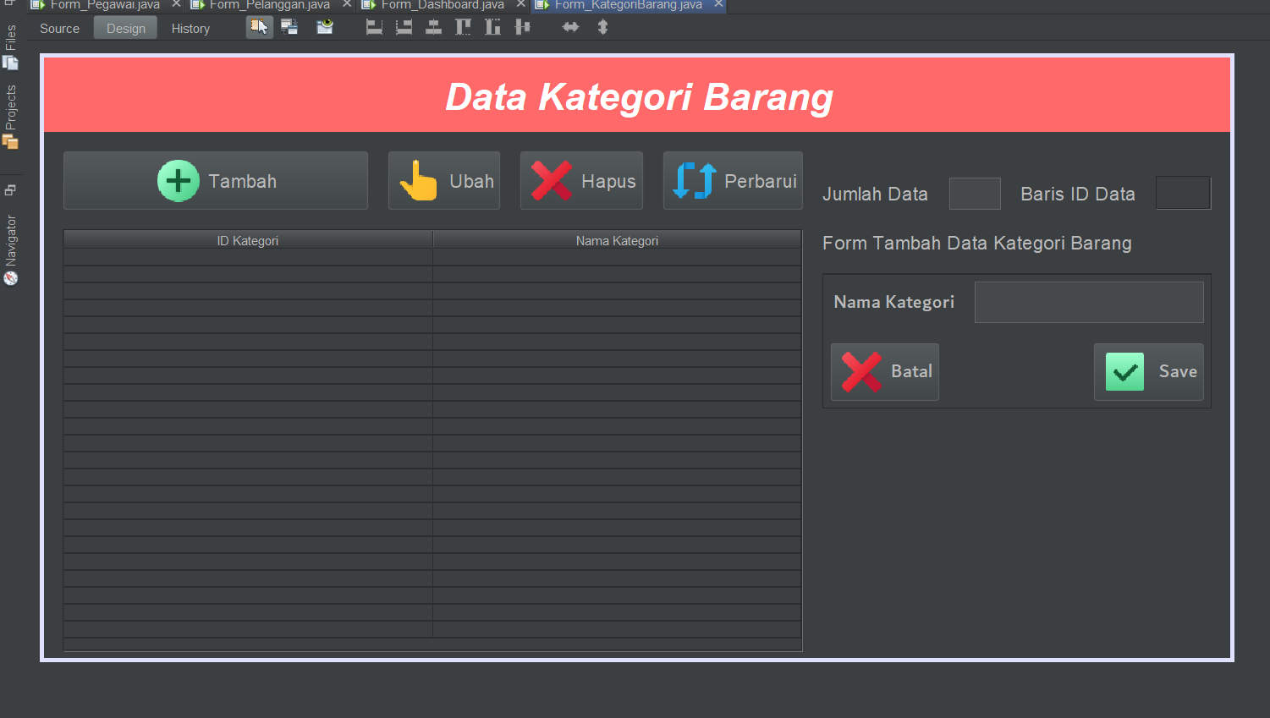

### 2.4.5 Form Barang

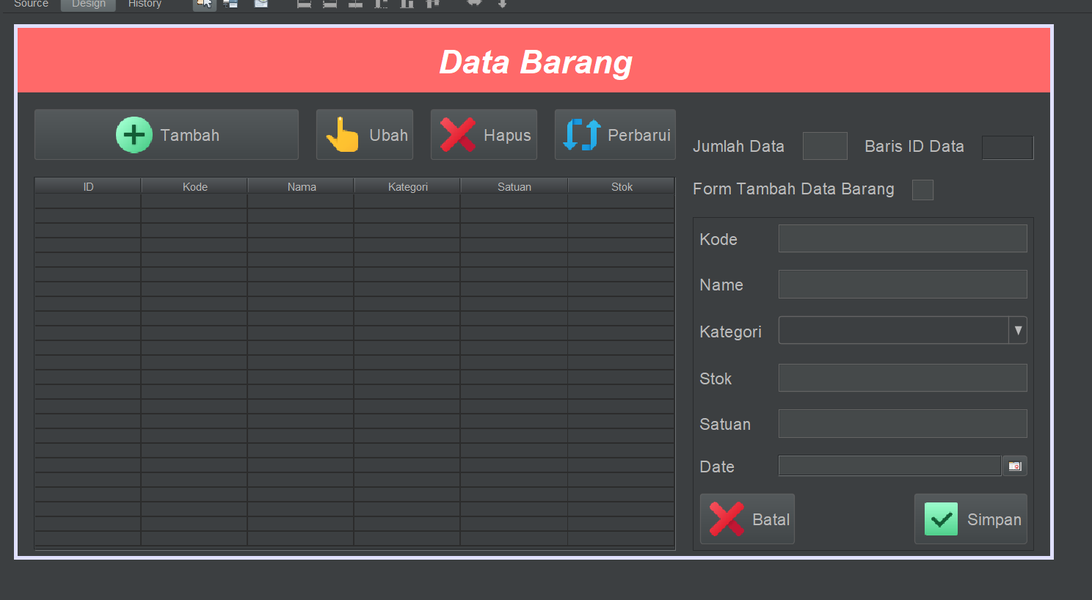

### 2.4.6 Form Distributor

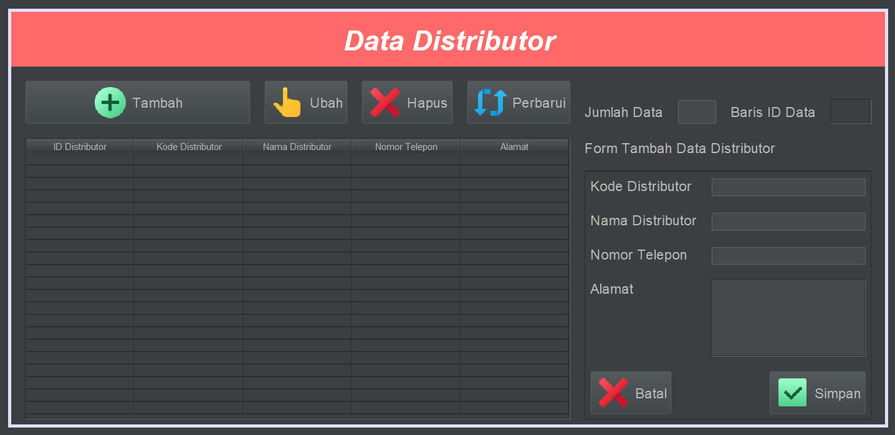

### 2.4.7 Form Pelanggan

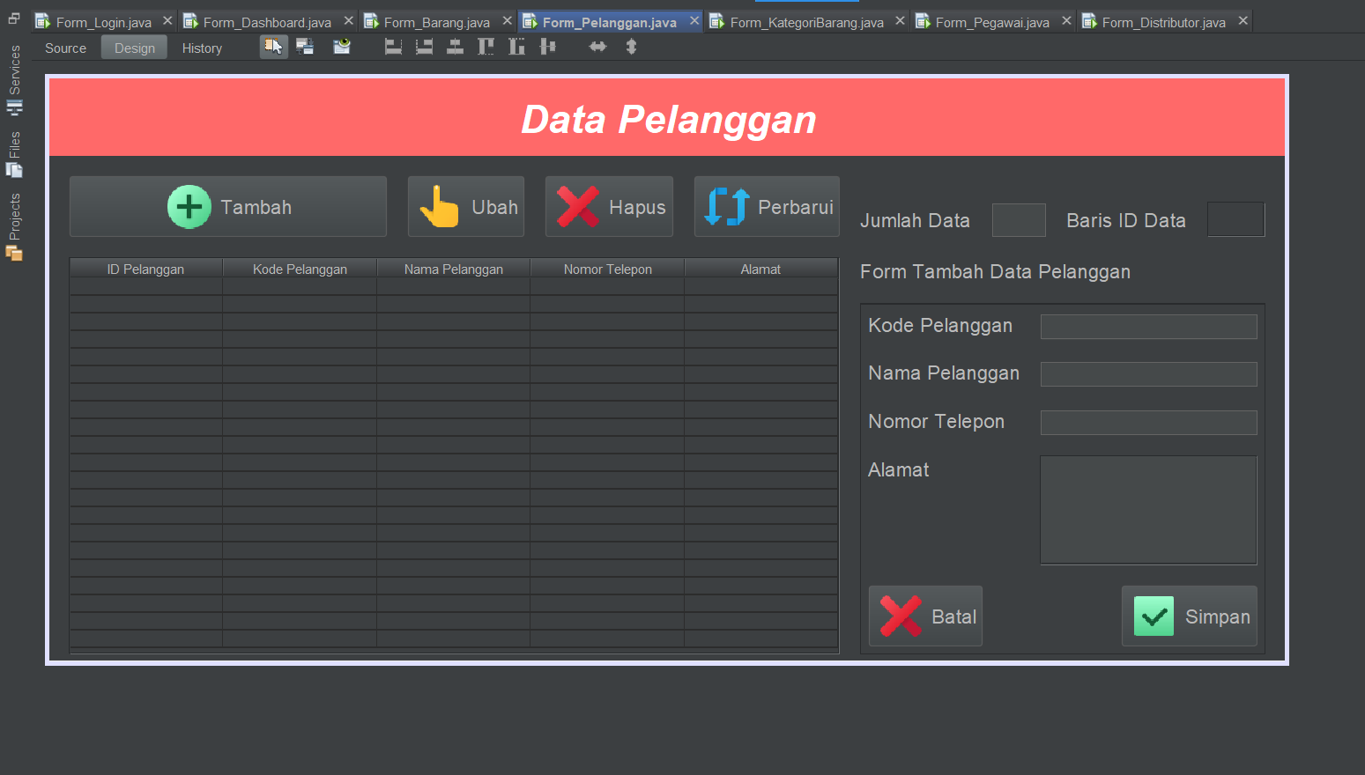

### 2.4.8 Form Akun

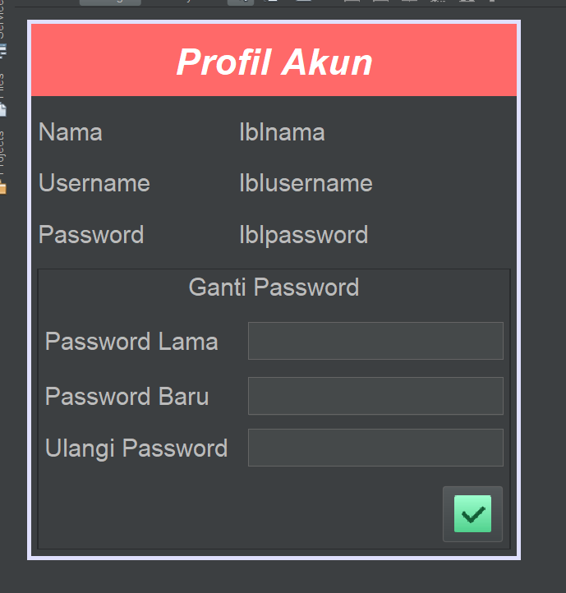

### 2.4.9 Form Transaksi Barang Masuk

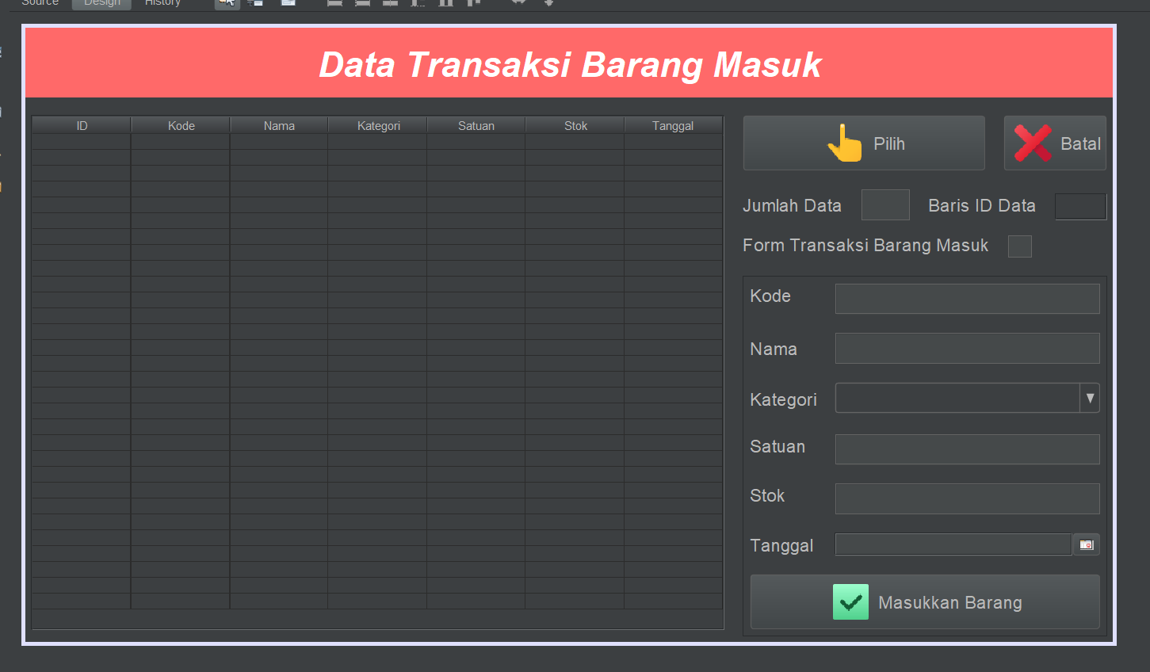

### 2.4.10 Form Transaksi Barang Keluar

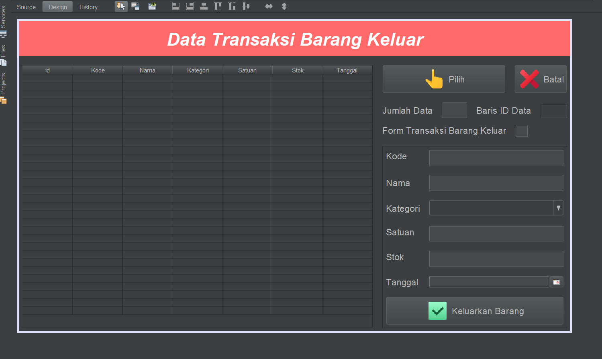

### 2.4.11 Form Laporan

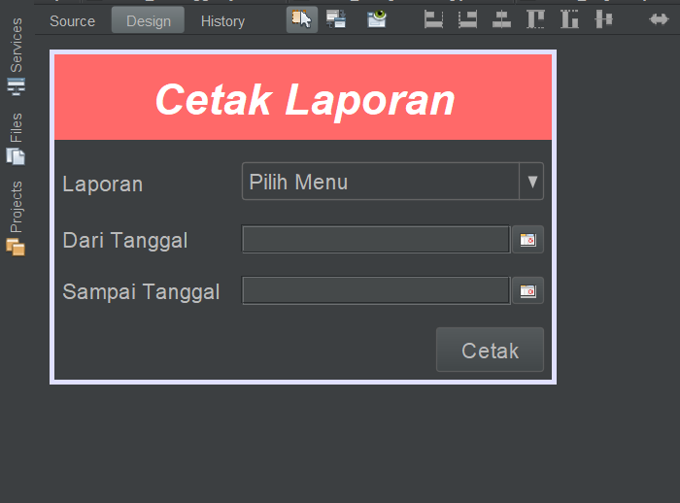

# BAB III – IMPLEMENTASI SISTEM

Sistem akan diimplementasikan akan menampilkan output dengan UI sesuai dengan desain yang dibuat. Berikut hasil implementasi dari sistem aplikasi Dimpra Autocar 777 ini:

## 3.1 Halaman Login

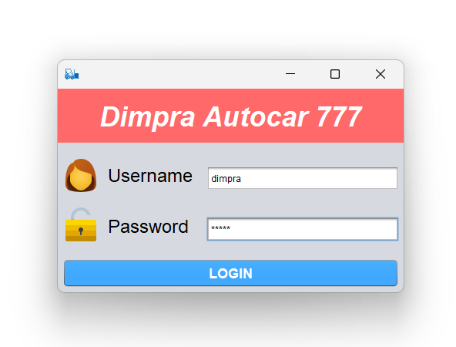

## 3.2 Halaman Dashboard

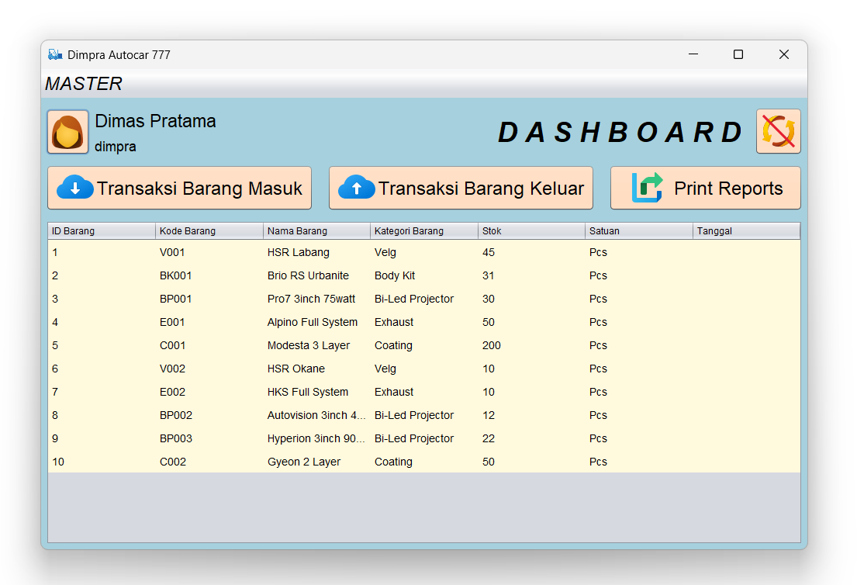

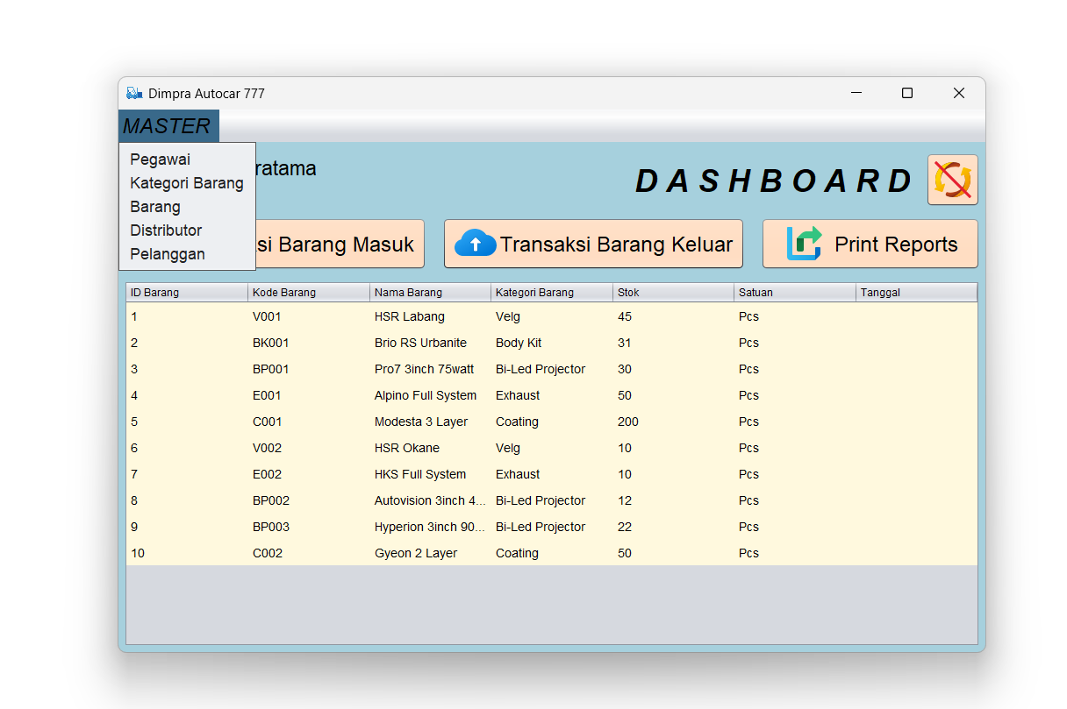

## 3.3 Halaman Pegawai

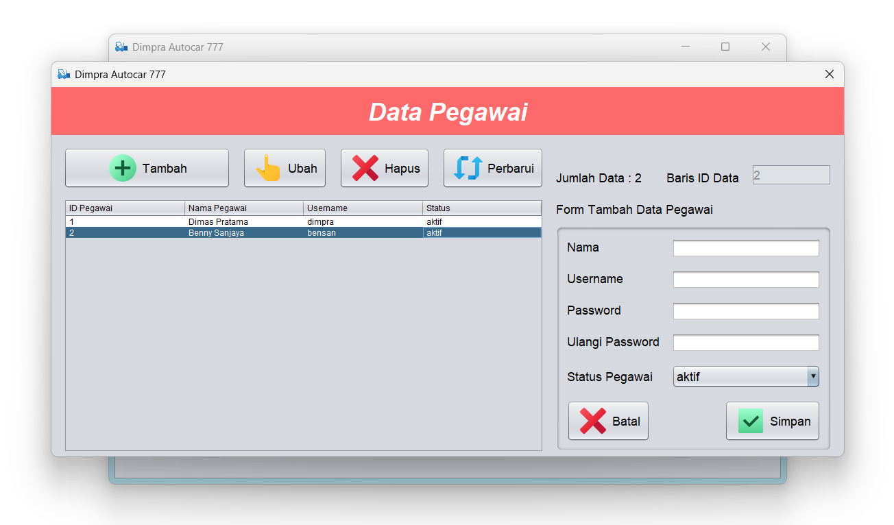

## 3.4 Halaman Kategori Barang

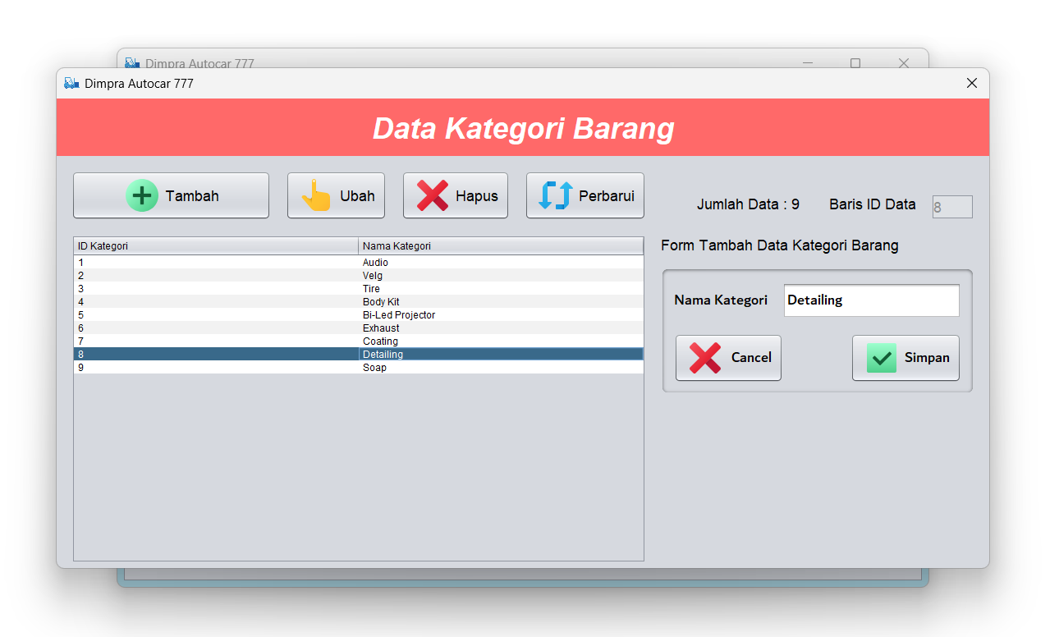

## 3.5 Halaman Barang

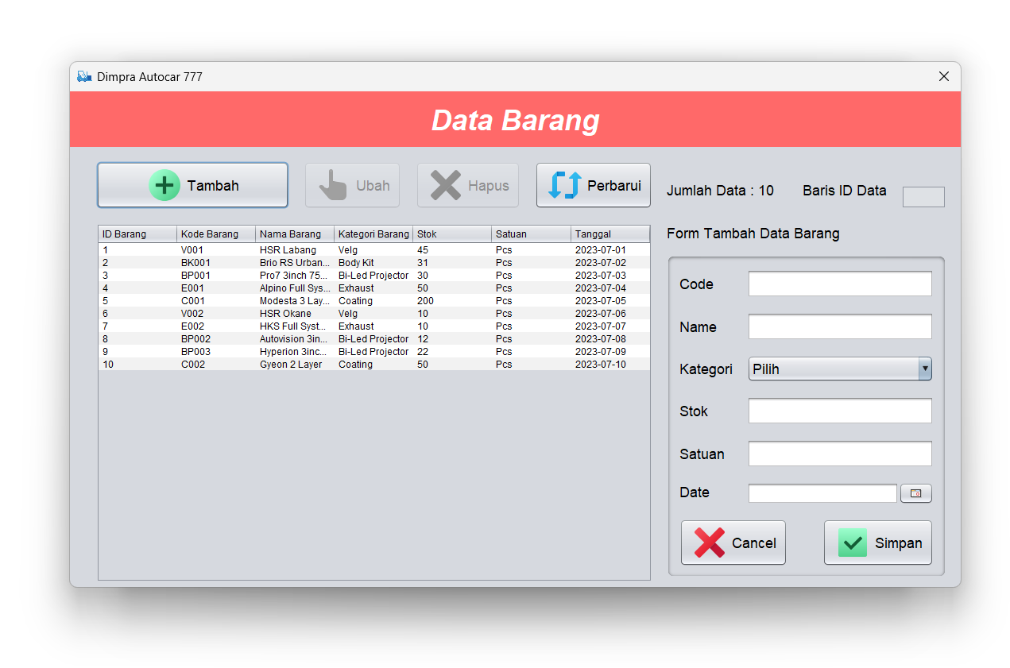

## 3.6 Halaman Distributor

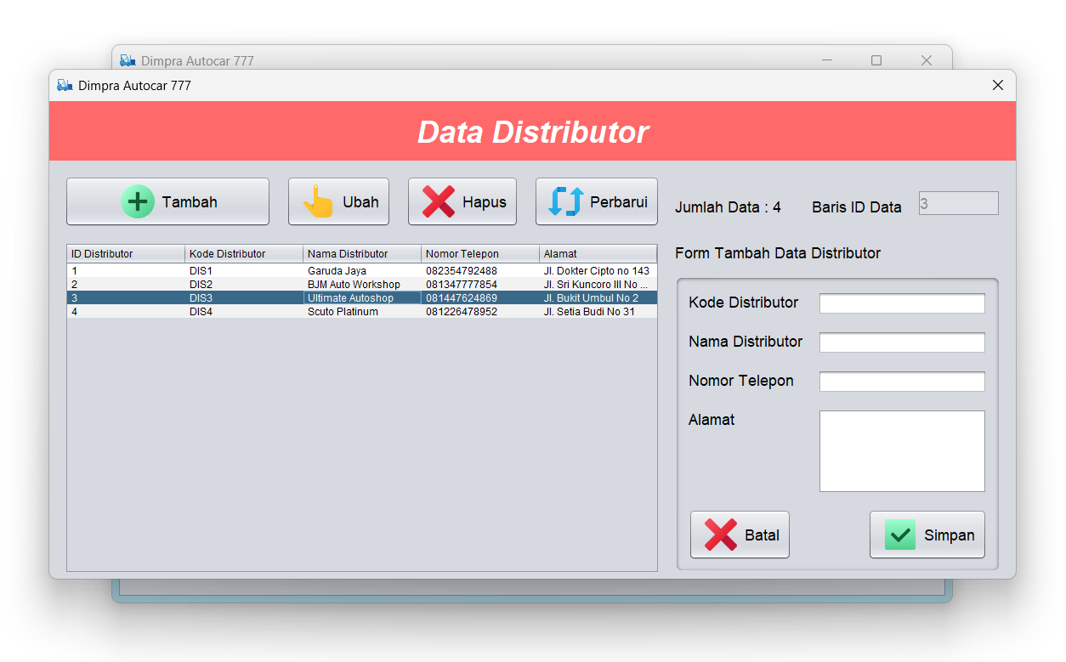

## 3.7 Halaman Pelanggan

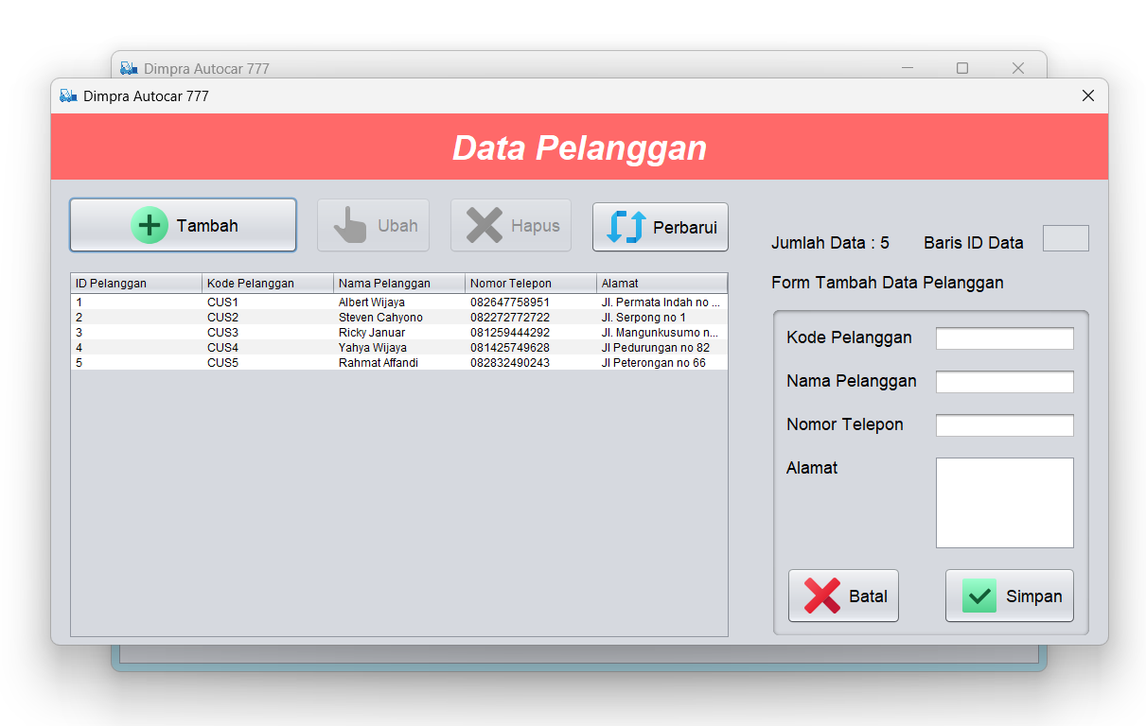

## 3.8 Halaman Akun

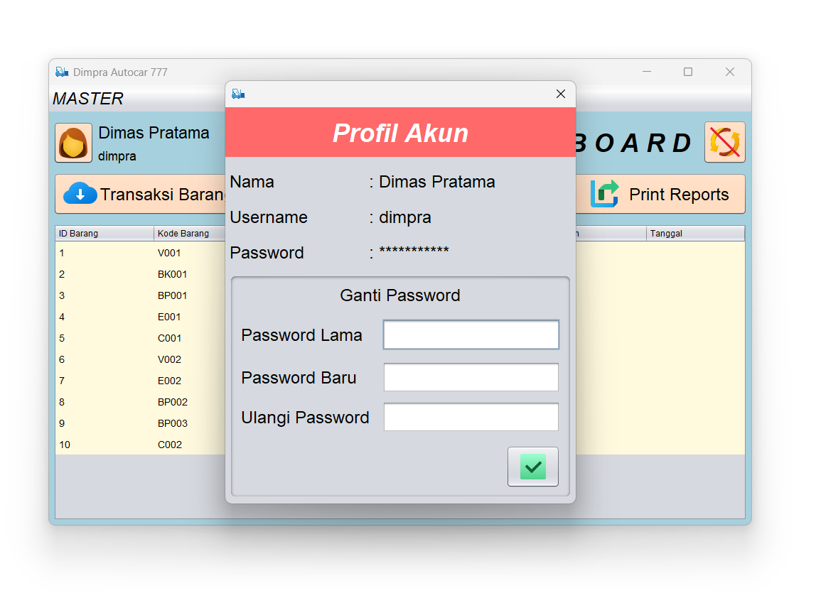

## 3.9 Halaman Transaksi Barang Masuk

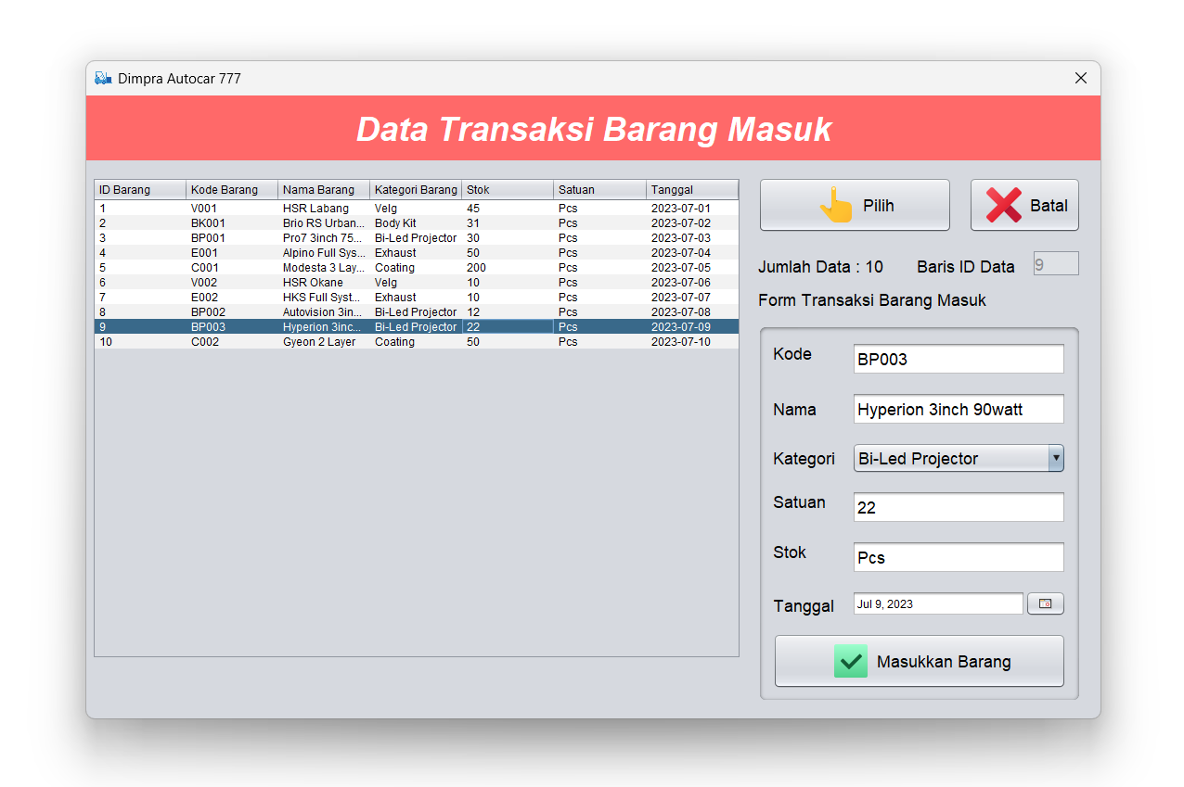

3.10 HalamanT ransaksi Barang Keluar. 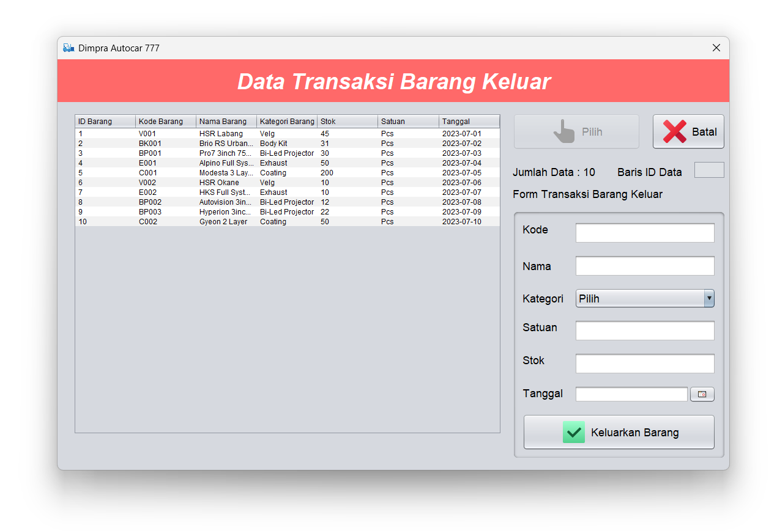

## 3.11 Halaman Laporan

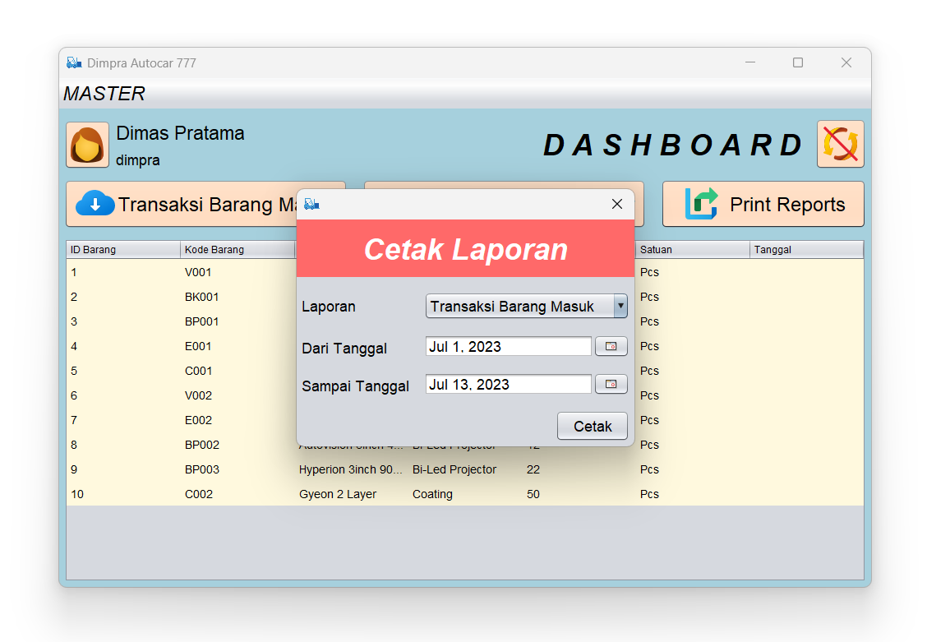

# BAB IV – PENUTUP

## 4.1 Kesimpulan

Dapat disimpulkan bahwa aplikasi Dimpra Autocar 777 ini memiliki peran yang sangat penting dalam pengelolaan inventaris secara efisien dan akurat. Aplikasi ini memungkinkan pengguna untuk mencatat, mengelola, dan melacak semua barang dengan cepat dan mudah.

## 4.2 Saran

Aplikasi Dimpra Autocar 777 ini masih perlu ditambahkan fitur search untuk mempermudah pengguna dalam mencari barang dan menambahkan beberapa fitur lainnya yang lebih kompleks sehingga aplikasi ini lebih efektif dan efisien kedepannya.

# BAB V – LAMPIRAN KODE PROGRAM

## 5.1 Form_Akun.java

package inventori_barang;

import java.sql.Connection;

import java.sql.SQLException;

import java.util.logging.Level;

import java.util.logging.Logger;

import javax.swing.JOptionPane;

public class Form_Akun extends javax.swing.JDialog {

inventori_barang.Connection_DB konek = new inventori_barang.Connection_DB();

inventori_barang.Session_Employee PetugasSession = new inventori_barang.Session_Employee();

public Form_Akun(java.awt.Frame parent, boolean modal) {

super(parent, modal);

initComponents();

lblnama.setText(": " + PetugasSession.getEmployee_name());

lblusername.setText(": " + PetugasSession.getEmployee_username());

lblpassword.setText(": ***********");

}

@SuppressWarnings("unchecked")

// <editor-fold defaultstate="collapsed" desc="Generated Code">

private void initComponents() {

jPasswordField3 = new javax.swing.JPasswordField();

jPanel1 = new javax.swing.JPanel();

jLabel9 = new javax.swing.JLabel();

jLabel3 = new javax.swing.JLabel();

jLabel4 = new javax.swing.JLabel();

lblnama = new javax.swing.JLabel();

lblusername = new javax.swing.JLabel();

jPanel2 = new javax.swing.JPanel();

txtcpassword = new javax.swing.JPasswordField();

btnsave_password = new javax.swing.JButton();

jLabel6 = new javax.swing.JLabel();

jLabel7 = new javax.swing.JLabel();

jLabel8 = new javax.swing.JLabel();

jLabel10 = new javax.swing.JLabel();

txtpassword_lama = new javax.swing.JPasswordField();

txtpassword = new javax.swing.JPasswordField();

lblpassword = new javax.swing.JLabel();

jLabel5 = new javax.swing.JLabel();

jPasswordField3.setText("jPasswordField3");

setDefaultCloseOperation(javax.swing.WindowConstants.DISPOSE_ON_CLOSE);

jPanel1.setBackground(new java.awt.Color(255, 105, 105));

jLabel9.setFont(new java.awt.Font("Dialog", 3, 36)); // NOI18N

jLabel9.setForeground(new java.awt.Color(255, 255, 255));

jLabel9.setHorizontalAlignment(javax.swing.SwingConstants.CENTER);

jLabel9.setText("Profil Akun");

javax.swing.GroupLayout jPanel1Layout = new javax.swing.GroupLayout(jPanel1);

jPanel1.setLayout(jPanel1Layout);

jPanel1Layout.setHorizontalGroup(

jPanel1Layout.createParallelGroup(javax.swing.GroupLayout.Alignment.LEADING)

.addComponent(jLabel9, javax.swing.GroupLayout.DEFAULT_SIZE, javax.swing.GroupLayout.DEFAULT_SIZE, Short.MAX_VALUE)

);

jPanel1Layout.setVerticalGroup(

jPanel1Layout.createParallelGroup(javax.swing.GroupLayout.Alignment.LEADING)

.addComponent(jLabel9, javax.swing.GroupLayout.DEFAULT_SIZE, 70, Short.MAX_VALUE)

);

jLabel3.setFont(new java.awt.Font("Dialog", 0, 24)); // NOI18N

jLabel3.setText("Username");

jLabel4.setFont(new java.awt.Font("Dialog", 0, 24)); // NOI18N

jLabel4.setText("Nama");

lblnama.setFont(new java.awt.Font("Dialog", 0, 24)); // NOI18N

lblnama.setText("lblnama");

lblusername.setFont(new java.awt.Font("Dialog", 0, 24)); // NOI18N

lblusername.setText("lblusername");

jPanel2.setBorder(javax.swing.BorderFactory.createTitledBorder(""));

txtcpassword.setFont(new java.awt.Font("Dialog", 0, 24)); // NOI18N

btnsave_password.setFont(new java.awt.Font("Calibri", 0, 24)); // NOI18N

btnsave_password.setIcon(new javax.swing.ImageIcon(getClass().getResource("/inventori_barang/img/save.png"))); // NOI18N

btnsave_password.setHideActionText(true);

btnsave_password.addActionListener(new java.awt.event.ActionListener() {

public void actionPerformed(java.awt.event.ActionEvent evt) {

btnsave_passwordActionPerformed(evt);

}

});

jLabel6.setFont(new java.awt.Font("Dialog", 0, 24)); // NOI18N

jLabel6.setHorizontalAlignment(javax.swing.SwingConstants.CENTER);

jLabel6.setText("Ganti Password");

jLabel7.setFont(new java.awt.Font("Dialog", 0, 24)); // NOI18N

jLabel7.setText("Password Lama");

jLabel8.setFont(new java.awt.Font("Dialog", 0, 24)); // NOI18N

jLabel8.setText("Password Baru");

jLabel10.setFont(new java.awt.Font("Dialog", 0, 24)); // NOI18N

jLabel10.setText("Ulangi Password");

txtpassword_lama.setFont(new java.awt.Font("Dialog", 0, 24)); // NOI18N

txtpassword.setFont(new java.awt.Font("Dialog", 0, 24)); // NOI18N

javax.swing.GroupLayout jPanel2Layout = new javax.swing.GroupLayout(jPanel2);

jPanel2.setLayout(jPanel2Layout);

jPanel2Layout.setHorizontalGroup(

jPanel2Layout.createParallelGroup(javax.swing.GroupLayout.Alignment.LEADING)

.addGroup(jPanel2Layout.createSequentialGroup()

.addContainerGap()

.addGroup(jPanel2Layout.createParallelGroup(javax.swing.GroupLayout.Alignment.LEADING)

.addComponent(jLabel6, javax.swing.GroupLayout.DEFAULT_SIZE, javax.swing.GroupLayout.DEFAULT_SIZE, Short.MAX_VALUE)

.addGroup(jPanel2Layout.createSequentialGroup()

.addGroup(jPanel2Layout.createParallelGroup(javax.swing.GroupLayout.Alignment.TRAILING)

.addComponent(btnsave_password)

.addGroup(jPanel2Layout.createSequentialGroup()

.addGroup(jPanel2Layout.createParallelGroup(javax.swing.GroupLayout.Alignment.LEADING)

.addComponent(jLabel7)

.addComponent(jLabel8)

.addComponent(jLabel10))

.addGap(18, 18, 18)

.addGroup(jPanel2Layout.createParallelGroup(javax.swing.GroupLayout.Alignment.LEADING)

.addComponent(txtcpassword, javax.swing.GroupLayout.PREFERRED_SIZE, 250, javax.swing.GroupLayout.PREFERRED_SIZE)

.addComponent(txtpassword, javax.swing.GroupLayout.PREFERRED_SIZE, 250, javax.swing.GroupLayout.PREFERRED_SIZE)

.addComponent(txtpassword_lama, javax.swing.GroupLayout.PREFERRED_SIZE, 250, javax.swing.GroupLayout.PREFERRED_SIZE))))

.addGap(0, 0, Short.MAX_VALUE)))

.addContainerGap())

);

jPanel2Layout.setVerticalGroup(

jPanel2Layout.createParallelGroup(javax.swing.GroupLayout.Alignment.LEADING)

.addGroup(jPanel2Layout.createSequentialGroup()

.addComponent(jLabel6)

.addGap(18, 18, 18)

.addGroup(jPanel2Layout.createParallelGroup(javax.swing.GroupLayout.Alignment.BASELINE)

.addComponent(jLabel7)

.addComponent(txtpassword_lama, javax.swing.GroupLayout.PREFERRED_SIZE, javax.swing.GroupLayout.DEFAULT_SIZE, javax.swing.GroupLayout.PREFERRED_SIZE))

.addGap(16, 16, 16)

.addGroup(jPanel2Layout.createParallelGroup(javax.swing.GroupLayout.Alignment.BASELINE)

.addComponent(jLabel8)

.addComponent(txtpassword, javax.swing.GroupLayout.PREFERRED_SIZE, javax.swing.GroupLayout.DEFAULT_SIZE, javax.swing.GroupLayout.PREFERRED_SIZE))

.addPreferredGap(javax.swing.LayoutStyle.ComponentPlacement.UNRELATED)

.addGroup(jPanel2Layout.createParallelGroup(javax.swing.GroupLayout.Alignment.BASELINE)

.addComponent(jLabel10)

.addComponent(txtcpassword, javax.swing.GroupLayout.PREFERRED_SIZE, javax.swing.GroupLayout.DEFAULT_SIZE, javax.swing.GroupLayout.PREFERRED_SIZE))

.addPreferredGap(javax.swing.LayoutStyle.ComponentPlacement.RELATED, 18, Short.MAX_VALUE)

.addComponent(btnsave_password)

.addContainerGap())

);

lblpassword.setFont(new java.awt.Font("Dialog", 0, 24)); // NOI18N

lblpassword.setText("lblpassword");

jLabel5.setFont(new java.awt.Font("Dialog", 0, 24)); // NOI18N

jLabel5.setText("Password");

javax.swing.GroupLayout layout = new javax.swing.GroupLayout(getContentPane());

getContentPane().setLayout(layout);

layout.setHorizontalGroup(

layout.createParallelGroup(javax.swing.GroupLayout.Alignment.LEADING)

.addComponent(jPanel1, javax.swing.GroupLayout.DEFAULT_SIZE, javax.swing.GroupLayout.DEFAULT_SIZE, Short.MAX_VALUE)

.addGroup(javax.swing.GroupLayout.Alignment.TRAILING, layout.createSequentialGroup()

.addContainerGap(javax.swing.GroupLayout.DEFAULT_SIZE, Short.MAX_VALUE)

.addGroup(layout.createParallelGroup(javax.swing.GroupLayout.Alignment.LEADING)

.addComponent(jPanel2, javax.swing.GroupLayout.PREFERRED_SIZE, javax.swing.GroupLayout.DEFAULT_SIZE, javax.swing.GroupLayout.PREFERRED_SIZE)

.addGroup(layout.createSequentialGroup()

.addGroup(layout.createParallelGroup(javax.swing.GroupLayout.Alignment.LEADING)

.addGroup(layout.createParallelGroup(javax.swing.GroupLayout.Alignment.LEADING)

.addComponent(jLabel4, javax.swing.GroupLayout.PREFERRED_SIZE, 160, javax.swing.GroupLayout.PREFERRED_SIZE)

.addComponent(jLabel3, javax.swing.GroupLayout.Alignment.TRAILING, javax.swing.GroupLayout.PREFERRED_SIZE, 160, javax.swing.GroupLayout.PREFERRED_SIZE))

.addComponent(jLabel5, javax.swing.GroupLayout.PREFERRED_SIZE, 160, javax.swing.GroupLayout.PREFERRED_SIZE))

.addGap(36, 36, 36)

.addGroup(layout.createParallelGroup(javax.swing.GroupLayout.Alignment.TRAILING, false)

.addComponent(lblusername, javax.swing.GroupLayout.Alignment.LEADING, javax.swing.GroupLayout.DEFAULT_SIZE, 240, Short.MAX_VALUE)

.addComponent(lblnama, javax.swing.GroupLayout.Alignment.LEADING, javax.swing.GroupLayout.DEFAULT_SIZE, javax.swing.GroupLayout.DEFAULT_SIZE, Short.MAX_VALUE)

.addComponent(lblpassword, javax.swing.GroupLayout.DEFAULT_SIZE, javax.swing.GroupLayout.DEFAULT_SIZE, Short.MAX_VALUE))))

.addContainerGap())

);

layout.setVerticalGroup(

layout.createParallelGroup(javax.swing.GroupLayout.Alignment.LEADING)

.addGroup(layout.createSequentialGroup()

.addComponent(jPanel1, javax.swing.GroupLayout.PREFERRED_SIZE, javax.swing.GroupLayout.DEFAULT_SIZE, javax.swing.GroupLayout.PREFERRED_SIZE)

.addGap(18, 18, 18)

.addGroup(layout.createParallelGroup(javax.swing.GroupLayout.Alignment.BASELINE)

.addComponent(jLabel4)

.addComponent(lblnama, javax.swing.GroupLayout.PREFERRED_SIZE, 30, javax.swing.GroupLayout.PREFERRED_SIZE))

.addGap(18, 18, 18)

.addGroup(layout.createParallelGroup(javax.swing.GroupLayout.Alignment.BASELINE)

.addComponent(jLabel3)

.addComponent(lblusername))

.addGap(18, 18, 18)

.addGroup(layout.createParallelGroup(javax.swing.GroupLayout.Alignment.BASELINE)

.addComponent(jLabel5)

.addComponent(lblpassword))

.addGap(18, 18, 18)

.addComponent(jPanel2, javax.swing.GroupLayout.PREFERRED_SIZE, javax.swing.GroupLayout.DEFAULT_SIZE, javax.swing.GroupLayout.PREFERRED_SIZE)

.addContainerGap(javax.swing.GroupLayout.DEFAULT_SIZE, Short.MAX_VALUE))

);

pack();

setLocationRelativeTo(null);

}// </editor-fold>

private void btnsave_passwordActionPerformed(java.awt.event.ActionEvent evt) {

if (txtpassword_lama.getPassword().length == 0 || txtpassword.getPassword().length == 0 || txtcpassword.getPassword().length == 0) {

JOptionPane.showMessageDialog(null, "Terdapat inputan yang kosong.");

} else {

String row_txtpassword_lama = new String(txtpassword_lama.getPassword());

String row_txtpassword = new String(txtpassword.getPassword());

String row_txtcpassword = new String(txtcpassword.getPassword());

if (!(row_txtpassword.equals(row_txtcpassword))) {

JOptionPane.showMessageDialog(null, "Ulangi password berbeda dengan inputan password baru.", "Gagal Disimpan", JOptionPane.ERROR_MESSAGE);

txtcpassword.setText("");

txtcpassword.requestFocus();

} else {

int u_id = PetugasSession.getEmployee_id();

try {

Connection conn = konek.openkoneksi();

java.sql.Statement stm = conn.createStatement();

java.sql.ResultSet rsLogin = stm.executeQuery("SELECT * FROM tmpetugas WHERE id = '" + u_id + "'");

if (rsLogin.next()) {

if (row_txtpassword_lama.equals(rsLogin.getString("password"))) {

try {

Connection conn2 = konek.openkoneksi();

java.sql.Statement stm2 = conn2.createStatement();

stm2.executeUpdate("UPDATE tmpetugas SET password='" + row_txtpassword + "' WHERE id = '" + u_id + "'");

JOptionPane.showMessageDialog(null, "Berhasil mengubah password.");

konek.closekoneksi();

this.setVisible(false);

} catch (SQLException e) {

JOptionPane.showMessageDialog(null, "Error " + e);

} catch (ClassNotFoundException ex) {

Logger.getLogger(Form_Akun.class.getName()).log(Level.SEVERE, null, ex);

}

} else {

JOptionPane.showMessageDialog(null, "Password lama Anda salah.");

txtpassword_lama.setText("");

txtpassword_lama.requestFocus();

}

} else {

JOptionPane.showMessageDialog(null, "Id tidak ditemukan.");

}

} catch (SQLException e) {

JOptionPane.showMessageDialog(null, "Error " + e);

} catch (ClassNotFoundException ex) {

Logger.getLogger(Form_Akun.class.getName()).log(Level.SEVERE, null, ex);

}

}

}

}

public static void main(String args[]) {

java.awt.EventQueue.invokeLater(new Runnable() {

public void run() {

Form_Akun dialog = new Form_Akun(new javax.swing.JFrame(), true);

dialog.addWindowListener(new java.awt.event.WindowAdapter() {

@Override

public void windowClosing(java.awt.event.WindowEvent e) {

System.exit(0);

}

});

dialog.setVisible(true);

}

});

}

// Variables declaration - do not modify

private javax.swing.JButton btnsave_password;

private javax.swing.JLabel jLabel10;

private javax.swing.JLabel jLabel3;

private javax.swing.JLabel jLabel4;

private javax.swing.JLabel jLabel5;

private javax.swing.JLabel jLabel6;

private javax.swing.JLabel jLabel7;

private javax.swing.JLabel jLabel8;

private javax.swing.JLabel jLabel9;

private javax.swing.JPanel jPanel1;

private javax.swing.JPanel jPanel2;

private javax.swing.JPasswordField jPasswordField3;

private javax.swing.JLabel lblnama;

private javax.swing.JLabel lblpassword;

private javax.swing.JLabel lblusername;

private javax.swing.JPasswordField txtcpassword;

private javax.swing.JPasswordField txtpassword;

private javax.swing.JPasswordField txtpassword_lama;

// End of variables declaration

}

## 5.2 Form_Barang.java

package inventori_barang;

import java.awt.Color;

import java.sql.Connection;

import java.sql.PreparedStatement;

import java.sql.SQLException;

import java.text.SimpleDateFormat;

import java.util.logging.Level;

import java.util.logging.Logger;

import javax.swing.JOptionPane;

import javax.swing.table.DefaultTableModel;

import javax.swing.table.JTableHeader;

import net.proteanit.sql.DbUtils;

public class Form_Barang extends javax.swing.JDialog {

inventori_barang.Connection_DB konek = new inventori_barang.Connection_DB();

public Form_Barang(java.awt.Frame parent, boolean modal) {

super(parent, modal);

initComponents();

SelectKategori();

txttemp_kode.hide();

txtid_kategori.hide();

GetData();

BtnEnabled(false);

btnsave.setText("Simpan");

}

private void SelectKategori() {

try {

Connection conn = konek.openkoneksi();

java.sql.Statement stm = conn.createStatement();

java.sql.ResultSet rs = stm.executeQuery("SELECT * FROM tmkategori");

cmbid_kategori.addItem("Pilih");

while (rs.next()) {

cmbid_kategori.addItem(rs.getString("nama"));

}

konek.closekoneksi();

} catch (SQLException e) {

JOptionPane.showMessageDialog(null, "Error " + e);

} catch (ClassNotFoundException ex) {

Logger.getLogger(Form_Barang.class.getName()).log(Level.SEVERE, null, ex);

}

}

private void TxtEmpty() {

txtid.setText("");

txtkode.setText("");

txtnama.setText("");

txtsatuan.setText("");

txtstok.setText("");

txtid_kategori.setText("");

txttemp_kode.setText("");

cmbid_kategori.setSelectedItem("Pilih");

txt_tanggal.setDate(null);

}

private void BtnEnabled(boolean x) {

btnedit.setEnabled(x);

btndelete.setEnabled(x);

}

private void GetData() {

try {

Connection conn = konek.openkoneksi();

java.sql.Statement stm = conn.createStatement();

java.sql.ResultSet sql = stm.executeQuery("SELECT tmbarang.id, tmbarang.kode, tmbarang.nama, tmkategori.nama as kategori, tmbarang.stok, tmbarang.satuan, tmbarang.tanggal FROM tmbarang JOIN tmkategori ON tmkategori.id = tmbarang.id_kategori");

DefaultTableModel model = (DefaultTableModel) DbUtils.resultSetToTableModel(sql);

datatable.setModel(model);

datatable.getColumnModel().getColumn(0).setPreferredWidth(7);

datatable.getColumnModel().getColumn(1).setPreferredWidth(20);

datatable.getColumnModel().getColumn(2).setPreferredWidth(90);

datatable.getColumnModel().getColumn(3).setPreferredWidth(60);

datatable.getColumnModel().getColumn(4).setPreferredWidth(40);

datatable.getColumnModel().getColumn(5).setPreferredWidth(25);

datatable.getColumnModel().getColumn(6).setPreferredWidth(40);

JTableHeader header = datatable.getTableHeader();

String[] columnNames = {"ID Barang", "Kode Barang", "Nama Barang", "Kategori Barang", "Stok", "Satuan", "Tanggal"};

header.setReorderingAllowed(false);

model.setColumnIdentifiers(columnNames);

String count_rows = String.valueOf(model.getRowCount());

lblcount_rows.setText("Jumlah Data : " + count_rows);

} catch (SQLException e) {

JOptionPane.showMessageDialog(null, "Error " + e);

} catch (ClassNotFoundException ex) {

Logger.getLogger(Form_Barang.class.getName()).log(Level.SEVERE, null, ex);

}

}

private void GetData_View() {

int row = datatable.getSelectedRow();

String row_id = (datatable.getModel().getValueAt(row, 0).toString());

txtid.setText(row_id);

BtnEnabled(true);

}

@SuppressWarnings("unchecked")

// <editor-fold defaultstate="collapsed" desc="Generated Code">

private void initComponents() {

btnedit = new javax.swing.JButton();

panel = new javax.swing.JPanel();

jLabel1 = new javax.swing.JLabel();

btnsave = new javax.swing.JButton();

jLabel2 = new javax.swing.JLabel();

txtkode = new javax.swing.JTextField();

jLabel4 = new javax.swing.JLabel();

txtnama = new javax.swing.JTextField();

jLabel6 = new javax.swing.JLabel();

btncancel = new javax.swing.JButton();

jLabel3 = new javax.swing.JLabel();

txtstok = new javax.swing.JTextField();

cmbid_kategori = new javax.swing.JComboBox<>();

txtsatuan = new javax.swing.JTextField();

txt_tanggal = new com.toedter.calendar.JDateChooser();

jLabel9 = new javax.swing.JLabel();

txttemp_kode = new javax.swing.JTextField();

jScrollPane1 = new javax.swing.JScrollPane();

datatable = new javax.swing.JTable(){

public boolean isCellEditable(int rowIndex, int colIndex) {

return false;

}

};

jLabel5 = new javax.swing.JLabel();

jScrollPane2 = new javax.swing.JScrollPane();

txtid = new javax.swing.JTextPane();

lbl_action = new javax.swing.JLabel();

jLabel7 = new javax.swing.JLabel();

btnadd = new javax.swing.JButton();

btndelete = new javax.swing.JButton();

jPanel1 = new javax.swing.JPanel();

jLabel8 = new javax.swing.JLabel();

lblcount_rows = new javax.swing.JLabel();

jButton1 = new javax.swing.JButton();

txtid_kategori = new javax.swing.JTextField();

setDefaultCloseOperation(javax.swing.WindowConstants.DISPOSE_ON_CLOSE);

setTitle("Dimpra Autocar 777");

btnedit.setFont(new java.awt.Font("Dialog", 0, 18)); // NOI18N

btnedit.setIcon(new javax.swing.ImageIcon(getClass().getResource("/inventori_barang/img/edit.png"))); // NOI18N

btnedit.setText("Ubah");

btnedit.addActionListener(new java.awt.event.ActionListener() {

public void actionPerformed(java.awt.event.ActionEvent evt) {

btneditActionPerformed(evt);

}

});

panel.setBorder(javax.swing.BorderFactory.createTitledBorder(""));

panel.setForeground(new java.awt.Color(245, 245, 245));

panel.setEnabled(false);

jLabel1.setFont(new java.awt.Font("Dialog", 0, 18)); // NOI18N

jLabel1.setLabelFor(txtkode);

jLabel1.setText("Kode");

btnsave.setFont(new java.awt.Font("Dialog", 0, 18)); // NOI18N

btnsave.setIcon(new javax.swing.ImageIcon(getClass().getResource("/inventori_barang/img/save.png"))); // NOI18N

btnsave.setText("Simpan");

btnsave.addActionListener(new java.awt.event.ActionListener() {

public void actionPerformed(java.awt.event.ActionEvent evt) {

btnsaveActionPerformed(evt);

}

});

jLabel2.setFont(new java.awt.Font("Dialog", 0, 18)); // NOI18N

jLabel2.setLabelFor(txtnama);

jLabel2.setText("Name");

txtkode.setFont(new java.awt.Font("Dialog", 0, 18)); // NOI18N

txtkode.addActionListener(new java.awt.event.ActionListener() {

public void actionPerformed(java.awt.event.ActionEvent evt) {

txtkodeActionPerformed(evt);

}

});

jLabel4.setFont(new java.awt.Font("Dialog", 0, 18)); // NOI18N

jLabel4.setLabelFor(txtsatuan);

jLabel4.setText("Kategori");

txtnama.setFont(new java.awt.Font("Dialog", 0, 18)); // NOI18N

txtnama.setAutoscrolls(false);

txtnama.addActionListener(new java.awt.event.ActionListener() {

public void actionPerformed(java.awt.event.ActionEvent evt) {

txtnamaActionPerformed(evt);

}

});

txtnama.addKeyListener(new java.awt.event.KeyAdapter() {

public void keyTyped(java.awt.event.KeyEvent evt) {

txtnamaKeyTyped(evt);

}

});

jLabel6.setFont(new java.awt.Font("Dialog", 0, 18)); // NOI18N

jLabel6.setText("Satuan");

jLabel6.addKeyListener(new java.awt.event.KeyAdapter() {

public void keyTyped(java.awt.event.KeyEvent evt) {

jLabel6KeyTyped(evt);

}

});

btncancel.setFont(new java.awt.Font("Dialog", 0, 18)); // NOI18N

btncancel.setIcon(new javax.swing.ImageIcon(getClass().getResource("/inventori_barang/img/delete.png"))); // NOI18N

btncancel.setText("Batal");

btncancel.addActionListener(new java.awt.event.ActionListener() {

public void actionPerformed(java.awt.event.ActionEvent evt) {

btncancelActionPerformed(evt);

}

});

jLabel3.setFont(new java.awt.Font("Dialog", 0, 18)); // NOI18N

jLabel3.setText("Stok");

txtstok.setFont(new java.awt.Font("Dialog", 0, 18)); // NOI18N

txtstok.addActionListener(new java.awt.event.ActionListener() {

public void actionPerformed(java.awt.event.ActionEvent evt) {

txtstokActionPerformed(evt);

}

});

txtstok.addKeyListener(new java.awt.event.KeyAdapter() {

public void keyTyped(java.awt.event.KeyEvent evt) {

txtstokKeyTyped(evt);

}

});

cmbid_kategori.setFont(new java.awt.Font("Dialog", 0, 18)); // NOI18N

cmbid_kategori.addItemListener(new java.awt.event.ItemListener() {

public void itemStateChanged(java.awt.event.ItemEvent evt) {

cmbid_kategoriItemStateChanged(evt);

}

});

txtsatuan.setFont(new java.awt.Font("Dialog", 0, 18)); // NOI18N

jLabel9.setFont(new java.awt.Font("Dialog", 0, 18)); // NOI18N

jLabel9.setText("Date");

jLabel9.addKeyListener(new java.awt.event.KeyAdapter() {

public void keyTyped(java.awt.event.KeyEvent evt) {

jLabel9KeyTyped(evt);

}

});

javax.swing.GroupLayout panelLayout = new javax.swing.GroupLayout(panel);

panel.setLayout(panelLayout);

panelLayout.setHorizontalGroup(

panelLayout.createParallelGroup(javax.swing.GroupLayout.Alignment.LEADING)

.addGroup(panelLayout.createSequentialGroup()

.addContainerGap()

.addGroup(panelLayout.createParallelGroup(javax.swing.GroupLayout.Alignment.LEADING)

.addGroup(panelLayout.createSequentialGroup()

.addComponent(btncancel)

.addPreferredGap(javax.swing.LayoutStyle.ComponentPlacement.RELATED, javax.swing.GroupLayout.DEFAULT_SIZE, Short.MAX_VALUE)

.addComponent(btnsave))

.addGroup(panelLayout.createSequentialGroup()

.addGroup(panelLayout.createParallelGroup(javax.swing.GroupLayout.Alignment.LEADING)

.addGroup(panelLayout.createParallelGroup(javax.swing.GroupLayout.Alignment.LEADING, false)

.addComponent(jLabel4, javax.swing.GroupLayout.DEFAULT_SIZE, javax.swing.GroupLayout.DEFAULT_SIZE, Short.MAX_VALUE)

.addComponent(jLabel2, javax.swing.GroupLayout.DEFAULT_SIZE, javax.swing.GroupLayout.DEFAULT_SIZE, Short.MAX_VALUE)

.addComponent(jLabel1, javax.swing.GroupLayout.DEFAULT_SIZE, javax.swing.GroupLayout.DEFAULT_SIZE, Short.MAX_VALUE)

.addComponent(jLabel3, javax.swing.GroupLayout.DEFAULT_SIZE, javax.swing.GroupLayout.DEFAULT_SIZE, Short.MAX_VALUE)

.addComponent(jLabel6, javax.swing.GroupLayout.DEFAULT_SIZE, javax.swing.GroupLayout.DEFAULT_SIZE, Short.MAX_VALUE))

.addComponent(jLabel9))

.addGap(18, 18, 18)

.addGroup(panelLayout.createParallelGroup(javax.swing.GroupLayout.Alignment.LEADING)

.addComponent(cmbid_kategori, 0, javax.swing.GroupLayout.DEFAULT_SIZE, Short.MAX_VALUE)

.addComponent(txtnama)

.addComponent(txtstok)

.addComponent(txtsatuan, javax.swing.GroupLayout.Alignment.TRAILING)

.addComponent(txt_tanggal, javax.swing.GroupLayout.DEFAULT_SIZE, javax.swing.GroupLayout.DEFAULT_SIZE, Short.MAX_VALUE)

.addComponent(txtkode))))

.addContainerGap())

);

panelLayout.setVerticalGroup(

panelLayout.createParallelGroup(javax.swing.GroupLayout.Alignment.LEADING)

.addGroup(panelLayout.createSequentialGroup()

.addContainerGap()

.addGroup(panelLayout.createParallelGroup(javax.swing.GroupLayout.Alignment.BASELINE)

.addComponent(txtkode, javax.swing.GroupLayout.PREFERRED_SIZE, javax.swing.GroupLayout.DEFAULT_SIZE, javax.swing.GroupLayout.PREFERRED_SIZE)

.addComponent(jLabel1))

.addGap(18, 18, 18)

.addGroup(panelLayout.createParallelGroup(javax.swing.GroupLayout.Alignment.BASELINE)

.addComponent(jLabel2, javax.swing.GroupLayout.PREFERRED_SIZE, 22, javax.swing.GroupLayout.PREFERRED_SIZE)

.addComponent(txtnama, javax.swing.GroupLayout.PREFERRED_SIZE, javax.swing.GroupLayout.DEFAULT_SIZE, javax.swing.GroupLayout.PREFERRED_SIZE))

.addGap(18, 18, 18)

.addGroup(panelLayout.createParallelGroup(javax.swing.GroupLayout.Alignment.BASELINE)

.addComponent(jLabel4)

.addComponent(cmbid_kategori, javax.swing.GroupLayout.PREFERRED_SIZE, javax.swing.GroupLayout.DEFAULT_SIZE, javax.swing.GroupLayout.PREFERRED_SIZE))

.addGap(18, 18, 18)

.addGroup(panelLayout.createParallelGroup(javax.swing.GroupLayout.Alignment.BASELINE)

.addComponent(jLabel3)

.addComponent(txtstok, javax.swing.GroupLayout.PREFERRED_SIZE, javax.swing.GroupLayout.DEFAULT_SIZE, javax.swing.GroupLayout.PREFERRED_SIZE))

.addGap(18, 18, 18)

.addGroup(panelLayout.createParallelGroup(javax.swing.GroupLayout.Alignment.BASELINE)

.addComponent(jLabel6)

.addComponent(txtsatuan, javax.swing.GroupLayout.PREFERRED_SIZE, javax.swing.GroupLayout.DEFAULT_SIZE, javax.swing.GroupLayout.PREFERRED_SIZE))

.addGap(18, 18, 18)

.addGroup(panelLayout.createParallelGroup(javax.swing.GroupLayout.Alignment.LEADING)

.addComponent(txt_tanggal, javax.swing.GroupLayout.PREFERRED_SIZE, javax.swing.GroupLayout.DEFAULT_SIZE, javax.swing.GroupLayout.PREFERRED_SIZE)

.addComponent(jLabel9))

.addGap(18, 18, 18)

.addGroup(panelLayout.createParallelGroup(javax.swing.GroupLayout.Alignment.LEADING)

.addComponent(btnsave)

.addComponent(btncancel))

.addContainerGap(javax.swing.GroupLayout.DEFAULT_SIZE, Short.MAX_VALUE))

);

txtsatuan.getAccessibleContext().setAccessibleDescription("");

txttemp_kode.setFont(new java.awt.Font("Dialog", 0, 18)); // NOI18N

datatable.setModel(new javax.swing.table.DefaultTableModel(

new Object [][] {

{null, null, null, null, null, null},

{null, null, null, null, null, null},

{null, null, null, null, null, null},

{null, null, null, null, null, null},

{null, null, null, null, null, null},

{null, null, null, null, null, null},

{null, null, null, null, null, null},

{null, null, null, null, null, null},

{null, null, null, null, null, null},

{null, null, null, null, null, null},

{null, null, null, null, null, null},

{null, null, null, null, null, null},

{null, null, null, null, null, null},

{null, null, null, null, null, null},

{null, null, null, null, null, null},

{null, null, null, null, null, null},

{null, null, null, null, null, null},

{null, null, null, null, null, null},

{null, null, null, null, null, null},

{null, null, null, null, null, null},

{null, null, null, null, null, null},

{null, null, null, null, null, null},

{null, null, null, null, null, null},

{null, null, null, null, null, null}

},

new String [] {

"ID", "Kode", "Nama", "Kategori", "Satuan", "Stok"

}

));

datatable.setSelectionMode(javax.swing.ListSelectionModel.SINGLE_SELECTION);

datatable.addMouseListener(new java.awt.event.MouseAdapter() {

public void mouseClicked(java.awt.event.MouseEvent evt) {

datatableMouseClicked(evt);

}

public void mouseReleased(java.awt.event.MouseEvent evt) {

datatableMouseReleased(evt);

}

});

datatable.addKeyListener(new java.awt.event.KeyAdapter() {

public void keyPressed(java.awt.event.KeyEvent evt) {

datatableKeyPressed(evt);

}

public void keyReleased(java.awt.event.KeyEvent evt) {

datatableKeyReleased(evt);

}

});

jScrollPane1.setViewportView(datatable);

jLabel5.setFont(new java.awt.Font("Lucida Grande", 0, 24)); // NOI18N

txtid.setBorder(null);

txtid.setFont(new java.awt.Font("Dialog", 0, 18)); // NOI18N

txtid.setForeground(new java.awt.Color(43, 152, 240));

txtid.setToolTipText("");

txtid.setCursor(new java.awt.Cursor(java.awt.Cursor.TEXT_CURSOR));

txtid.setEnabled(false);

txtid.setFocusable(false);

jScrollPane2.setViewportView(txtid);

lbl_action.setFont(new java.awt.Font("Dialog", 0, 18)); // NOI18N

lbl_action.setText("Form Tambah Data Barang");

jLabel7.setFont(new java.awt.Font("Dialog", 0, 18)); // NOI18N

jLabel7.setLabelFor(txtid);

jLabel7.setText("Baris ID Data");

btnadd.setFont(new java.awt.Font("Dialog", 0, 18)); // NOI18N

btnadd.setIcon(new javax.swing.ImageIcon(getClass().getResource("/inventori_barang/img/add.png"))); // NOI18N

btnadd.setText("Tambah");

btnadd.addActionListener(new java.awt.event.ActionListener() {

public void actionPerformed(java.awt.event.ActionEvent evt) {

btnaddActionPerformed(evt);

}

});

btndelete.setFont(new java.awt.Font("Dialog", 0, 18)); // NOI18N

btndelete.setIcon(new javax.swing.ImageIcon(getClass().getResource("/inventori_barang/img/delete.png"))); // NOI18N

btndelete.setText("Hapus");

btndelete.addActionListener(new java.awt.event.ActionListener() {

public void actionPerformed(java.awt.event.ActionEvent evt) {

btndeleteActionPerformed(evt);

}

});

jPanel1.setBackground(new java.awt.Color(255, 105, 105));

jLabel8.setFont(new java.awt.Font("Dialog", 3, 36)); // NOI18N

jLabel8.setForeground(new java.awt.Color(255, 255, 255));

jLabel8.setHorizontalAlignment(javax.swing.SwingConstants.CENTER);

jLabel8.setText("Data Barang");

javax.swing.GroupLayout jPanel1Layout = new javax.swing.GroupLayout(jPanel1);

jPanel1.setLayout(jPanel1Layout);

jPanel1Layout.setHorizontalGroup(

jPanel1Layout.createParallelGroup(javax.swing.GroupLayout.Alignment.LEADING)

.addComponent(jLabel8, javax.swing.GroupLayout.DEFAULT_SIZE, javax.swing.GroupLayout.DEFAULT_SIZE, Short.MAX_VALUE)

);

jPanel1Layout.setVerticalGroup(

jPanel1Layout.createParallelGroup(javax.swing.GroupLayout.Alignment.LEADING)

.addComponent(jLabel8, javax.swing.GroupLayout.DEFAULT_SIZE, 70, Short.MAX_VALUE)

);

lblcount_rows.setFont(new java.awt.Font("Lucida Grande", 0, 18)); // NOI18N

lblcount_rows.setText("Jumlah Data");

jButton1.setFont(new java.awt.Font("Dialog", 0, 18)); // NOI18N

jButton1.setIcon(new javax.swing.ImageIcon(getClass().getResource("/inventori_barang/img/refresh.png"))); // NOI18N

jButton1.setText("Perbarui");

jButton1.addActionListener(new java.awt.event.ActionListener() {

public void actionPerformed(java.awt.event.ActionEvent evt) {

jButton1ActionPerformed(evt);

}

});

javax.swing.GroupLayout layout = new javax.swing.GroupLayout(getContentPane());

getContentPane().setLayout(layout);

layout.setHorizontalGroup(

layout.createParallelGroup(javax.swing.GroupLayout.Alignment.LEADING)

.addComponent(jPanel1, javax.swing.GroupLayout.DEFAULT_SIZE, javax.swing.GroupLayout.DEFAULT_SIZE, Short.MAX_VALUE)

.addGroup(layout.createSequentialGroup()

.addContainerGap(javax.swing.GroupLayout.DEFAULT_SIZE, Short.MAX_VALUE)

.addComponent(jLabel5)

.addPreferredGap(javax.swing.LayoutStyle.ComponentPlacement.UNRELATED)

.addGroup(layout.createParallelGroup(javax.swing.GroupLayout.Alignment.TRAILING, false)

.addComponent(jScrollPane1, javax.swing.GroupLayout.PREFERRED_SIZE, 700, javax.swing.GroupLayout.PREFERRED_SIZE)

.addGroup(layout.createSequentialGroup()

.addComponent(btnadd, javax.swing.GroupLayout.DEFAULT_SIZE, javax.swing.GroupLayout.DEFAULT_SIZE, Short.MAX_VALUE)

.addGap(18, 18, 18)

.addComponent(btnedit)

.addGap(18, 18, 18)

.addComponent(btndelete)

.addGap(18, 18, 18)

.addComponent(jButton1)))

.addGap(18, 18, 18)

.addGroup(layout.createParallelGroup(javax.swing.GroupLayout.Alignment.LEADING, false)

.addGroup(layout.createSequentialGroup()

.addComponent(lbl_action)

.addGap(18, 18, 18)

.addComponent(txtid_kategori, javax.swing.GroupLayout.PREFERRED_SIZE, 25, javax.swing.GroupLayout.PREFERRED_SIZE))

.addGroup(layout.createSequentialGroup()

.addComponent(lblcount_rows)

.addGap(18, 18, 18)

.addComponent(txttemp_kode, javax.swing.GroupLayout.PREFERRED_SIZE, 50, javax.swing.GroupLayout.PREFERRED_SIZE)

.addGap(18, 18, 18)

.addComponent(jLabel7)

.addGap(18, 18, 18)

.addComponent(jScrollPane2, javax.swing.GroupLayout.PREFERRED_SIZE, 57, javax.swing.GroupLayout.PREFERRED_SIZE))

.addComponent(panel, javax.swing.GroupLayout.DEFAULT_SIZE, javax.swing.GroupLayout.DEFAULT_SIZE, Short.MAX_VALUE))

.addGap(18, 18, 18))

);

layout.setVerticalGroup(

layout.createParallelGroup(javax.swing.GroupLayout.Alignment.LEADING)

.addGroup(layout.createSequentialGroup()

.addComponent(jPanel1, javax.swing.GroupLayout.PREFERRED_SIZE, javax.swing.GroupLayout.DEFAULT_SIZE, javax.swing.GroupLayout.PREFERRED_SIZE)

.addGroup(layout.createParallelGroup(javax.swing.GroupLayout.Alignment.LEADING)

.addGroup(layout.createSequentialGroup()

.addGap(42, 42, 42)

.addGroup(layout.createParallelGroup(javax.swing.GroupLayout.Alignment.BASELINE)

.addComponent(lblcount_rows)

.addComponent(txttemp_kode, javax.swing.GroupLayout.PREFERRED_SIZE, javax.swing.GroupLayout.DEFAULT_SIZE, javax.swing.GroupLayout.PREFERRED_SIZE)

.addComponent(jLabel7)))

.addGroup(layout.createSequentialGroup()

.addGap(18, 18, 18)

.addGroup(layout.createParallelGroup(javax.swing.GroupLayout.Alignment.BASELINE)

.addComponent(btnadd)

.addComponent(btndelete)

.addComponent(btnedit)

.addComponent(jButton1)))

.addGroup(javax.swing.GroupLayout.Alignment.TRAILING, layout.createSequentialGroup()

.addPreferredGap(javax.swing.LayoutStyle.ComponentPlacement.RELATED)

.addComponent(jScrollPane2, javax.swing.GroupLayout.PREFERRED_SIZE, javax.swing.GroupLayout.DEFAULT_SIZE, javax.swing.GroupLayout.PREFERRED_SIZE)))

.addGap(18, 18, 18)

.addGroup(layout.createParallelGroup(javax.swing.GroupLayout.Alignment.LEADING)

.addGroup(layout.createSequentialGroup()

.addGroup(layout.createParallelGroup(javax.swing.GroupLayout.Alignment.LEADING)

.addGroup(layout.createSequentialGroup()

.addGap(326, 326, 326)

.addComponent(jLabel5))

.addGroup(layout.createSequentialGroup()

.addGroup(layout.createParallelGroup(javax.swing.GroupLayout.Alignment.BASELINE)

.addComponent(lbl_action)

.addComponent(txtid_kategori, javax.swing.GroupLayout.PREFERRED_SIZE, javax.swing.GroupLayout.DEFAULT_SIZE, javax.swing.GroupLayout.PREFERRED_SIZE))

.addGap(18, 18, 18)

.addComponent(panel, javax.swing.GroupLayout.PREFERRED_SIZE, javax.swing.GroupLayout.DEFAULT_SIZE, javax.swing.GroupLayout.PREFERRED_SIZE)))

.addGap(0, 0, Short.MAX_VALUE))

.addComponent(jScrollPane1, javax.swing.GroupLayout.PREFERRED_SIZE, 0, Short.MAX_VALUE))

.addContainerGap())

);

pack();

setLocationRelativeTo(null);

}// </editor-fold>

private void btneditActionPerformed(java.awt.event.ActionEvent evt) {

String row_id = txtid.getText();

if (!"0".equals(row_id)) {

try {

btnsave.setText("Simpan");

Connection conn = konek.openkoneksi();

java.sql.Statement stm = conn.createStatement();

java.sql.ResultSet sql = stm.executeQuery("SELECT tmbarang.id, tmbarang.kode, tmbarang.nama, tmbarang.id_kategori, tmkategori.nama as kategori, tmbarang.satuan, tmbarang.stok FROM tmbarang JOIN tmkategori ON tmkategori.id = tmbarang.id_kategori WHERE tmbarang.id='" + row_id + "'");

if (sql.next()) {

lbl_action.setForeground(new Color(43, 152, 240));

String kode = sql.getString("kode");

lbl_action.setText("Edit Data | " + kode);

txtid.setText(sql.getString("id"));

txtkode.setText(kode);

txtnama.setText(sql.getString("nama"));

cmbid_kategori.setSelectedItem(sql.getString("kategori"));

// txtid_kategori.setText(sql.getString("id_kategori"));

txtsatuan.setText(sql.getString("satuan"));

txtstok.setText(sql.getString("stok"));

txttemp_kode.setText(kode);

txtkode.requestFocus();

}

konek.closekoneksi();

} catch (SQLException e) {

JOptionPane.showMessageDialog(null, "Error " + e);

} catch (ClassNotFoundException ex) {

Logger.getLogger(Form_Barang.class.getName()).log(Level.SEVERE, null, ex);

}

} else {

JOptionPane.showMessageDialog(null, "Terdapat kesalahan id null!");

}

}

private void datatableMouseClicked(java.awt.event.MouseEvent evt) {

GetData_View();

}

private void btnaddActionPerformed(java.awt.event.ActionEvent evt) {

lbl_action.setForeground(Color.black);

lbl_action.setText("Tambah Data");

datatable.clearSelection();

TxtEmpty();

BtnEnabled(false);

btnsave.setText("Simpan");

txtkode.requestFocus();

}

private void btndeleteActionPerformed(java.awt.event.ActionEvent evt) {

int ok = JOptionPane.showConfirmDialog(null, "Anda yakin ingin menghapus data ini?", "Konfirmasi", JOptionPane.OK_CANCEL_OPTION);

if (ok == 0) {

try {

String row_id = txtid.getText();

Connection conn = konek.openkoneksi();

java.sql.Statement stm = conn.createStatement();

stm.executeUpdate("DELETE FROM tmbarang WHERE id = '" + row_id + "'");

JOptionPane.showMessageDialog(null, "Berhasil menghapus data.");

btnadd.doClick();

konek.closekoneksi();

GetData();

} catch (SQLException e) {

JOptionPane.showMessageDialog(null, "Error " + e);

} catch (ClassNotFoundException ex) {

Logger.getLogger(Form_Barang.class.getName()).log(Level.SEVERE, null, ex);

}

}

}

private void datatableKeyPressed(java.awt.event.KeyEvent evt) {

}

private void datatableKeyReleased(java.awt.event.KeyEvent evt) {

GetData_View();

}

private void datatableMouseReleased(java.awt.event.MouseEvent evt) {

GetData_View();

}

private void jButton1ActionPerformed(java.awt.event.ActionEvent evt) {

GetData();

}

private void jLabel9KeyTyped(java.awt.event.KeyEvent evt) {

}

private void cmbid_kategoriItemStateChanged(java.awt.event.ItemEvent evt) {

String nm_kategori = cmbid_kategori.getSelectedItem().toString();

if (!nm_kategori.equals("")) {

try {

Connection conn = konek.openkoneksi();

java.sql.Statement stm = conn.createStatement();

java.sql.ResultSet sql = stm.executeQuery("SELECT id FROM tmkategori WHERE nama='" + nm_kategori + "'");

if (sql.next()) {

txtid_kategori.setText(sql.getString("id"));

}

konek.closekoneksi();

} catch (SQLException e) {

JOptionPane.showMessageDialog(null, "Error " + e);

} catch (ClassNotFoundException ex) {

Logger.getLogger(Form_BarangKeluar.class.getName()).log(Level.SEVERE, null, ex);

}

} else {

txtid_kategori.setText("");

}

}

private void txtstokKeyTyped(java.awt.event.KeyEvent evt) {

char c = evt.getKeyChar();

if (Character.isWhitespace(c)) {

JOptionPane.showMessageDialog(null, "Inputan tidak boleh mengandung spasi", "Ilegal Input", JOptionPane.ERROR_MESSAGE);

evt.consume();

}

}

private void txtstokActionPerformed(java.awt.event.ActionEvent evt) {

}

private void btncancelActionPerformed(java.awt.event.ActionEvent evt) {

btnadd.doClick();

}

private void jLabel6KeyTyped(java.awt.event.KeyEvent evt) {

}

private void txtnamaKeyTyped(java.awt.event.KeyEvent evt) {

}

private void txtnamaActionPerformed(java.awt.event.ActionEvent evt) {

}

private void txtkodeActionPerformed(java.awt.event.ActionEvent evt) {

}

private void btnsaveActionPerformed(java.awt.event.ActionEvent evt) {

String row_id = txtid.getText();

String row_txttemp_kode = txttemp_kode.getText();

String row_txtkode = txtkode.getText();

String row_txtnama = txtnama.getText();

String row_txtkategori = txtid_kategori.getText();

String row_txtsatuan = txtsatuan.getText();

String row_txtstok = txtstok.getText();

SimpleDateFormat dateFormat = new SimpleDateFormat("yyyy-MM-dd");

String row_txttanggal = dateFormat.format(txt_tanggal.getDate());

int c_kode = 0;

if (!"".equals(row_txtkode) && !"".equals(row_txtnama) && !"".equals(row_txtkategori) && !"".equals(row_txtsatuan) && !"".equals(row_txtstok)) {

try {

Connection conn = konek.openkoneksi();

java.sql.Statement stm = conn.createStatement();

java.sql.ResultSet sql = stm.executeQuery("SELECT COUNT(tmbarang.id) as count FROM tmbarang WHERE tmbarang.kode='" + row_txtkode + "'");

sql.next();

c_kode = sql.getInt("count");

konek.closekoneksi();

} catch (SQLException e) {

JOptionPane.showMessageDialog(null, "Error " + e);

} catch (ClassNotFoundException ex) {

Logger.getLogger(Form_Barang.class.getName()).log(Level.SEVERE, null, ex);

}

if ("".equals(row_id)) {

if (c_kode == 0) {

try {

Connection conn = konek.openkoneksi();

java.sql.Statement stm = conn.createStatement();

String query = "INSERT INTO tmbarang(kode, nama, id_kategori, satuan, stok, tanggal) VALUES (?, ?, ?, ?, ?, ?)";

PreparedStatement pstmt = conn.prepareStatement(query);

pstmt.setString(1, row_txtkode);

pstmt.setString(2, row_txtnama);

pstmt.setString(3, row_txtkategori);

pstmt.setString(4, row_txtsatuan);

pstmt.setString(5, row_txtstok);

pstmt.setString(6, row_txttanggal);

pstmt.executeUpdate();

JOptionPane.showMessageDialog(null, "Berhasil menyimpan data.");

btnadd.doClick();

konek.closekoneksi();

GetData();

} catch (SQLException e) {

JOptionPane.showMessageDialog(null, "Error " + e);

} catch (ClassNotFoundException ex) {

Logger.getLogger(Form_Barang.class.getName()).log(Level.SEVERE, null, ex);

}

} else {

JOptionPane.showMessageDialog(null, "Kode barang sudah pernah disimpan.", "Gagal Disimpan", JOptionPane.ERROR_MESSAGE);

}

} else {

if (c_kode == 0 || row_txtkode.equals(row_txttemp_kode)) {

try {

Connection conn = konek.openkoneksi();

java.sql.Statement stm = conn.createStatement();

String query = "UPDATE tmbarang SET kode=?, nama=?, id_kategori=?, satuan=?, stok=stok+?, tanggal=? WHERE id=?";

PreparedStatement pstmt = conn.prepareStatement(query);

pstmt.setString(1, row_txtkode);

pstmt.setString(2, row_txtnama);

pstmt.setString(3, row_txtkategori);

pstmt.setString(4, row_txtsatuan);

pstmt.setString(5, row_txtstok);

pstmt.setString(6, row_txttanggal);

pstmt.setString(7, row_id);

pstmt.executeUpdate();

JOptionPane.showMessageDialog(null, "Berhasil mengubah data.");

btnadd.doClick();

konek.closekoneksi();

GetData();

} catch (SQLException e) {

JOptionPane.showMessageDialog(null, "Error " + e);

} catch (ClassNotFoundException ex) {

Logger.getLogger(Form_Barang.class.getName()).log(Level.SEVERE, null, ex);

}

} else {

JOptionPane.showMessageDialog(null, "Kode barang sudah pernah disimpan.", "Gagal Disimpan", JOptionPane.ERROR_MESSAGE);

}

}

} else {

JOptionPane.showMessageDialog(null, "Terdapat inputan yang kosong.");

}

}

public static void main(String args[]) {

java.awt.EventQueue.invokeLater(() -> {

Form_Barang dialog = new Form_Barang(new javax.swing.JFrame(), true);

dialog.addWindowListener(new java.awt.event.WindowAdapter() {

@Override

public void windowClosing(java.awt.event.WindowEvent e) {

System.exit(0);

}

});

dialog.setVisible(true);

});

}

// Variables declaration - do not modify

private javax.swing.JButton btnadd;

private javax.swing.JButton btncancel;

private javax.swing.JButton btndelete;

private javax.swing.JButton btnedit;

private javax.swing.JButton btnsave;

private javax.swing.JComboBox<String> cmbid_kategori;

private javax.swing.JTable datatable;

private javax.swing.JButton jButton1;

private javax.swing.JLabel jLabel1;

private javax.swing.JLabel jLabel2;

private javax.swing.JLabel jLabel3;

private javax.swing.JLabel jLabel4;

private javax.swing.JLabel jLabel5;

private javax.swing.JLabel jLabel6;

private javax.swing.JLabel jLabel7;

private javax.swing.JLabel jLabel8;

private javax.swing.JLabel jLabel9;

private javax.swing.JPanel jPanel1;

private javax.swing.JScrollPane jScrollPane1;

private javax.swing.JScrollPane jScrollPane2;

private javax.swing.JLabel lbl_action;

private javax.swing.JLabel lblcount_rows;

private javax.swing.JPanel panel;

private com.toedter.calendar.JDateChooser txt_tanggal;

private javax.swing.JTextPane txtid;

private javax.swing.JTextField txtid_kategori;

private javax.swing.JTextField txtkode;

private javax.swing.JTextField txtnama;

private javax.swing.JTextField txtsatuan;

private javax.swing.JTextField txtstok;

private javax.swing.JTextField txttemp_kode;

// End of variables declaration

}

## 5.3 Form_BarangKeluar.java

package inventori_barang;

import java.awt.Color;

import java.sql.Connection;

import java.sql.PreparedStatement;

import java.sql.SQLException;

import java.text.SimpleDateFormat;

import java.util.Date;

import java.util.logging.Level;

import java.util.logging.Logger;

import javax.swing.JOptionPane;

import javax.swing.table.DefaultTableModel;

import javax.swing.table.JTableHeader;

import net.proteanit.sql.DbUtils;

public class Form_BarangKeluar extends javax.swing.JDialog {

inventori_barang.Connection_DB konek = new inventori_barang.Connection_DB();

public Form_BarangKeluar(java.awt.Frame parent, boolean modal) {

super(parent, modal);

initComponents();

SelectKategori();

txttemp_kode.hide();

txtid_kategori.hide();

GetData();

BtnEnabled(false);

btnsave.setText("Keluarkan Barang");

}

private void SelectKategori() {

try {

Connection conn = konek.openkoneksi();

java.sql.Statement stm = conn.createStatement();

java.sql.ResultSet rs = stm.executeQuery("SELECT * FROM tmkategori");

cmbid_kategori.addItem("Pilih");

while (rs.next()) {

cmbid_kategori.addItem(rs.getString("nama"));

}

konek.closekoneksi();

} catch (SQLException e) {

JOptionPane.showMessageDialog(null, "Error " + e);

} catch (ClassNotFoundException ex) {

Logger.getLogger(Form_BarangKeluar.class.getName()).log(Level.SEVERE, null, ex);

}

}

private void TxtEmpty() {

txtid.setText("");

txtkode.setText("");

txtnama.setText("");

txtsatuan.setText("");

txtstok.setText("");

txtid_kategori.setText("");

txttemp_kode.setText("");

cmbid_kategori.setSelectedItem("Pilih");

txttanggal.setDate(null);

}

private void BtnEnabled(boolean x) {

btnedit.setEnabled(x);

}

private void GetData() {

try {

Connection conn = konek.openkoneksi();

java.sql.Statement stm = conn.createStatement();

java.sql.ResultSet sql = stm.executeQuery("SELECT tmbarang.id, tmbarang.kode, tmbarang.nama, tmkategori.nama as kategori, tmbarang.stok, tmbarang.satuan, tmbarang.tanggal FROM tmbarang JOIN tmkategori ON tmkategori.id = tmbarang.id_kategori");

DefaultTableModel model = (DefaultTableModel) DbUtils.resultSetToTableModel(sql);

datatable.setModel(model);

datatable.getColumnModel().getColumn(0).setPreferredWidth(7);

datatable.getColumnModel().getColumn(1).setPreferredWidth(20);

datatable.getColumnModel().getColumn(2).setPreferredWidth(90);

datatable.getColumnModel().getColumn(3).setPreferredWidth(60);

datatable.getColumnModel().getColumn(4).setPreferredWidth(40);

datatable.getColumnModel().getColumn(5).setPreferredWidth(25);

datatable.getColumnModel().getColumn(6).setPreferredWidth(40);

JTableHeader header = datatable.getTableHeader();

String[] columnNames = {"ID Barang", "Kode Barang", "Nama Barang", "Kategori Barang", "Stok", "Satuan", "Tanggal"};

header.setReorderingAllowed(false);

model.setColumnIdentifiers(columnNames);

String count_rows = String.valueOf(model.getRowCount());

lblcount_rows.setText("Jumlah Data : " + count_rows);

} catch (SQLException e) {

JOptionPane.showMessageDialog(null, "Error " + e);

} catch (ClassNotFoundException ex) {

Logger.getLogger(Form_BarangKeluar.class.getName()).log(Level.SEVERE, null, ex);

}

}

private void GetData_View() {

int row = datatable.getSelectedRow();

String row_id = datatable.getModel().getValueAt(row, 0).toString();

String row_txttemp_kode = datatable.getModel().getValueAt(row, 0).toString();

String row_txtkode = datatable.getModel().getValueAt(row, 1).toString();

String row_txtnama = datatable.getModel().getValueAt(row, 2).toString();

String row_txtkategori = datatable.getModel().getValueAt(row, 3).toString();

String row_txtsatuan = datatable.getModel().getValueAt(row, 4).toString();

String row_txtstok = datatable.getModel().getValueAt(row, 5).toString();

Date row_txttanggal = (Date) datatable.getModel().getValueAt(row, 6);

txtid.setText(row_id);

txttemp_kode.setText(row_txttemp_kode);

txtkode.setText(row_txtkode);

txtnama.setText(row_txtnama);

cmbid_kategori.setSelectedItem(row_txtkategori);

txtsatuan.setText(row_txtsatuan);

txtstok.setText(row_txtstok);

txttanggal.setDate(row_txttanggal);

BtnEnabled(true);

}

@SuppressWarnings("unchecked")

// <editor-fold defaultstate="collapsed" desc="Generated Code">

private void initComponents() {

panel = new javax.swing.JPanel();

jLabel1 = new javax.swing.JLabel();

btnsave = new javax.swing.JButton();

jLabel2 = new javax.swing.JLabel();

txtkode = new javax.swing.JTextField();

jLabel4 = new javax.swing.JLabel();

txtnama = new javax.swing.JTextField();

jLabel6 = new javax.swing.JLabel();

jLabel3 = new javax.swing.JLabel();

txtstok = new javax.swing.JTextField();

cmbid_kategori = new javax.swing.JComboBox<>();

txtsatuan = new javax.swing.JTextField();

jLabel9 = new javax.swing.JLabel();

txttanggal = new com.toedter.calendar.JDateChooser();

txttemp_kode = new javax.swing.JTextField();

jScrollPane1 = new javax.swing.JScrollPane();

datatable = new javax.swing.JTable(){

public boolean isCellEditable(int rowIndex, int colIndex) {

return false;

}

};

jLabel5 = new javax.swing.JLabel();

jScrollPane2 = new javax.swing.JScrollPane();

txtid = new javax.swing.JTextPane();

lbl_action = new javax.swing.JLabel();

jLabel7 = new javax.swing.JLabel();

jPanel1 = new javax.swing.JPanel();

jLabel8 = new javax.swing.JLabel();

lblcount_rows = new javax.swing.JLabel();

txtid_kategori = new javax.swing.JTextField();

btnedit = new javax.swing.JButton();

btncancel = new javax.swing.JButton();

setDefaultCloseOperation(javax.swing.WindowConstants.DISPOSE_ON_CLOSE);

setTitle("Dimpra Autocar 777");

panel.setBorder(javax.swing.BorderFactory.createTitledBorder(""));

panel.setForeground(new java.awt.Color(245, 245, 245));

panel.setEnabled(false);

jLabel1.setFont(new java.awt.Font("Dialog", 0, 18)); // NOI18N

jLabel1.setLabelFor(txtkode);

jLabel1.setText("Kode");

btnsave.setFont(new java.awt.Font("Dialog", 0, 18)); // NOI18N

btnsave.setIcon(new javax.swing.ImageIcon(getClass().getResource("/inventori_barang/img/save.png"))); // NOI18N

btnsave.setText("Keluarkan Barang");

btnsave.addActionListener(new java.awt.event.ActionListener() {

public void actionPerformed(java.awt.event.ActionEvent evt) {

btnsaveActionPerformed(evt);

}

});

jLabel2.setFont(new java.awt.Font("Dialog", 0, 18)); // NOI18N

jLabel2.setLabelFor(txtnama);

jLabel2.setText("Nama");

txtkode.setFont(new java.awt.Font("Dialog", 0, 18)); // NOI18N

txtkode.addActionListener(new java.awt.event.ActionListener() {

public void actionPerformed(java.awt.event.ActionEvent evt) {

txtkodeActionPerformed(evt);

}

});

jLabel4.setFont(new java.awt.Font("Dialog", 0, 18)); // NOI18N

jLabel4.setLabelFor(txtsatuan);

jLabel4.setText("Kategori");

txtnama.setFont(new java.awt.Font("Dialog", 0, 18)); // NOI18N

txtnama.addActionListener(new java.awt.event.ActionListener() {

public void actionPerformed(java.awt.event.ActionEvent evt) {

txtnamaActionPerformed(evt);

}

});

txtnama.addKeyListener(new java.awt.event.KeyAdapter() {

public void keyTyped(java.awt.event.KeyEvent evt) {

txtnamaKeyTyped(evt);

}

});

jLabel6.setFont(new java.awt.Font("Dialog", 0, 18)); // NOI18N

jLabel6.setText("Stok");

jLabel6.addKeyListener(new java.awt.event.KeyAdapter() {

public void keyTyped(java.awt.event.KeyEvent evt) {

jLabel6KeyTyped(evt);

}

});

jLabel3.setFont(new java.awt.Font("Dialog", 0, 18)); // NOI18N

jLabel3.setText("Satuan");

txtstok.setFont(new java.awt.Font("Dialog", 0, 18)); // NOI18N

txtstok.addActionListener(new java.awt.event.ActionListener() {

public void actionPerformed(java.awt.event.ActionEvent evt) {

txtstokActionPerformed(evt);

}

});

txtstok.addKeyListener(new java.awt.event.KeyAdapter() {

public void keyTyped(java.awt.event.KeyEvent evt) {

txtstokKeyTyped(evt);

}

});

cmbid_kategori.setFont(new java.awt.Font("Dialog", 0, 18)); // NOI18N

cmbid_kategori.addItemListener(new java.awt.event.ItemListener() {

public void itemStateChanged(java.awt.event.ItemEvent evt) {

cmbid_kategoriItemStateChanged(evt);

}

});

txtsatuan.setFont(new java.awt.Font("Dialog", 0, 18)); // NOI18N

jLabel9.setFont(new java.awt.Font("Dialog", 0, 18)); // NOI18N

jLabel9.setText("Tanggal");

jLabel9.addKeyListener(new java.awt.event.KeyAdapter() {

public void keyTyped(java.awt.event.KeyEvent evt) {

jLabel9KeyTyped(evt);

}

});

txttanggal.setFont(new java.awt.Font("Dialog", 0, 18)); // NOI18N

javax.swing.GroupLayout panelLayout = new javax.swing.GroupLayout(panel);

panel.setLayout(panelLayout);

panelLayout.setHorizontalGroup(

panelLayout.createParallelGroup(javax.swing.GroupLayout.Alignment.LEADING)

.addGroup(panelLayout.createSequentialGroup()

.addContainerGap()

.addGroup(panelLayout.createParallelGroup(javax.swing.GroupLayout.Alignment.LEADING)

.addGroup(javax.swing.GroupLayout.Alignment.TRAILING, panelLayout.createSequentialGroup()

.addGroup(panelLayout.createParallelGroup(javax.swing.GroupLayout.Alignment.LEADING, false)

.addComponent(jLabel4, javax.swing.GroupLayout.DEFAULT_SIZE, javax.swing.GroupLayout.DEFAULT_SIZE, Short.MAX_VALUE)

.addComponent(jLabel2, javax.swing.GroupLayout.DEFAULT_SIZE, javax.swing.GroupLayout.DEFAULT_SIZE, Short.MAX_VALUE)

.addComponent(jLabel1, javax.swing.GroupLayout.DEFAULT_SIZE, javax.swing.GroupLayout.DEFAULT_SIZE, Short.MAX_VALUE)

.addComponent(jLabel3)

.addComponent(jLabel6, javax.swing.GroupLayout.DEFAULT_SIZE, javax.swing.GroupLayout.DEFAULT_SIZE, Short.MAX_VALUE)

.addComponent(jLabel9, javax.swing.GroupLayout.DEFAULT_SIZE, javax.swing.GroupLayout.DEFAULT_SIZE, Short.MAX_VALUE))

.addGap(18, 18, 18)

.addGroup(panelLayout.createParallelGroup(javax.swing.GroupLayout.Alignment.LEADING)

.addComponent(txtstok, javax.swing.GroupLayout.Alignment.TRAILING)

.addComponent(txtsatuan)

.addComponent(txtnama, javax.swing.GroupLayout.Alignment.TRAILING)

.addComponent(cmbid_kategori, javax.swing.GroupLayout.Alignment.TRAILING, 0, javax.swing.GroupLayout.DEFAULT_SIZE, Short.MAX_VALUE)

.addComponent(txtkode)

.addComponent(txttanggal, javax.swing.GroupLayout.Alignment.TRAILING, javax.swing.GroupLayout.DEFAULT_SIZE, javax.swing.GroupLayout.DEFAULT_SIZE, Short.MAX_VALUE)))

.addComponent(btnsave, javax.swing.GroupLayout.DEFAULT_SIZE, javax.swing.GroupLayout.DEFAULT_SIZE, Short.MAX_VALUE))

.addContainerGap())

);

panelLayout.setVerticalGroup(

panelLayout.createParallelGroup(javax.swing.GroupLayout.Alignment.LEADING)

.addGroup(panelLayout.createSequentialGroup()

.addContainerGap()

.addGroup(panelLayout.createParallelGroup(javax.swing.GroupLayout.Alignment.LEADING)

.addComponent(jLabel1)

.addComponent(txtkode, javax.swing.GroupLayout.PREFERRED_SIZE, javax.swing.GroupLayout.DEFAULT_SIZE, javax.swing.GroupLayout.PREFERRED_SIZE))

.addGap(18, 18, 18)

.addGroup(panelLayout.createParallelGroup(javax.swing.GroupLayout.Alignment.BASELINE)

.addComponent(jLabel2, javax.swing.GroupLayout.PREFERRED_SIZE, 22, javax.swing.GroupLayout.PREFERRED_SIZE)

.addComponent(txtnama, javax.swing.GroupLayout.PREFERRED_SIZE, javax.swing.GroupLayout.DEFAULT_SIZE, javax.swing.GroupLayout.PREFERRED_SIZE))

.addGap(18, 18, 18)

.addGroup(panelLayout.createParallelGroup(javax.swing.GroupLayout.Alignment.BASELINE)

.addComponent(jLabel4)

.addComponent(cmbid_kategori, javax.swing.GroupLayout.PREFERRED_SIZE, javax.swing.GroupLayout.DEFAULT_SIZE, javax.swing.GroupLayout.PREFERRED_SIZE))

.addGap(18, 18, 18)

.addGroup(panelLayout.createParallelGroup(javax.swing.GroupLayout.Alignment.LEADING)

.addComponent(jLabel3)

.addComponent(txtsatuan, javax.swing.GroupLayout.PREFERRED_SIZE, javax.swing.GroupLayout.DEFAULT_SIZE, javax.swing.GroupLayout.PREFERRED_SIZE))

.addGap(18, 18, 18)

.addGroup(panelLayout.createParallelGroup(javax.swing.GroupLayout.Alignment.LEADING)

.addComponent(jLabel6)

.addComponent(txtstok, javax.swing.GroupLayout.PREFERRED_SIZE, javax.swing.GroupLayout.DEFAULT_SIZE, javax.swing.GroupLayout.PREFERRED_SIZE))

.addGap(18, 18, 18)

.addGroup(panelLayout.createParallelGroup(javax.swing.GroupLayout.Alignment.LEADING)

.addComponent(txttanggal, javax.swing.GroupLayout.PREFERRED_SIZE, javax.swing.GroupLayout.DEFAULT_SIZE, javax.swing.GroupLayout.PREFERRED_SIZE)

.addComponent(jLabel9))

.addGap(18, 18, 18)

.addComponent(btnsave)

.addContainerGap(javax.swing.GroupLayout.DEFAULT_SIZE, Short.MAX_VALUE))

);

txttemp_kode.setFont(new java.awt.Font("Dialog", 0, 18)); // NOI18N

datatable.setModel(new javax.swing.table.DefaultTableModel(

new Object [][] {

{null, null, null, null, null, null, null},

{null, null, null, null, null, null, null},

{null, null, null, null, null, null, null},

{null, null, null, null, null, null, null},

{null, null, null, null, null, null, null},

{null, null, null, null, null, null, null},

{null, null, null, null, null, null, null},

{null, null, null, null, null, null, null},

{null, null, null, null, null, null, null},

{null, null, null, null, null, null, null},

{null, null, null, null, null, null, null},

{null, null, null, null, null, null, null},

{null, null, null, null, null, null, null},

{null, null, null, null, null, null, null},

{null, null, null, null, null, null, null},

{null, null, null, null, null, null, null},

{null, null, null, null, null, null, null},

{null, null, null, null, null, null, null},

{null, null, null, null, null, null, null},

{null, null, null, null, null, null, null},

{null, null, null, null, null, null, null},

{null, null, null, null, null, null, null},

{null, null, null, null, null, null, null},

{null, null, null, null, null, null, null},

{null, null, null, null, null, null, null},

{null, null, null, null, null, null, null},

{null, null, null, null, null, null, null},

{null, null, null, null, null, null, null},

{null, null, null, null, null, null, null},

{null, null, null, null, null, null, null}

},

new String [] {

"id", "Kode", "Nama", "Kategori", "Satuan", "Stok", "Tanggal"

}

));

datatable.setSelectionMode(javax.swing.ListSelectionModel.SINGLE_SELECTION);

datatable.addMouseListener(new java.awt.event.MouseAdapter() {

public void mouseClicked(java.awt.event.MouseEvent evt) {

datatableMouseClicked(evt);

}

public void mouseReleased(java.awt.event.MouseEvent evt) {

datatableMouseReleased(evt);

}

});

datatable.addKeyListener(new java.awt.event.KeyAdapter() {

public void keyPressed(java.awt.event.KeyEvent evt) {

datatableKeyPressed(evt);

}

public void keyReleased(java.awt.event.KeyEvent evt) {

datatableKeyReleased(evt);

}

});

jScrollPane1.setViewportView(datatable);

jLabel5.setFont(new java.awt.Font("Lucida Grande", 0, 24)); // NOI18N

txtid.setBorder(null);

txtid.setFont(new java.awt.Font("Dialog", 0, 18)); // NOI18N

txtid.setForeground(new java.awt.Color(43, 152, 240));

txtid.setToolTipText("");

txtid.setCursor(new java.awt.Cursor(java.awt.Cursor.TEXT_CURSOR));

txtid.setEnabled(false);

txtid.setFocusable(false);

jScrollPane2.setViewportView(txtid);

lbl_action.setFont(new java.awt.Font("Dialog", 0, 18)); // NOI18N

lbl_action.setText("Form Transaksi Barang Keluar");

jLabel7.setFont(new java.awt.Font("Dialog", 0, 18)); // NOI18N

jLabel7.setLabelFor(txtid);

jLabel7.setText("Baris ID Data");

jPanel1.setBackground(new java.awt.Color(255, 105, 105));

jLabel8.setFont(new java.awt.Font("Dialog", 3, 36)); // NOI18N

jLabel8.setForeground(new java.awt.Color(255, 255, 255));

jLabel8.setHorizontalAlignment(javax.swing.SwingConstants.CENTER);

jLabel8.setText("Data Transaksi Barang Keluar");

javax.swing.GroupLayout jPanel1Layout = new javax.swing.GroupLayout(jPanel1);

jPanel1.setLayout(jPanel1Layout);

jPanel1Layout.setHorizontalGroup(

jPanel1Layout.createParallelGroup(javax.swing.GroupLayout.Alignment.LEADING)

.addComponent(jLabel8, javax.swing.GroupLayout.DEFAULT_SIZE, javax.swing.GroupLayout.DEFAULT_SIZE, Short.MAX_VALUE)

);

jPanel1Layout.setVerticalGroup(

jPanel1Layout.createParallelGroup(javax.swing.GroupLayout.Alignment.LEADING)

.addComponent(jLabel8, javax.swing.GroupLayout.DEFAULT_SIZE, 70, Short.MAX_VALUE)

);

lblcount_rows.setFont(new java.awt.Font("Lucida Grande", 0, 18)); // NOI18N

lblcount_rows.setText("Jumlah Data");

txtid_kategori.addActionListener(new java.awt.event.ActionListener() {

public void actionPerformed(java.awt.event.ActionEvent evt) {

txtid_kategoriActionPerformed(evt);

}

});

btnedit.setFont(new java.awt.Font("Dialog", 0, 18)); // NOI18N

btnedit.setIcon(new javax.swing.ImageIcon(getClass().getResource("/inventori_barang/img/edit.png"))); // NOI18N

btnedit.setText("Pilih");

btnedit.addActionListener(new java.awt.event.ActionListener() {

public void actionPerformed(java.awt.event.ActionEvent evt) {

btneditActionPerformed(evt);

}

});

btncancel.setFont(new java.awt.Font("Dialog", 0, 18)); // NOI18N

btncancel.setIcon(new javax.swing.ImageIcon(getClass().getResource("/inventori_barang/img/delete.png"))); // NOI18N

btncancel.setText("Batal");

btncancel.addActionListener(new java.awt.event.ActionListener() {

public void actionPerformed(java.awt.event.ActionEvent evt) {

btncancelActionPerformed(evt);

}

});

javax.swing.GroupLayout layout = new javax.swing.GroupLayout(getContentPane());

getContentPane().setLayout(layout);

layout.setHorizontalGroup(

layout.createParallelGroup(javax.swing.GroupLayout.Alignment.LEADING)

.addComponent(jPanel1, javax.swing.GroupLayout.DEFAULT_SIZE, javax.swing.GroupLayout.DEFAULT_SIZE, Short.MAX_VALUE)

.addGroup(layout.createSequentialGroup()

.addGap(521, 521, 521)

.addComponent(jLabel5)

.addContainerGap(577, Short.MAX_VALUE))

.addGroup(javax.swing.GroupLayout.Alignment.TRAILING, layout.createSequentialGroup()

.addContainerGap(javax.swing.GroupLayout.DEFAULT_SIZE, Short.MAX_VALUE)

.addComponent(jScrollPane1, javax.swing.GroupLayout.PREFERRED_SIZE, 700, javax.swing.GroupLayout.PREFERRED_SIZE)

.addGap(18, 18, 18)

.addGroup(layout.createParallelGroup(javax.swing.GroupLayout.Alignment.LEADING, false)

.addGroup(layout.createSequentialGroup()

.addComponent(lbl_action)

.addGap(18, 18, 18)

.addComponent(txtid_kategori, javax.swing.GroupLayout.PREFERRED_SIZE, 25, javax.swing.GroupLayout.PREFERRED_SIZE))

.addGroup(layout.createSequentialGroup()

.addComponent(lblcount_rows)

.addGap(18, 18, 18)

.addComponent(txttemp_kode, javax.swing.GroupLayout.PREFERRED_SIZE, 50, javax.swing.GroupLayout.PREFERRED_SIZE)

.addGap(18, 18, 18)

.addComponent(jLabel7)

.addGap(18, 18, 18)

.addComponent(jScrollPane2, javax.swing.GroupLayout.DEFAULT_SIZE, 53, Short.MAX_VALUE))

.addComponent(panel, javax.swing.GroupLayout.DEFAULT_SIZE, javax.swing.GroupLayout.DEFAULT_SIZE, Short.MAX_VALUE)

.addGroup(javax.swing.GroupLayout.Alignment.TRAILING, layout.createSequentialGroup()

.addComponent(btnedit, javax.swing.GroupLayout.DEFAULT_SIZE, javax.swing.GroupLayout.DEFAULT_SIZE, Short.MAX_VALUE)

.addGap(18, 18, 18)

.addComponent(btncancel)))

.addContainerGap())

);

layout.setVerticalGroup(

layout.createParallelGroup(javax.swing.GroupLayout.Alignment.LEADING)

.addGroup(layout.createSequentialGroup()

.addComponent(jPanel1, javax.swing.GroupLayout.PREFERRED_SIZE, javax.swing.GroupLayout.DEFAULT_SIZE, javax.swing.GroupLayout.PREFERRED_SIZE)

.addGap(18, 18, 18)

.addGroup(layout.createParallelGroup(javax.swing.GroupLayout.Alignment.LEADING)

.addGroup(layout.createSequentialGroup()

.addGroup(layout.createParallelGroup(javax.swing.GroupLayout.Alignment.BASELINE)

.addComponent(btnedit)

.addComponent(btncancel))

.addGap(18, 18, 18)

.addGroup(layout.createParallelGroup(javax.swing.GroupLayout.Alignment.LEADING)

.addGroup(javax.swing.GroupLayout.Alignment.TRAILING, layout.createParallelGroup(javax.swing.GroupLayout.Alignment.BASELINE)

.addComponent(lblcount_rows)

.addComponent(txttemp_kode, javax.swing.GroupLayout.PREFERRED_SIZE, javax.swing.GroupLayout.DEFAULT_SIZE, javax.swing.GroupLayout.PREFERRED_SIZE)

.addComponent(jLabel7))

.addComponent(jScrollPane2, javax.swing.GroupLayout.Alignment.TRAILING, javax.swing.GroupLayout.PREFERRED_SIZE, javax.swing.GroupLayout.DEFAULT_SIZE, javax.swing.GroupLayout.PREFERRED_SIZE))

.addPreferredGap(javax.swing.LayoutStyle.ComponentPlacement.UNRELATED)

.addGroup(layout.createParallelGroup(javax.swing.GroupLayout.Alignment.BASELINE)

.addComponent(lbl_action)

.addComponent(txtid_kategori, javax.swing.GroupLayout.PREFERRED_SIZE, javax.swing.GroupLayout.DEFAULT_SIZE, javax.swing.GroupLayout.PREFERRED_SIZE))

.addGap(18, 18, 18)

.addComponent(panel, javax.swing.GroupLayout.PREFERRED_SIZE, javax.swing.GroupLayout.DEFAULT_SIZE, javax.swing.GroupLayout.PREFERRED_SIZE))

.addComponent(jScrollPane1, javax.swing.GroupLayout.PREFERRED_SIZE, 526, javax.swing.GroupLayout.PREFERRED_SIZE))

.addPreferredGap(javax.swing.LayoutStyle.ComponentPlacement.RELATED)

.addComponent(jLabel5))

);

pack();

setLocationRelativeTo(null);

}// </editor-fold>

private void btnsaveActionPerformed(java.awt.event.ActionEvent evt) {

String row_id = txtid.getText();

String row_txttemp_kode = txttemp_kode.getText();

String row_txtkode = txtkode.getText();

String row_txtnama = txtnama.getText();

String row_txtkategori = txtid_kategori.getText();

String row_txtsatuan = txtsatuan.getText();

String row_txtstok = txtstok.getText();

SimpleDateFormat dateFormat = new SimpleDateFormat("yyyy-MM-dd");

String row_txttanggal = dateFormat.format(txttanggal.getDate());

int c_kode = 0;

if (!"".equals(row_txtkode) && !"".equals(row_txtnama) && !"".equals(row_txtkategori) && !"".equals(row_txtsatuan) && !"".equals(row_txtstok) && !"".equals(row_txttanggal)) {

try {

Connection conn = konek.openkoneksi();

java.sql.Statement stm = conn.createStatement();

java.sql.ResultSet sql = stm.executeQuery("SELECT COUNT(tmbarang.id) as count FROM tmbarang WHERE tmbarang.kode='" + row_txtkode + "'");

sql.next();

c_kode = sql.getInt("count");

konek.closekoneksi();

} catch (SQLException e) {

JOptionPane.showMessageDialog(null, "Error " + e);

} catch (ClassNotFoundException ex) {

Logger.getLogger(Form_BarangKeluar.class.getName()).log(Level.SEVERE, null, ex);

}

if ("".equals(row_id)) {

if (c_kode == 0) {

try {

Connection conn = konek.openkoneksi();

java.sql.Statement stm = conn.createStatement();

String query = "INSERT INTO tmbarang(kode, nama, id_kategori, satuan, stok, tanggal) VALUES (?, ?, ?, ?, ?, ?)";

PreparedStatement pstmt = conn.prepareStatement(query);

pstmt.setString(1, row_txtkode);

pstmt.setString(2, row_txtnama);

pstmt.setString(3, row_txtkategori);

pstmt.setString(4, row_txtsatuan);

pstmt.setString(5, row_txtstok);

pstmt.setString(6, row_txttanggal);

pstmt.executeUpdate();

JOptionPane.showMessageDialog(null, "Berhasil menyimpan data.");

konek.closekoneksi();

GetData();

} catch (SQLException e) {

JOptionPane.showMessageDialog(null, "Error " + e);

} catch (ClassNotFoundException ex) {

Logger.getLogger(Form_Barang.class.getName()).log(Level.SEVERE, null, ex);

}

} else {

JOptionPane.showMessageDialog(null, "Kode barang sudah pernah disimpan.", "Gagal Disimpan", JOptionPane.ERROR_MESSAGE);

}

} else {

if (c_kode == 0 || row_txtkode.equals(row_txttemp_kode)) {

try {

Connection conn = konek.openkoneksi();

java.sql.Statement stm = conn.createStatement();

String query = "UPDATE tmbarang SET kode=?, nama=?, id_kategori=?, satuan=?, stok=stok-?, tanggal=? WHERE id=?";

PreparedStatement pstmt = conn.prepareStatement(query);

pstmt.setString(1, row_txtkode);

pstmt.setString(2, row_txtnama);

pstmt.setString(3, row_txtkategori);

pstmt.setString(4, row_txtsatuan);

pstmt.setString(5, row_txtstok);

pstmt.setString(6, row_txttanggal);

pstmt.setString(7, row_id);

pstmt.executeUpdate();

JOptionPane.showMessageDialog(null, "Berhasil mengubah data.");

konek.closekoneksi();

GetData();

} catch (SQLException e) {

JOptionPane.showMessageDialog(null, "Error " + e);

} catch (ClassNotFoundException ex) {

Logger.getLogger(Form_BarangKeluar.class.getName()).log(Level.SEVERE, null, ex);

}

} else {

JOptionPane.showMessageDialog(null, "Kode barang sudah pernah disimpan.", "Gagal Disimpan", JOptionPane.ERROR_MESSAGE);

}

}

} else {

JOptionPane.showMessageDialog(null, "Terdapat inputan yang kosong.");

}

}

private void txtkodeActionPerformed(java.awt.event.ActionEvent evt) {

}

private void txtnamaActionPerformed(java.awt.event.ActionEvent evt) {

}

private void btncancelActionPerformed(java.awt.event.ActionEvent evt) {

}

private void datatableMouseClicked(java.awt.event.MouseEvent evt) {

GetData_View();

}

private void datatableKeyPressed(java.awt.event.KeyEvent evt) {

}

private void datatableKeyReleased(java.awt.event.KeyEvent evt) {

GetData_View();

}

private void datatableMouseReleased(java.awt.event.MouseEvent evt) {

GetData_View();

}

private void txtnamaKeyTyped(java.awt.event.KeyEvent evt) {

}

private void cmbid_kategoriItemStateChanged(java.awt.event.ItemEvent evt) {

String nm_kategori = cmbid_kategori.getSelectedItem().toString();

if (!nm_kategori.equals("")) {

try {

Connection conn = konek.openkoneksi();

java.sql.Statement stm = conn.createStatement();

java.sql.ResultSet sql = stm.executeQuery("SELECT id FROM tmkategori WHERE nama='" + nm_kategori + "'");

if (sql.next()) {

txtid_kategori.setText(sql.getString("id"));

}

konek.closekoneksi();

} catch (SQLException e) {

JOptionPane.showMessageDialog(null, "Error " + e);

} catch (ClassNotFoundException ex) {

Logger.getLogger(Form_BarangKeluar.class.getName()).log(Level.SEVERE, null, ex);

}

} else {

txtid_kategori.setText("");

}

}

private void jLabel6KeyTyped(java.awt.event.KeyEvent evt) {

}

private void txtstokKeyTyped(java.awt.event.KeyEvent evt) {

char c = evt.getKeyChar();

if (Character.isWhitespace(c)) {

JOptionPane.showMessageDialog(null, "Inputan tidak boleh mengandung spasi", "Ilegal Input", JOptionPane.ERROR_MESSAGE);

evt.consume();

}

}

private void jLabel9KeyTyped(java.awt.event.KeyEvent evt) {

}

private void txtstokActionPerformed(java.awt.event.ActionEvent evt) {

}

private void btneditActionPerformed(java.awt.event.ActionEvent evt) {

String row_id = txtid.getText();

if (!"0".equals(row_id)) {

try {

btnsave.setText("Keluarkan Barang");

Connection conn = konek.openkoneksi();

java.sql.Statement stm = conn.createStatement();

java.sql.ResultSet sql = stm.executeQuery("SELECT tmbarang.id, tmbarang.kode, tmbarang.nama, tmbarang.id_kategori, tmkategori.nama as kategori, tmbarang.satuan, tmbarang.stok, tmbarang.tanggal FROM tmbarang JOIN tmkategori ON tmkategori.id = tmbarang.id_kategori WHERE tmbarang.id='" + row_id + "'");

if (sql.next()) {

lbl_action.setForeground(new Color(43, 152, 240));

String kode = sql.getString("kode");

lbl_action.setText("Edit Data | " + kode);

txtid.setText(sql.getString("id"));

txtkode.setText(kode);

txtnama.setText(sql.getString("nama"));

cmbid_kategori.setSelectedItem(sql.getString("kategori"));

txtid_kategori.setText(sql.getString("id_kategori"));

txtsatuan.setText(sql.getString("satuan"));

txtstok.setText(sql.getString("stok"));

Date tanggal = sql.getDate("tanggal");

if (tanggal != null) {

txttanggal.setDate(tanggal);

} else {

txttanggal.setDate(null);

}

txttemp_kode.setText(kode);

txtkode.requestFocus();

}

konek.closekoneksi();

} catch (SQLException e) {

JOptionPane.showMessageDialog(null, "Error " + e);

} catch (ClassNotFoundException ex) {

Logger.getLogger(Form_BarangKeluar.class.getName()).log(Level.SEVERE, null, ex);

}

} else {

JOptionPane.showMessageDialog(null, "Terdapat kesalahan id null!");

}

}

private void txtid_kategoriActionPerformed(java.awt.event.ActionEvent evt) {

}

public static void main(String args[]) {

java.awt.EventQueue.invokeLater(() -> {

Form_BarangKeluar dialog = new Form_BarangKeluar(new javax.swing.JFrame(), true);

dialog.addWindowListener(new java.awt.event.WindowAdapter() {

@Override

public void windowClosing(java.awt.event.WindowEvent e) {

System.exit(0);

}

});

dialog.setVisible(true);

});

}

// Variables declaration - do not modify

private javax.swing.JButton btncancel;

private javax.swing.JButton btnedit;

private javax.swing.JButton btnsave;

private javax.swing.JComboBox<String> cmbid_kategori;

private javax.swing.JTable datatable;

private javax.swing.JLabel jLabel1;

private javax.swing.JLabel jLabel2;

private javax.swing.JLabel jLabel3;

private javax.swing.JLabel jLabel4;

private javax.swing.JLabel jLabel5;

private javax.swing.JLabel jLabel6;

private javax.swing.JLabel jLabel7;

private javax.swing.JLabel jLabel8;

private javax.swing.JLabel jLabel9;

private javax.swing.JPanel jPanel1;

private javax.swing.JScrollPane jScrollPane1;

private javax.swing.JScrollPane jScrollPane2;

private javax.swing.JLabel lbl_action;

private javax.swing.JLabel lblcount_rows;

private javax.swing.JPanel panel;

private javax.swing.JTextPane txtid;

private javax.swing.JTextField txtid_kategori;

private javax.swing.JTextField txtkode;

private javax.swing.JTextField txtnama;

private javax.swing.JTextField txtsatuan;

private javax.swing.JTextField txtstok;

private com.toedter.calendar.JDateChooser txttanggal;

private javax.swing.JTextField txttemp_kode;

// End of variables declaration

}

## 5.4 Form_BarangMasuk.java

package inventori_barang;

import java.awt.Color;

import java.sql.Connection;

import java.sql.PreparedStatement;

import java.sql.SQLException;

import java.text.SimpleDateFormat;

import java.util.Date;

import java.util.logging.Level;

import java.util.logging.Logger;

import javax.swing.JOptionPane;

import javax.swing.table.DefaultTableModel;

import javax.swing.table.JTableHeader;

import net.proteanit.sql.DbUtils;

public class Form_BarangMasuk extends javax.swing.JDialog {

inventori_barang.Connection_DB konek = new inventori_barang.Connection_DB();

public Form_BarangMasuk(java.awt.Frame parent, boolean modal) {

super(parent, modal);

initComponents();

SelectKategori();

txttemp_kode.hide();

txtid_kategori.hide();

GetData();

BtnEnabled(false);

btnsave.setText("Masukkan Barang");

}

private void SelectKategori() {

try {

Connection conn = konek.openkoneksi();

java.sql.Statement stm = conn.createStatement();

java.sql.ResultSet rs = stm.executeQuery("SELECT * FROM tmkategori");

cmbid_kategori.addItem("Pilih");

while (rs.next()) {

cmbid_kategori.addItem(rs.getString("nama"));

}

konek.closekoneksi();

} catch (SQLException e) {

JOptionPane.showMessageDialog(null, "Error " + e);

} catch (ClassNotFoundException ex) {

Logger.getLogger(Form_BarangMasuk.class.getName()).log(Level.SEVERE, null, ex);

}

}

private void TxtEmpty() {

txtid.setText("");

txtkode.setText("");

txtnama.setText("");

txtsatuan.setText("");

txtstok.setText("");

txtid_kategori.setText("");

txttemp_kode.setText("");

cmbid_kategori.setSelectedItem("Pilih");

txttanggal.setDate(null);

}

private void BtnEnabled(boolean x) {

btnedit.setEnabled(x);

}

private void GetData() {

try {

Connection conn = konek.openkoneksi();

java.sql.Statement stm = conn.createStatement();

java.sql.ResultSet sql = stm.executeQuery("SELECT tmbarang.id, tmbarang.kode, tmbarang.nama, tmkategori.nama as kategori, tmbarang.stok, tmbarang.satuan, tmbarang.tanggal FROM tmbarang JOIN tmkategori ON tmkategori.id = tmbarang.id_kategori");

DefaultTableModel model = (DefaultTableModel) DbUtils.resultSetToTableModel(sql);

datatable.setModel(model);

datatable.getColumnModel().getColumn(0).setPreferredWidth(7);

datatable.getColumnModel().getColumn(1).setPreferredWidth(20);

datatable.getColumnModel().getColumn(2).setPreferredWidth(90);

datatable.getColumnModel().getColumn(3).setPreferredWidth(60);

datatable.getColumnModel().getColumn(4).setPreferredWidth(40);

datatable.getColumnModel().getColumn(5).setPreferredWidth(25);

datatable.getColumnModel().getColumn(6).setPreferredWidth(40);

JTableHeader header = datatable.getTableHeader();

String[] columnNames = {"ID Barang", "Kode Barang", "Nama Barang", "Kategori Barang", "Stok", "Satuan", "Tanggal"};

header.setReorderingAllowed(false);

model.setColumnIdentifiers(columnNames);

String count_rows = String.valueOf(model.getRowCount());

lblcount_rows.setText("Jumlah Data : " + count_rows);

} catch (SQLException e) {

JOptionPane.showMessageDialog(null, "Error " + e);

} catch (ClassNotFoundException ex) {

Logger.getLogger(Form_BarangMasuk.class.getName()).log(Level.SEVERE, null, ex);

}

}

private void GetData_View() {

int row = datatable.getSelectedRow();

String row_id = datatable.getModel().getValueAt(row, 0).toString();

String row_txttemp_kode = datatable.getModel().getValueAt(row, 0).toString();

String row_txtkode = datatable.getModel().getValueAt(row, 1).toString();

String row_txtnama = datatable.getModel().getValueAt(row, 2).toString();

String row_txtkategori = datatable.getModel().getValueAt(row, 3).toString();

String row_txtsatuan = datatable.getModel().getValueAt(row, 4).toString();

String row_txtstok = datatable.getModel().getValueAt(row, 5).toString();

Date row_txttanggal = (Date) datatable.getModel().getValueAt(row, 6);

txtid.setText(row_id);

txttemp_kode.setText(row_txttemp_kode);

txtkode.setText(row_txtkode);

txtnama.setText(row_txtnama);

cmbid_kategori.setSelectedItem(row_txtkategori);

txtsatuan.setText(row_txtsatuan);

txtstok.setText(row_txtstok);

txttanggal.setDate(row_txttanggal);

BtnEnabled(true);

}

@SuppressWarnings("unchecked")

// <editor-fold defaultstate="collapsed" desc="Generated Code">

private void initComponents() {

btnedit = new javax.swing.JButton();

panel = new javax.swing.JPanel();

jLabel1 = new javax.swing.JLabel();

jLabel2 = new javax.swing.JLabel();

txtkode = new javax.swing.JTextField();

jLabel4 = new javax.swing.JLabel();

txtnama = new javax.swing.JTextField();

jLabel6 = new javax.swing.JLabel();

jLabel3 = new javax.swing.JLabel();

txtstok = new javax.swing.JTextField();

cmbid_kategori = new javax.swing.JComboBox<>();

txtsatuan = new javax.swing.JTextField();

jLabel9 = new javax.swing.JLabel();

txttanggal = new com.toedter.calendar.JDateChooser();

btnsave = new javax.swing.JButton();

txttemp_kode = new javax.swing.JTextField();

jScrollPane1 = new javax.swing.JScrollPane();

datatable = new javax.swing.JTable(){

public boolean isCellEditable(int rowIndex, int colIndex) {

return false;

}

};

jLabel5 = new javax.swing.JLabel();

jScrollPane2 = new javax.swing.JScrollPane();

txtid = new javax.swing.JTextPane();

lbl_action = new javax.swing.JLabel();

jLabel7 = new javax.swing.JLabel();

jPanel1 = new javax.swing.JPanel();

jLabel8 = new javax.swing.JLabel();

lblcount_rows = new javax.swing.JLabel();

txtid_kategori = new javax.swing.JTextField();

btncancel = new javax.swing.JButton();

setDefaultCloseOperation(javax.swing.WindowConstants.DISPOSE_ON_CLOSE);

setTitle("Dimpra Autocar 777");

btnedit.setFont(new java.awt.Font("Dialog", 0, 18)); // NOI18N

btnedit.setIcon(new javax.swing.ImageIcon(getClass().getResource("/inventori_barang/img/edit.png"))); // NOI18N

btnedit.setText("Pilih");

btnedit.addActionListener(new java.awt.event.ActionListener() {

public void actionPerformed(java.awt.event.ActionEvent evt) {

btneditActionPerformed(evt);

}

});

panel.setBorder(javax.swing.BorderFactory.createTitledBorder(""));

panel.setForeground(new java.awt.Color(245, 245, 245));

panel.setEnabled(false);

jLabel1.setFont(new java.awt.Font("Dialog", 0, 18)); // NOI18N

jLabel1.setLabelFor(txtkode);

jLabel1.setText("Kode");

jLabel2.setFont(new java.awt.Font("Dialog", 0, 18)); // NOI18N

jLabel2.setLabelFor(txtnama);

jLabel2.setText("Nama");

txtkode.setFont(new java.awt.Font("Dialog", 0, 18)); // NOI18N

txtkode.addActionListener(new java.awt.event.ActionListener() {

public void actionPerformed(java.awt.event.ActionEvent evt) {

txtkodeActionPerformed(evt);

}

});

jLabel4.setFont(new java.awt.Font("Dialog", 0, 18)); // NOI18N

jLabel4.setLabelFor(txtsatuan);

jLabel4.setText("Kategori");

txtnama.setFont(new java.awt.Font("Dialog", 0, 18)); // NOI18N

txtnama.addActionListener(new java.awt.event.ActionListener() {

public void actionPerformed(java.awt.event.ActionEvent evt) {

txtnamaActionPerformed(evt);

}

});

txtnama.addKeyListener(new java.awt.event.KeyAdapter() {

public void keyTyped(java.awt.event.KeyEvent evt) {

txtnamaKeyTyped(evt);

}

});

jLabel6.setFont(new java.awt.Font("Dialog", 0, 18)); // NOI18N

jLabel6.setText("Stok");

jLabel6.addKeyListener(new java.awt.event.KeyAdapter() {

public void keyTyped(java.awt.event.KeyEvent evt) {

jLabel6KeyTyped(evt);

}

});

jLabel3.setFont(new java.awt.Font("Dialog", 0, 18)); // NOI18N

jLabel3.setText("Satuan");

txtstok.setFont(new java.awt.Font("Dialog", 0, 18)); // NOI18N

txtstok.addActionListener(new java.awt.event.ActionListener() {

public void actionPerformed(java.awt.event.ActionEvent evt) {

txtstokActionPerformed(evt);

}

});

txtstok.addKeyListener(new java.awt.event.KeyAdapter() {

public void keyTyped(java.awt.event.KeyEvent evt) {

txtstokKeyTyped(evt);

}

});

cmbid_kategori.setFont(new java.awt.Font("Dialog", 0, 18)); // NOI18N

cmbid_kategori.addItemListener(new java.awt.event.ItemListener() {

public void itemStateChanged(java.awt.event.ItemEvent evt) {

cmbid_kategoriItemStateChanged(evt);

}

});

cmbid_kategori.addActionListener(new java.awt.event.ActionListener() {

public void actionPerformed(java.awt.event.ActionEvent evt) {

cmbid_kategoriActionPerformed(evt);

}

});

txtsatuan.setFont(new java.awt.Font("Dialog", 0, 18)); // NOI18N

jLabel9.setFont(new java.awt.Font("Dialog", 0, 18)); // NOI18N

jLabel9.setText("Tanggal");

jLabel9.addKeyListener(new java.awt.event.KeyAdapter() {

public void keyTyped(java.awt.event.KeyEvent evt) {

jLabel9KeyTyped(evt);

}

});

btnsave.setFont(new java.awt.Font("Dialog", 0, 18)); // NOI18N

btnsave.setIcon(new javax.swing.ImageIcon(getClass().getResource("/inventori_barang/img/save.png"))); // NOI18N

btnsave.setText("Masukkan Barang");

btnsave.addActionListener(new java.awt.event.ActionListener() {

public void actionPerformed(java.awt.event.ActionEvent evt) {

btnsaveActionPerformed(evt);

}

});

javax.swing.GroupLayout panelLayout = new javax.swing.GroupLayout(panel);

panel.setLayout(panelLayout);

panelLayout.setHorizontalGroup(

panelLayout.createParallelGroup(javax.swing.GroupLayout.Alignment.LEADING)

.addGroup(javax.swing.GroupLayout.Alignment.TRAILING, panelLayout.createSequentialGroup()

.addContainerGap()

.addGroup(panelLayout.createParallelGroup(javax.swing.GroupLayout.Alignment.TRAILING)

.addComponent(btnsave, javax.swing.GroupLayout.DEFAULT_SIZE, javax.swing.GroupLayout.DEFAULT_SIZE, Short.MAX_VALUE)

.addGroup(panelLayout.createSequentialGroup()

.addGroup(panelLayout.createParallelGroup(javax.swing.GroupLayout.Alignment.LEADING, false)

.addComponent(jLabel4, javax.swing.GroupLayout.DEFAULT_SIZE, javax.swing.GroupLayout.DEFAULT_SIZE, Short.MAX_VALUE)

.addComponent(jLabel2, javax.swing.GroupLayout.DEFAULT_SIZE, javax.swing.GroupLayout.DEFAULT_SIZE, Short.MAX_VALUE)

.addComponent(jLabel1, javax.swing.GroupLayout.DEFAULT_SIZE, javax.swing.GroupLayout.DEFAULT_SIZE, Short.MAX_VALUE)

.addComponent(jLabel9)

.addComponent(jLabel3)

.addComponent(jLabel6))

.addGap(18, 18, 18)

.addGroup(panelLayout.createParallelGroup(javax.swing.GroupLayout.Alignment.LEADING)

.addComponent(txtsatuan, javax.swing.GroupLayout.Alignment.TRAILING)

.addComponent(txtkode, javax.swing.GroupLayout.Alignment.TRAILING)

.addComponent(txtnama, javax.swing.GroupLayout.Alignment.TRAILING)

.addComponent(txttanggal, javax.swing.GroupLayout.DEFAULT_SIZE, javax.swing.GroupLayout.DEFAULT_SIZE, Short.MAX_VALUE)

.addComponent(cmbid_kategori, javax.swing.GroupLayout.Alignment.TRAILING, 0, javax.swing.GroupLayout.DEFAULT_SIZE, Short.MAX_VALUE)

.addComponent(txtstok))))

.addContainerGap())

);

panelLayout.setVerticalGroup(

panelLayout.createParallelGroup(javax.swing.GroupLayout.Alignment.LEADING)

.addGroup(panelLayout.createSequentialGroup()

.addContainerGap()

.addGroup(panelLayout.createParallelGroup(javax.swing.GroupLayout.Alignment.TRAILING)

.addGroup(panelLayout.createSequentialGroup()

.addGroup(panelLayout.createParallelGroup(javax.swing.GroupLayout.Alignment.LEADING)

.addComponent(jLabel1)

.addComponent(txtkode, javax.swing.GroupLayout.PREFERRED_SIZE, javax.swing.GroupLayout.DEFAULT_SIZE, javax.swing.GroupLayout.PREFERRED_SIZE))

.addGap(18, 18, 18)

.addGroup(panelLayout.createParallelGroup(javax.swing.GroupLayout.Alignment.BASELINE)

.addComponent(jLabel2, javax.swing.GroupLayout.PREFERRED_SIZE, 22, javax.swing.GroupLayout.PREFERRED_SIZE)

.addComponent(txtnama, javax.swing.GroupLayout.PREFERRED_SIZE, javax.swing.GroupLayout.DEFAULT_SIZE, javax.swing.GroupLayout.PREFERRED_SIZE))

.addGap(18, 18, 18)

.addGroup(panelLayout.createParallelGroup(javax.swing.GroupLayout.Alignment.BASELINE)

.addComponent(jLabel4)

.addComponent(cmbid_kategori, javax.swing.GroupLayout.PREFERRED_SIZE, javax.swing.GroupLayout.DEFAULT_SIZE, javax.swing.GroupLayout.PREFERRED_SIZE))

.addGap(18, 18, 18)

.addGroup(panelLayout.createParallelGroup(javax.swing.GroupLayout.Alignment.LEADING)

.addComponent(jLabel3)

.addComponent(txtsatuan, javax.swing.GroupLayout.PREFERRED_SIZE, javax.swing.GroupLayout.DEFAULT_SIZE, javax.swing.GroupLayout.PREFERRED_SIZE))

.addGap(18, 18, 18)

.addGroup(panelLayout.createParallelGroup(javax.swing.GroupLayout.Alignment.LEADING)

.addComponent(jLabel6)

.addComponent(txtstok, javax.swing.GroupLayout.PREFERRED_SIZE, javax.swing.GroupLayout.DEFAULT_SIZE, javax.swing.GroupLayout.PREFERRED_SIZE))

.addGap(18, 18, 18)

.addComponent(txttanggal, javax.swing.GroupLayout.PREFERRED_SIZE, javax.swing.GroupLayout.DEFAULT_SIZE, javax.swing.GroupLayout.PREFERRED_SIZE))

.addComponent(jLabel9))

.addGap(18, 18, 18)

.addComponent(btnsave)

.addContainerGap(javax.swing.GroupLayout.DEFAULT_SIZE, Short.MAX_VALUE))

);

txttemp_kode.setFont(new java.awt.Font("Dialog", 0, 18)); // NOI18N

datatable.setModel(new javax.swing.table.DefaultTableModel(

new Object [][] {

{null, null, null, null, null, null, null},

{null, null, null, null, null, null, null},

{null, null, null, null, null, null, null},

{null, null, null, null, null, null, null},

{null, null, null, null, null, null, null},

{null, null, null, null, null, null, null},

{null, null, null, null, null, null, null},

{null, null, null, null, null, null, null},

{null, null, null, null, null, null, null},

{null, null, null, null, null, null, null},

{null, null, null, null, null, null, null},

{null, null, null, null, null, null, null},

{null, null, null, null, null, null, null},

{null, null, null, null, null, null, null},

{null, null, null, null, null, null, null},

{null, null, null, null, null, null, null},

{null, null, null, null, null, null, null},

{null, null, null, null, null, null, null},

{null, null, null, null, null, null, null},

{null, null, null, null, null, null, null},

{null, null, null, null, null, null, null},

{null, null, null, null, null, null, null},

{null, null, null, null, null, null, null},

{null, null, null, null, null, null, null},

{null, null, null, null, null, null, null},

{null, null, null, null, null, null, null},

{null, null, null, null, null, null, null},

{null, null, null, null, null, null, null},

{null, null, null, null, null, null, null},

{null, null, null, null, null, null, null}

},

new String [] {

"ID", "Kode", "Nama", "Kategori", "Satuan", "Stok", "Tanggal"

}

));

datatable.setSelectionMode(javax.swing.ListSelectionModel.SINGLE_SELECTION);

datatable.addMouseListener(new java.awt.event.MouseAdapter() {

public void mouseClicked(java.awt.event.MouseEvent evt) {

datatableMouseClicked(evt);

}

public void mouseReleased(java.awt.event.MouseEvent evt) {

datatableMouseReleased(evt);

}

});

datatable.addKeyListener(new java.awt.event.KeyAdapter() {

public void keyPressed(java.awt.event.KeyEvent evt) {

datatableKeyPressed(evt);

}

public void keyReleased(java.awt.event.KeyEvent evt) {

datatableKeyReleased(evt);

}

});

jScrollPane1.setViewportView(datatable);

jLabel5.setFont(new java.awt.Font("Lucida Grande", 0, 24)); // NOI18N

txtid.setBorder(null);

txtid.setFont(new java.awt.Font("Dialog", 0, 18)); // NOI18N

txtid.setForeground(new java.awt.Color(43, 152, 240));

txtid.setToolTipText("");

txtid.setCursor(new java.awt.Cursor(java.awt.Cursor.TEXT_CURSOR));

txtid.setEnabled(false);

txtid.setFocusable(false);

jScrollPane2.setViewportView(txtid);

lbl_action.setFont(new java.awt.Font("Dialog", 0, 18)); // NOI18N

lbl_action.setText("Form Transaksi Barang Masuk");

jLabel7.setFont(new java.awt.Font("Dialog", 0, 18)); // NOI18N

jLabel7.setLabelFor(txtid);

jLabel7.setText("Baris ID Data");

jPanel1.setBackground(new java.awt.Color(255, 105, 105));

jLabel8.setFont(new java.awt.Font("Dialog", 3, 36)); // NOI18N

jLabel8.setForeground(new java.awt.Color(255, 255, 255));

jLabel8.setHorizontalAlignment(javax.swing.SwingConstants.CENTER);

jLabel8.setText("Data Transaksi Barang Masuk");

javax.swing.GroupLayout jPanel1Layout = new javax.swing.GroupLayout(jPanel1);

jPanel1.setLayout(jPanel1Layout);

jPanel1Layout.setHorizontalGroup(

jPanel1Layout.createParallelGroup(javax.swing.GroupLayout.Alignment.LEADING)

.addComponent(jLabel8, javax.swing.GroupLayout.DEFAULT_SIZE, javax.swing.GroupLayout.DEFAULT_SIZE, Short.MAX_VALUE)

);

jPanel1Layout.setVerticalGroup(

jPanel1Layout.createParallelGroup(javax.swing.GroupLayout.Alignment.LEADING)

.addComponent(jLabel8, javax.swing.GroupLayout.DEFAULT_SIZE, 70, Short.MAX_VALUE)

);

lblcount_rows.setFont(new java.awt.Font("Lucida Grande", 0, 18)); // NOI18N

lblcount_rows.setText("Jumlah Data");

txtid_kategori.addActionListener(new java.awt.event.ActionListener() {

public void actionPerformed(java.awt.event.ActionEvent evt) {

txtid_kategoriActionPerformed(evt);

}

});

btncancel.setFont(new java.awt.Font("Dialog", 0, 18)); // NOI18N

btncancel.setIcon(new javax.swing.ImageIcon(getClass().getResource("/inventori_barang/img/delete.png"))); // NOI18N

btncancel.setText("Batal");

btncancel.addActionListener(new java.awt.event.ActionListener() {

public void actionPerformed(java.awt.event.ActionEvent evt) {

btncancelActionPerformed(evt);

}

});

javax.swing.GroupLayout layout = new javax.swing.GroupLayout(getContentPane());

getContentPane().setLayout(layout);

layout.setHorizontalGroup(

layout.createParallelGroup(javax.swing.GroupLayout.Alignment.LEADING)

.addComponent(jPanel1, javax.swing.GroupLayout.DEFAULT_SIZE, javax.swing.GroupLayout.DEFAULT_SIZE, Short.MAX_VALUE)

.addGroup(layout.createSequentialGroup()

.addContainerGap()

.addGroup(layout.createParallelGroup(javax.swing.GroupLayout.Alignment.LEADING)

.addGroup(layout.createSequentialGroup()

.addComponent(jScrollPane1, javax.swing.GroupLayout.PREFERRED_SIZE, 700, javax.swing.GroupLayout.PREFERRED_SIZE)

.addGap(18, 18, 18)

.addGroup(layout.createParallelGroup(javax.swing.GroupLayout.Alignment.LEADING, false)

.addGroup(layout.createSequentialGroup()

.addComponent(lbl_action)

.addGap(18, 18, 18)

.addComponent(txtid_kategori, javax.swing.GroupLayout.PREFERRED_SIZE, 25, javax.swing.GroupLayout.PREFERRED_SIZE))

.addComponent(panel, javax.swing.GroupLayout.DEFAULT_SIZE, javax.swing.GroupLayout.DEFAULT_SIZE, Short.MAX_VALUE)

.addGroup(layout.createSequentialGroup()

.addComponent(lblcount_rows)

.addGap(18, 18, 18)

.addComponent(txttemp_kode, javax.swing.GroupLayout.PREFERRED_SIZE, 50, javax.swing.GroupLayout.PREFERRED_SIZE)

.addGap(18, 18, 18)

.addComponent(jLabel7)

.addGap(18, 18, 18)

.addComponent(jScrollPane2, javax.swing.GroupLayout.DEFAULT_SIZE, 53, Short.MAX_VALUE))

.addGroup(javax.swing.GroupLayout.Alignment.TRAILING, layout.createSequentialGroup()

.addComponent(btnedit, javax.swing.GroupLayout.DEFAULT_SIZE, javax.swing.GroupLayout.DEFAULT_SIZE, Short.MAX_VALUE)

.addGap(18, 18, 18)

.addComponent(btncancel))))

.addComponent(jLabel5))

.addContainerGap(javax.swing.GroupLayout.DEFAULT_SIZE, Short.MAX_VALUE))

);

layout.setVerticalGroup(

layout.createParallelGroup(javax.swing.GroupLayout.Alignment.LEADING)

.addGroup(layout.createSequentialGroup()

.addComponent(jPanel1, javax.swing.GroupLayout.PREFERRED_SIZE, javax.swing.GroupLayout.DEFAULT_SIZE, javax.swing.GroupLayout.PREFERRED_SIZE)

.addGap(18, 18, 18)

.addGroup(layout.createParallelGroup(javax.swing.GroupLayout.Alignment.LEADING)

.addGroup(layout.createSequentialGroup()

.addGroup(layout.createParallelGroup(javax.swing.GroupLayout.Alignment.BASELINE)

.addComponent(btnedit)

.addComponent(btncancel))

.addGap(18, 18, 18)

.addGroup(layout.createParallelGroup(javax.swing.GroupLayout.Alignment.LEADING)

.addGroup(javax.swing.GroupLayout.Alignment.TRAILING, layout.createParallelGroup(javax.swing.GroupLayout.Alignment.BASELINE)

.addComponent(lblcount_rows)

.addComponent(txttemp_kode, javax.swing.GroupLayout.PREFERRED_SIZE, javax.swing.GroupLayout.DEFAULT_SIZE, javax.swing.GroupLayout.PREFERRED_SIZE)

.addComponent(jLabel7))

.addComponent(jScrollPane2, javax.swing.GroupLayout.Alignment.TRAILING, javax.swing.GroupLayout.PREFERRED_SIZE, javax.swing.GroupLayout.DEFAULT_SIZE, javax.swing.GroupLayout.PREFERRED_SIZE))

.addPreferredGap(javax.swing.LayoutStyle.ComponentPlacement.UNRELATED)

.addGroup(layout.createParallelGroup(javax.swing.GroupLayout.Alignment.BASELINE)

.addComponent(lbl_action)

.addComponent(txtid_kategori, javax.swing.GroupLayout.PREFERRED_SIZE, javax.swing.GroupLayout.DEFAULT_SIZE, javax.swing.GroupLayout.PREFERRED_SIZE))

.addGap(18, 18, 18)

.addComponent(panel, javax.swing.GroupLayout.PREFERRED_SIZE, javax.swing.GroupLayout.DEFAULT_SIZE, javax.swing.GroupLayout.PREFERRED_SIZE))

.addComponent(jScrollPane1, javax.swing.GroupLayout.PREFERRED_SIZE, 520, javax.swing.GroupLayout.PREFERRED_SIZE))

.addPreferredGap(javax.swing.LayoutStyle.ComponentPlacement.RELATED)

.addComponent(jLabel5))

);

pack();

setLocationRelativeTo(null);

}// </editor-fold>

private void btnsaveActionPerformed(java.awt.event.ActionEvent evt) {

String row_id = txtid.getText();

String row_txttemp_kode = txttemp_kode.getText();

String row_txtkode = txtkode.getText();

String row_txtnama = txtnama.getText();

String row_txtkategori = txtid_kategori.getText();

String row_txtsatuan = txtsatuan.getText();

String row_txtstok = txtstok.getText();

SimpleDateFormat dateFormat = new SimpleDateFormat("yyyy-MM-dd");

String row_txttanggal = dateFormat.format(txttanggal.getDate());

int c_kode = 0;

if (!"".equals(row_txtkode) && !"".equals(row_txtnama) && !"".equals(row_txtkategori) && !"".equals(row_txtsatuan) && !"".equals(row_txtstok) && !"".equals(row_txttanggal)) {

try {

Connection conn = konek.openkoneksi();

java.sql.Statement stm = conn.createStatement();

java.sql.ResultSet sql = stm.executeQuery("SELECT COUNT(tmbarang.id) as count FROM tmbarang WHERE tmbarang.kode='" + row_txtkode + "'");

sql.next();

c_kode = sql.getInt("count");

konek.closekoneksi();

} catch (SQLException e) {

JOptionPane.showMessageDialog(null, "Error " + e);

} catch (ClassNotFoundException ex) {

Logger.getLogger(Form_BarangMasuk.class.getName()).log(Level.SEVERE, null, ex);

}

if ("".equals(row_id)) {

if (c_kode == 0) {

try {

Connection conn = konek.openkoneksi();

java.sql.Statement stm = conn.createStatement();

String query = "INSERT INTO tmbarang(kode, nama, id_kategori, satuan, stok, tanggal) VALUES (?, ?, ?, ?, ?, ?)";

PreparedStatement pstmt = conn.prepareStatement(query);

pstmt.setString(1, row_txtkode);

pstmt.setString(2, row_txtnama);

pstmt.setString(3, row_txtkategori);

pstmt.setString(4, row_txtsatuan);

pstmt.setString(5, row_txtstok);

pstmt.setString(6, row_txttanggal);

pstmt.executeUpdate();

JOptionPane.showMessageDialog(null, "Berhasil menyimpan data.");

konek.closekoneksi();

GetData();

} catch (SQLException e) {

JOptionPane.showMessageDialog(null, "Error " + e);

} catch (ClassNotFoundException ex) {

Logger.getLogger(Form_Barang.class.getName()).log(Level.SEVERE, null, ex);

}

} else {

JOptionPane.showMessageDialog(null, "Kode barang sudah pernah disimpan.", "Gagal Disimpan", JOptionPane.ERROR_MESSAGE);

}

} else {

if (c_kode == 0 || row_txtkode.equals(row_txttemp_kode)) {

try {

Connection conn = konek.openkoneksi();

java.sql.Statement stm = conn.createStatement();

String query = "UPDATE tmbarang SET kode=?, nama=?, id_kategori=?, satuan=?, stok=stok+?, tanggal=? WHERE id=?";

PreparedStatement pstmt = conn.prepareStatement(query);

pstmt.setString(1, row_txtkode);

pstmt.setString(2, row_txtnama);

pstmt.setString(3, row_txtkategori);

pstmt.setString(4, row_txtsatuan);

pstmt.setString(5, row_txtstok);

pstmt.setString(6, row_txttanggal);

pstmt.setString(7, row_id);

pstmt.executeUpdate();

JOptionPane.showMessageDialog(null, "Berhasil mengubah data.");

konek.closekoneksi();

GetData();

} catch (SQLException e) {

JOptionPane.showMessageDialog(null, "Error " + e);

} catch (ClassNotFoundException ex) {

Logger.getLogger(Form_BarangMasuk.class.getName()).log(Level.SEVERE, null, ex);

}

} else {

JOptionPane.showMessageDialog(null, "Kode barang sudah pernah disimpan.", "Gagal Disimpan", JOptionPane.ERROR_MESSAGE);

}

}

} else {

JOptionPane.showMessageDialog(null, "Terdapat inputan yang kosong.");

}

}

private void txtkodeActionPerformed(java.awt.event.ActionEvent evt) {

}

private void txtnamaActionPerformed(java.awt.event.ActionEvent evt) {

}

private void btncancelActionPerformed(java.awt.event.ActionEvent evt) {

}

private void datatableMouseClicked(java.awt.event.MouseEvent evt) {

GetData_View();

}

private void datatableKeyPressed(java.awt.event.KeyEvent evt) {

}

private void datatableKeyReleased(java.awt.event.KeyEvent evt) {

GetData_View();

}

private void datatableMouseReleased(java.awt.event.MouseEvent evt) {

GetData_View();

}

private void txtnamaKeyTyped(java.awt.event.KeyEvent evt) {

}

private void cmbid_kategoriItemStateChanged(java.awt.event.ItemEvent evt) {

String nm_kategori = cmbid_kategori.getSelectedItem().toString();

if (!nm_kategori.equals("")) {

try {

Connection conn = konek.openkoneksi();

java.sql.Statement stm = conn.createStatement();

java.sql.ResultSet sql = stm.executeQuery("SELECT id FROM tmkategori WHERE nama='" + nm_kategori + "'");

if (sql.next()) {

txtid_kategori.setText(sql.getString("id"));

}

konek.closekoneksi();

} catch (SQLException e) {

JOptionPane.showMessageDialog(null, "Error " + e);

} catch (ClassNotFoundException ex) {

Logger.getLogger(Form_BarangKeluar.class.getName()).log(Level.SEVERE, null, ex);

}

} else {

txtid_kategori.setText("");

}

}

private void jLabel6KeyTyped(java.awt.event.KeyEvent evt) {

}

private void txtstokKeyTyped(java.awt.event.KeyEvent evt) {

char c = evt.getKeyChar();

if (Character.isWhitespace(c)) {

JOptionPane.showMessageDialog(null, "Inputan tidak boleh mengandung spasi", "Ilegal Input", JOptionPane.ERROR_MESSAGE);

evt.consume();

}

}

private void jLabel9KeyTyped(java.awt.event.KeyEvent evt) {

}

private void txtstokActionPerformed(java.awt.event.ActionEvent evt) {

}

private void btneditActionPerformed(java.awt.event.ActionEvent evt) {

String row_id = txtid.getText();

if (!"0".equals(row_id)) {

try {

btnsave.setText("Masukkan Barang");

Connection conn = konek.openkoneksi();

java.sql.Statement stm = conn.createStatement();

java.sql.ResultSet sql = stm.executeQuery("SELECT tmbarang.id, tmbarang.kode, tmbarang.nama, tmbarang.id_kategori, tmkategori.nama as kategori, tmbarang.satuan, tmbarang.stok, tmbarang.tanggal FROM tmbarang JOIN tmkategori ON tmkategori.id = tmbarang.id_kategori WHERE tmbarang.id='" + row_id + "'");

if (sql.next()) {

lbl_action.setForeground(new Color(43, 152, 240));

String kode = sql.getString("kode");

lbl_action.setText("Edit Data | " + kode);

txtid.setText(sql.getString("id"));

txtkode.setText(kode);

txtnama.setText(sql.getString("nama"));

cmbid_kategori.setSelectedItem(sql.getString("kategori"));

txtid_kategori.setText(sql.getString("id_kategori"));

txtsatuan.setText(sql.getString("satuan"));

txtstok.setText(sql.getString("stok"));

Date tanggal = sql.getDate("tanggal");

if (tanggal != null) {

txttanggal.setDate(tanggal);

} else {

txttanggal.setDate(null);

}

txttemp_kode.setText(kode);

txtkode.requestFocus();

}

konek.closekoneksi();

} catch (SQLException e) {

JOptionPane.showMessageDialog(null, "Error " + e);

} catch (ClassNotFoundException ex) {

Logger.getLogger(Form_BarangMasuk.class.getName()).log(Level.SEVERE, null, ex);

}

} else {

JOptionPane.showMessageDialog(null, "Terdapat kesalahan id null!");

}

}

private void cmbid_kategoriActionPerformed(java.awt.event.ActionEvent evt) {

}

private void txtid_kategoriActionPerformed(java.awt.event.ActionEvent evt) {

}

public static void main(String args[]) {

java.awt.EventQueue.invokeLater(() -> {

Form_BarangMasuk dialog = new Form_BarangMasuk(new javax.swing.JFrame(), true);

dialog.addWindowListener(new java.awt.event.WindowAdapter() {

@Override

public void windowClosing(java.awt.event.WindowEvent e) {

System.exit(0);

}

});

dialog.setVisible(true);

});

}

// Variables declaration - do not modify

private javax.swing.JButton btncancel;

private javax.swing.JButton btnedit;

private javax.swing.JButton btnsave;

private javax.swing.JComboBox<String> cmbid_kategori;

private javax.swing.JTable datatable;

private javax.swing.JLabel jLabel1;

private javax.swing.JLabel jLabel2;

private javax.swing.JLabel jLabel3;

private javax.swing.JLabel jLabel4;

private javax.swing.JLabel jLabel5;

private javax.swing.JLabel jLabel6;

private javax.swing.JLabel jLabel7;

private javax.swing.JLabel jLabel8;

private javax.swing.JLabel jLabel9;

private javax.swing.JPanel jPanel1;

private javax.swing.JScrollPane jScrollPane1;

private javax.swing.JScrollPane jScrollPane2;

private javax.swing.JLabel lbl_action;

private javax.swing.JLabel lblcount_rows;

private javax.swing.JPanel panel;

private javax.swing.JTextPane txtid;

private javax.swing.JTextField txtid_kategori;

private javax.swing.JTextField txtkode;

private javax.swing.JTextField txtnama;

private javax.swing.JTextField txtsatuan;

private javax.swing.JTextField txtstok;

private com.toedter.calendar.JDateChooser txttanggal;

private javax.swing.JTextField txttemp_kode;

// End of variables declaration

}

## 5.5 Form_Dashboard.java

package inventori_barang;

import java.awt.event.FocusEvent;

import java.awt.event.WindowAdapter;

import java.awt.event.WindowEvent;

import java.sql.*;

import java.util.logging.Level;

import java.util.logging.Logger;

import javax.swing.ImageIcon;

import javax.swing.JOptionPane;

import javax.swing.table.DefaultTableModel;

import javax.swing.table.JTableHeader;

import net.proteanit.sql.DbUtils;

public final class Form_Dashboard extends javax.swing.JFrame {

inventori_barang.Connection_DB konek = new inventori_barang.Connection_DB();

inventori_barang.Session_Employee PetugasSession = new inventori_barang.Session_Employee();

public Form_Dashboard() {

ImageIcon img = new ImageIcon("src/inventori_barang/img/icon.png");

this.setIconImage(img.getImage());

initComponents();

lblnama.setText(PetugasSession.getEmployee_name());

lblusername.setText(PetugasSession.getEmployee_username());

this.addWindowListener(new WindowAdapter() {

@Override

public void windowActivated(WindowEvent e) {

GetData();

}

});

}

public void windowActivated(WindowEvent e) {

System.out.println("Window Activated Event");

}

public void windowDeactivated(WindowEvent e) {

System.out.println("Window Deactivated Event");

}

public void focusGained(FocusEvent fe) {

System.out.println("Focus gained in JPanel");

}

public void focusLost(FocusEvent fe) {

System.out.println("Focus lost in JPanel");

}

private void GetData() {

try {

Connection conn = konek.openkoneksi();

java.sql.Statement stm = conn.createStatement();

java.sql.ResultSet sql = stm.executeQuery("SELECT tmbarang.id, tmbarang.kode, tmbarang.nama, tmkategori.nama as kategori, tmbarang.stok, tmbarang.satuan FROM tmbarang JOIN tmkategori ON tmkategori.id = tmbarang.id_kategori");

DefaultTableModel model = (DefaultTableModel) DbUtils.resultSetToTableModel(sql);

datatable.setModel(model);

datatable.getColumnModel().getColumn(0).setPreferredWidth(7);

datatable.getColumnModel().getColumn(1).setPreferredWidth(20);

datatable.getColumnModel().getColumn(2).setPreferredWidth(90);

datatable.getColumnModel().getColumn(3).setPreferredWidth(60);

datatable.getColumnModel().getColumn(4).setPreferredWidth(40);

datatable.getColumnModel().getColumn(5).setPreferredWidth(25);

JTableHeader header = datatable.getTableHeader();

String[] columnNames = {"ID Barang", "Kode Barang", "Nama Barang", "Kategori Barang", "Stok", "Satuan", "Tanggal"};

header.setReorderingAllowed(false);

model.setColumnIdentifiers(columnNames);

String count_rows = String.valueOf(sql.getRow());

konek.closekoneksi();

} catch (SQLException e) {

JOptionPane.showMessageDialog(null, "Error " + e);

} catch (ClassNotFoundException ex) {

Logger.getLogger(Form_Barang.class.getName()).log(Level.SEVERE, null, ex);

}

}

private void GetData_View() {

}

// <editor-fold defaultstate="collapsed" desc="Generated Code">

private void initComponents() {

jPanel1 = new javax.swing.JPanel();

btnTransaksiBarangMasuk = new javax.swing.JButton();

btnTransaksiBarangKeluar = new javax.swing.JButton();

btnLaporan = new javax.swing.JButton();

btnLogout = new javax.swing.JButton();

lblnama = new javax.swing.JLabel();

lblusername = new javax.swing.JLabel();

jScrollPane1 = new javax.swing.JScrollPane();

datatable = new javax.swing.JTable(){

public boolean isCellEditable(int rowIndex, int colIndex) {

return false;

}

};

jLabel1 = new javax.swing.JLabel();

btnAkun = new javax.swing.JButton();

jMenuBar1 = new javax.swing.JMenuBar();

jMenu2 = new javax.swing.JMenu();

submenuPegawai = new javax.swing.JMenuItem();

submenuKategoriBarang = new javax.swing.JMenuItem();

submenuBarang = new javax.swing.JMenuItem();

submenuDistributor = new javax.swing.JMenuItem();

submenuPelanggan = new javax.swing.JMenuItem();

setDefaultCloseOperation(javax.swing.WindowConstants.EXIT_ON_CLOSE);

setTitle("Inventori Barang");

jPanel1.setBackground(new java.awt.Color(166, 208, 221));

btnTransaksiBarangMasuk.setBackground(new java.awt.Color(255, 211, 176));

btnTransaksiBarangMasuk.setFont(new java.awt.Font("Dialog", 0, 24)); // NOI18N

btnTransaksiBarangMasuk.setForeground(new java.awt.Color(0, 0, 0));

btnTransaksiBarangMasuk.setIcon(new javax.swing.ImageIcon(getClass().getResource("/inventori_barang/img/incoming.png"))); // NOI18N

btnTransaksiBarangMasuk.setText("Transaksi Barang Masuk");

btnTransaksiBarangMasuk.addActionListener(new java.awt.event.ActionListener() {

public void actionPerformed(java.awt.event.ActionEvent evt) {

btnTransaksiBarangMasukActionPerformed(evt);

}

});

btnTransaksiBarangKeluar.setBackground(new java.awt.Color(255, 211, 176));

btnTransaksiBarangKeluar.setFont(new java.awt.Font("Dialog", 0, 24)); // NOI18N

btnTransaksiBarangKeluar.setForeground(new java.awt.Color(0, 0, 0));

btnTransaksiBarangKeluar.setIcon(new javax.swing.ImageIcon(getClass().getResource("/inventori_barang/img/outgoing.png"))); // NOI18N

btnTransaksiBarangKeluar.setText("Transaksi Barang Keluar");

btnTransaksiBarangKeluar.addActionListener(new java.awt.event.ActionListener() {

public void actionPerformed(java.awt.event.ActionEvent evt) {

btnTransaksiBarangKeluarActionPerformed(evt);

}

});

btnLaporan.setBackground(new java.awt.Color(255, 211, 176));

btnLaporan.setFont(new java.awt.Font("Dialog", 0, 24)); // NOI18N

btnLaporan.setForeground(new java.awt.Color(0, 0, 0));

btnLaporan.setIcon(new javax.swing.ImageIcon(getClass().getResource("/inventori_barang/img/print.png"))); // NOI18N

btnLaporan.setText("Print Reports");

btnLaporan.addActionListener(new java.awt.event.ActionListener() {

public void actionPerformed(java.awt.event.ActionEvent evt) {

btnLaporanActionPerformed(evt);

}

});

btnLogout.setBackground(new java.awt.Color(255, 211, 176));

btnLogout.setFont(new java.awt.Font("Microsoft Sans Serif", 0, 18)); // NOI18N

btnLogout.setForeground(new java.awt.Color(0, 0, 0));

btnLogout.setIcon(new javax.swing.ImageIcon(getClass().getResource("/inventori_barang/img/logout.png"))); // NOI18N

btnLogout.addActionListener(new java.awt.event.ActionListener() {

public void actionPerformed(java.awt.event.ActionEvent evt) {

btnLogoutActionPerformed(evt);

}

});

lblnama.setBackground(new java.awt.Color(0, 0, 0));

lblnama.setFont(new java.awt.Font("Dialog", 0, 23)); // NOI18N

lblnama.setForeground(new java.awt.Color(0, 0, 0));

lblnama.setText("Nama");

lblusername.setFont(new java.awt.Font("Dialog", 0, 18)); // NOI18N

lblusername.setForeground(new java.awt.Color(0, 0, 0));

lblusername.setText("Username");

datatable.setBackground(new java.awt.Color(255, 249, 222));

datatable.setFont(new java.awt.Font("Dialog", 0, 14)); // NOI18N

datatable.setForeground(new java.awt.Color(0, 0, 0));

datatable.setModel(new javax.swing.table.DefaultTableModel(

new Object [][] {

{null, null, null, null, null, null, null},

{null, null, null, null, null, null, null},

{null, null, null, null, null, null, null},

{null, null, null, null, null, null, null},

{null, null, null, null, null, null, null},

{null, null, null, null, null, null, null},

{null, null, null, null, null, null, null},

{null, null, null, null, null, null, null},

{null, null, null, null, null, null, null},

{null, null, null, null, null, null, null},

{null, null, null, null, null, null, null},

{null, null, null, null, null, null, null},

{null, null, null, null, null, null, null}

},

new String [] {

"ID Barang", "Kode Barang", "Nama Barang", "Kategori Barang", "Stok", "Satuan", "Tanggal"

}

));

datatable.setRowHeight(30);

datatable.setSelectionMode(javax.swing.ListSelectionModel.SINGLE_SELECTION);

datatable.addMouseListener(new java.awt.event.MouseAdapter() {

public void mouseClicked(java.awt.event.MouseEvent evt) {

datatableMouseClicked(evt);

}

public void mouseReleased(java.awt.event.MouseEvent evt) {

datatableMouseReleased(evt);

}

});

datatable.addKeyListener(new java.awt.event.KeyAdapter() {

public void keyPressed(java.awt.event.KeyEvent evt) {

datatableKeyPressed(evt);

}

public void keyReleased(java.awt.event.KeyEvent evt) {

datatableKeyReleased(evt);

}

});

jScrollPane1.setViewportView(datatable);

jLabel1.setFont(new java.awt.Font("Dialog", 3, 36)); // NOI18N

jLabel1.setForeground(new java.awt.Color(0, 0, 0));

jLabel1.setHorizontalAlignment(javax.swing.SwingConstants.CENTER);

jLabel1.setText("D A S H B O A R D");

btnAkun.setBackground(new java.awt.Color(255, 211, 176));

btnAkun.setIcon(new javax.swing.ImageIcon(getClass().getResource("/inventori_barang/img/Female User.png"))); // NOI18N

btnAkun.addActionListener(new java.awt.event.ActionListener() {

public void actionPerformed(java.awt.event.ActionEvent evt) {

btnAkunActionPerformed(evt);

}

});

javax.swing.GroupLayout jPanel1Layout = new javax.swing.GroupLayout(jPanel1);

jPanel1.setLayout(jPanel1Layout);

jPanel1Layout.setHorizontalGroup(

jPanel1Layout.createParallelGroup(javax.swing.GroupLayout.Alignment.LEADING)

.addGroup(jPanel1Layout.createSequentialGroup()

.addContainerGap()

.addGroup(jPanel1Layout.createParallelGroup(javax.swing.GroupLayout.Alignment.TRAILING)

.addComponent(jScrollPane1)

.addGroup(jPanel1Layout.createSequentialGroup()

.addGroup(jPanel1Layout.createParallelGroup(javax.swing.GroupLayout.Alignment.LEADING)

.addGroup(jPanel1Layout.createSequentialGroup()

.addComponent(btnAkun, javax.swing.GroupLayout.PREFERRED_SIZE, 57, javax.swing.GroupLayout.PREFERRED_SIZE)

.addPreferredGap(javax.swing.LayoutStyle.ComponentPlacement.RELATED)

.addGroup(jPanel1Layout.createParallelGroup(javax.swing.GroupLayout.Alignment.LEADING)

.addComponent(lblusername)

.addComponent(lblnama))

.addGap(83, 83, 83))

.addGroup(jPanel1Layout.createSequentialGroup()

.addComponent(btnTransaksiBarangMasuk, javax.swing.GroupLayout.DEFAULT_SIZE, javax.swing.GroupLayout.DEFAULT_SIZE, Short.MAX_VALUE)

.addGap(18, 18, 18)))

.addGroup(jPanel1Layout.createParallelGroup(javax.swing.GroupLayout.Alignment.TRAILING)

.addGroup(jPanel1Layout.createSequentialGroup()

.addComponent(btnTransaksiBarangKeluar)

.addGap(18, 18, 18)

.addComponent(btnLaporan, javax.swing.GroupLayout.PREFERRED_SIZE, 250, javax.swing.GroupLayout.PREFERRED_SIZE))

.addGroup(jPanel1Layout.createSequentialGroup()

.addComponent(jLabel1)

.addGap(18, 18, 18)

.addComponent(btnLogout, javax.swing.GroupLayout.PREFERRED_SIZE, 62, javax.swing.GroupLayout.PREFERRED_SIZE)))))

.addContainerGap())

);

jPanel1Layout.setVerticalGroup(

jPanel1Layout.createParallelGroup(javax.swing.GroupLayout.Alignment.LEADING)

.addGroup(jPanel1Layout.createSequentialGroup()

.addGroup(jPanel1Layout.createParallelGroup(javax.swing.GroupLayout.Alignment.LEADING)

.addGroup(jPanel1Layout.createSequentialGroup()

.addGap(14, 14, 14)

.addGroup(jPanel1Layout.createParallelGroup(javax.swing.GroupLayout.Alignment.LEADING)

.addComponent(btnAkun)

.addGroup(jPanel1Layout.createSequentialGroup()

.addComponent(lblnama)

.addPreferredGap(javax.swing.LayoutStyle.ComponentPlacement.RELATED, javax.swing.GroupLayout.DEFAULT_SIZE, Short.MAX_VALUE)

.addComponent(lblusername))))

.addGroup(javax.swing.GroupLayout.Alignment.TRAILING, jPanel1Layout.createSequentialGroup()

.addContainerGap(javax.swing.GroupLayout.DEFAULT_SIZE, Short.MAX_VALUE)

.addGroup(jPanel1Layout.createParallelGroup(javax.swing.GroupLayout.Alignment.LEADING)

.addComponent(btnLogout, javax.swing.GroupLayout.PREFERRED_SIZE, 62, javax.swing.GroupLayout.PREFERRED_SIZE)

.addComponent(jLabel1, javax.swing.GroupLayout.PREFERRED_SIZE, 62, javax.swing.GroupLayout.PREFERRED_SIZE))))

.addPreferredGap(javax.swing.LayoutStyle.ComponentPlacement.UNRELATED)

.addGroup(jPanel1Layout.createParallelGroup(javax.swing.GroupLayout.Alignment.LEADING)

.addGroup(javax.swing.GroupLayout.Alignment.TRAILING, jPanel1Layout.createParallelGroup(javax.swing.GroupLayout.Alignment.BASELINE)

.addComponent(btnTransaksiBarangMasuk, javax.swing.GroupLayout.PREFERRED_SIZE, 60, javax.swing.GroupLayout.PREFERRED_SIZE)

.addComponent(btnTransaksiBarangKeluar, javax.swing.GroupLayout.PREFERRED_SIZE, 60, javax.swing.GroupLayout.PREFERRED_SIZE))

.addComponent(btnLaporan, javax.swing.GroupLayout.Alignment.TRAILING, javax.swing.GroupLayout.PREFERRED_SIZE, 60, javax.swing.GroupLayout.PREFERRED_SIZE))

.addPreferredGap(javax.swing.LayoutStyle.ComponentPlacement.UNRELATED)

.addComponent(jScrollPane1, javax.swing.GroupLayout.PREFERRED_SIZE, 418, javax.swing.GroupLayout.PREFERRED_SIZE)

.addContainerGap())

);

jMenuBar1.setBackground(new java.awt.Color(255, 105, 105));

jMenuBar1.setBorder(null);

jMenuBar1.setForeground(new java.awt.Color(0, 0, 0));

jMenu2.setBackground(new java.awt.Color(255, 153, 0));

jMenu2.setForeground(new java.awt.Color(0, 0, 0));

jMenu2.setText("MASTER");

jMenu2.setFont(new java.awt.Font("Dialog", 2, 24)); // NOI18N

jMenu2.setPreferredSize(new java.awt.Dimension(115, 37));

submenuPegawai.setFont(new java.awt.Font("Dialog", 0, 18)); // NOI18N

submenuPegawai.setText("Pegawai");

submenuPegawai.addActionListener(new java.awt.event.ActionListener() {

public void actionPerformed(java.awt.event.ActionEvent evt) {

submenuPegawaiActionPerformed(evt);

}

});

jMenu2.add(submenuPegawai);

submenuKategoriBarang.setFont(new java.awt.Font("Dialog", 0, 18)); // NOI18N

submenuKategoriBarang.setText("Kategori Barang");

submenuKategoriBarang.addActionListener(new java.awt.event.ActionListener() {

public void actionPerformed(java.awt.event.ActionEvent evt) {

submenuKategoriBarangActionPerformed(evt);

}

});

jMenu2.add(submenuKategoriBarang);

submenuBarang.setFont(new java.awt.Font("Dialog", 0, 18)); // NOI18N

submenuBarang.setText("Barang");

submenuBarang.addActionListener(new java.awt.event.ActionListener() {

public void actionPerformed(java.awt.event.ActionEvent evt) {

submenuBarangActionPerformed(evt);

}

});

jMenu2.add(submenuBarang);

submenuDistributor.setFont(new java.awt.Font("Dialog", 0, 18)); // NOI18N

submenuDistributor.setText("Distributor");

submenuDistributor.addActionListener(new java.awt.event.ActionListener() {

public void actionPerformed(java.awt.event.ActionEvent evt) {

submenuDistributorActionPerformed(evt);

}

});

jMenu2.add(submenuDistributor);

submenuPelanggan.setFont(new java.awt.Font("Dialog", 0, 18)); // NOI18N

submenuPelanggan.setText("Pelanggan");

submenuPelanggan.addActionListener(new java.awt.event.ActionListener() {

public void actionPerformed(java.awt.event.ActionEvent evt) {

submenuPelangganActionPerformed(evt);

}

});

jMenu2.add(submenuPelanggan);

jMenuBar1.add(jMenu2);

setJMenuBar(jMenuBar1);

javax.swing.GroupLayout layout = new javax.swing.GroupLayout(getContentPane());

getContentPane().setLayout(layout);

layout.setHorizontalGroup(

layout.createParallelGroup(javax.swing.GroupLayout.Alignment.LEADING)

.addComponent(jPanel1, javax.swing.GroupLayout.PREFERRED_SIZE, javax.swing.GroupLayout.DEFAULT_SIZE, javax.swing.GroupLayout.PREFERRED_SIZE)

);

layout.setVerticalGroup(

layout.createParallelGroup(javax.swing.GroupLayout.Alignment.LEADING)

.addGroup(layout.createSequentialGroup()

.addGap(0, 0, Short.MAX_VALUE)

.addComponent(jPanel1, javax.swing.GroupLayout.PREFERRED_SIZE, javax.swing.GroupLayout.DEFAULT_SIZE, javax.swing.GroupLayout.PREFERRED_SIZE)

.addGap(0, 0, Short.MAX_VALUE))

);

pack();

setLocationRelativeTo(null);

}// </editor-fold>

private void submenuDistributorActionPerformed(java.awt.event.ActionEvent evt) {

new Form_Distributor(this, rootPaneCheckingEnabled).setVisible(true);

}

private void submenuBarangActionPerformed(java.awt.event.ActionEvent evt) {

new Form_Barang(this, rootPaneCheckingEnabled).setVisible(true);

}

private void submenuKategoriBarangActionPerformed(java.awt.event.ActionEvent evt) {

new Form_KategoriBarang(this, rootPaneCheckingEnabled).setVisible(true);

}

private void submenuPegawaiActionPerformed(java.awt.event.ActionEvent evt) {

new Form_Pegawai(this, rootPaneCheckingEnabled).setVisible(true);

}

private void submenuPelangganActionPerformed(java.awt.event.ActionEvent evt) {

new Form_Pelanggan(this, rootPaneCheckingEnabled).setVisible(true);

}

private void datatableKeyReleased(java.awt.event.KeyEvent evt) {

GetData_View();

}

private void datatableKeyPressed(java.awt.event.KeyEvent evt) {

}

private void datatableMouseReleased(java.awt.event.MouseEvent evt) {

GetData_View();

}

private void datatableMouseClicked(java.awt.event.MouseEvent evt) {

GetData_View();

}

private void btnLogoutActionPerformed(java.awt.event.ActionEvent evt) {

new Form_Login().setVisible(true);

this.dispose();

}

private void btnLaporanActionPerformed(java.awt.event.ActionEvent evt) {

new Form_Laporan(this, rootPaneCheckingEnabled).setVisible(true);

}

private void btnTransaksiBarangKeluarActionPerformed(java.awt.event.ActionEvent evt) {

new Form_BarangKeluar(this, rootPaneCheckingEnabled).setVisible(true);

}

private void btnTransaksiBarangMasukActionPerformed(java.awt.event.ActionEvent evt) {

new Form_BarangMasuk(this, rootPaneCheckingEnabled).setVisible(true);

}

private void btnAkunActionPerformed(java.awt.event.ActionEvent evt) {

new Form_Akun(this, rootPaneCheckingEnabled).setVisible(true);

}

public static void main(String args[]) {

java.awt.EventQueue.invokeLater(new Runnable() {

public void run() {

new Form_Dashboard().setVisible(true);

}

});

}

// Variables declaration - do not modify

private javax.swing.JButton btnAkun;

private javax.swing.JButton btnLaporan;

private javax.swing.JButton btnLogout;

private javax.swing.JButton btnTransaksiBarangKeluar;

private javax.swing.JButton btnTransaksiBarangMasuk;

private javax.swing.JTable datatable;

private javax.swing.JLabel jLabel1;

private javax.swing.JMenu jMenu2;

private javax.swing.JMenuBar jMenuBar1;

private javax.swing.JPanel jPanel1;

private javax.swing.JScrollPane jScrollPane1;

private javax.swing.JLabel lblnama;

private javax.swing.JLabel lblusername;

private javax.swing.JMenuItem submenuBarang;

private javax.swing.JMenuItem submenuDistributor;

private javax.swing.JMenuItem submenuKategoriBarang;

private javax.swing.JMenuItem submenuPegawai;

private javax.swing.JMenuItem submenuPelanggan;

// End of variables declaration

}

## 5.6 Form_Distributor.java

package inventori_barang;

import java.awt.Color;

import java.awt.event.KeyEvent;

import java.sql.Connection;

import java.sql.SQLException;

import java.util.logging.Level;

import java.util.logging.Logger;

import javax.swing.JOptionPane;

import javax.swing.table.DefaultTableModel;

import javax.swing.table.JTableHeader;

import net.proteanit.sql.DbUtils;

public class Form_Distributor extends javax.swing.JDialog {

inventori_barang.Connection_DB konek = new inventori_barang.Connection_DB();

public Form_Distributor(java.awt.Frame parent, boolean modal) {

super(parent, modal);

initComponents();

txttemp_kode.hide();

GetData();

BtnEnabled(false);

btnsave.setText("Simpan");

}

private void TxtEmpty() {

txtid.setText("");

txtkode.setText("");

txtnama.setText("");

txttelp.setText("");

txtalamat.setText("");

txttemp_kode.setText("");

}

private void BtnEnabled(boolean x) {

btnedit.setEnabled(x);

btndelete.setEnabled(x);

}

private void GetData() {

try {

Connection conn = konek.openkoneksi();

java.sql.Statement stm = conn.createStatement();

java.sql.ResultSet sql = stm.executeQuery("SELECT tmsupplier.id, tmsupplier.kode, tmsupplier.nama, tmsupplier.no_telp, tmsupplier.alamat FROM tmsupplier");

DefaultTableModel model = (DefaultTableModel) DbUtils.resultSetToTableModel(sql);

datatable.setModel(model);

datatable.getColumnModel().getColumn(0).setPreferredWidth(35);

datatable.getColumnModel().getColumn(1).setPreferredWidth(70);

datatable.getColumnModel().getColumn(2).setPreferredWidth(100);

datatable.getColumnModel().getColumn(3).setPreferredWidth(80);

datatable.getColumnModel().getColumn(4).setPreferredWidth(100);

JTableHeader header = datatable.getTableHeader();

String[] columnNames = {"ID Distributor", "Kode Distributor", "Nama Distributor", "Nomor Telepon", "Alamat"};

header.setReorderingAllowed(false);

model.setColumnIdentifiers(columnNames);

String count_rows = String.valueOf(datatable.getRowCount());

lblcount_rows.setText("Jumlah Data : " + count_rows);

konek.closekoneksi();

} catch (SQLException e) {

JOptionPane.showMessageDialog(null, "Error " + e);

} catch (ClassNotFoundException ex) {

Logger.getLogger(Form_Distributor.class.getName()).log(Level.SEVERE, null, ex);

}

}

private void GetData_View() {

int row = datatable.getSelectedRow();

String row_id = (datatable.getModel().getValueAt(row, 0).toString());

txtid.setText(row_id);

BtnEnabled(true);

}

@SuppressWarnings("unchecked")

// <editor-fold defaultstate="collapsed" desc="Generated Code">

private void initComponents() {

btnedit = new javax.swing.JButton();

panel = new javax.swing.JPanel();

txttelp = new javax.swing.JTextField();

jLabel1 = new javax.swing.JLabel();

btnsave = new javax.swing.JButton();

jLabel2 = new javax.swing.JLabel();

txtkode = new javax.swing.JTextField();

jLabel4 = new javax.swing.JLabel();

txtnama = new javax.swing.JTextField();

jLabel6 = new javax.swing.JLabel();

btncancel = new javax.swing.JButton();

jScrollPane3 = new javax.swing.JScrollPane();

txtalamat = new javax.swing.JTextArea();

txttemp_kode = new javax.swing.JTextField();

jScrollPane1 = new javax.swing.JScrollPane();

datatable = new javax.swing.JTable(){

public boolean isCellEditable(int rowIndex, int colIndex) {

return false;

}

};

jLabel5 = new javax.swing.JLabel();

jScrollPane2 = new javax.swing.JScrollPane();

txtid = new javax.swing.JTextPane();

lbl_action = new javax.swing.JLabel();

jLabel7 = new javax.swing.JLabel();

btnadd = new javax.swing.JButton();

btndelete = new javax.swing.JButton();

jPanel1 = new javax.swing.JPanel();

jLabel8 = new javax.swing.JLabel();

lblcount_rows = new javax.swing.JLabel();

jButton1 = new javax.swing.JButton();

setDefaultCloseOperation(javax.swing.WindowConstants.DISPOSE_ON_CLOSE);

setTitle("Dimpra Autocar 777");

btnedit.setFont(new java.awt.Font("Dialog", 0, 18)); // NOI18N

btnedit.setIcon(new javax.swing.ImageIcon(getClass().getResource("/inventori_barang/img/edit.png"))); // NOI18N

btnedit.setText("Ubah");

btnedit.addActionListener(new java.awt.event.ActionListener() {

public void actionPerformed(java.awt.event.ActionEvent evt) {

btneditActionPerformed(evt);

}

});

panel.setBorder(javax.swing.BorderFactory.createTitledBorder(""));

panel.setForeground(new java.awt.Color(245, 245, 245));

panel.setEnabled(false);

txttelp.addActionListener(new java.awt.event.ActionListener() {

public void actionPerformed(java.awt.event.ActionEvent evt) {

txttelpActionPerformed(evt);

}

});

txttelp.addKeyListener(new java.awt.event.KeyAdapter() {

public void keyTyped(java.awt.event.KeyEvent evt) {

txttelpKeyTyped(evt);

}

});

jLabel1.setFont(new java.awt.Font("Dialog", 0, 18)); // NOI18N

jLabel1.setLabelFor(txtkode);

jLabel1.setText("Kode Distributor");

btnsave.setFont(new java.awt.Font("Dialog", 0, 18)); // NOI18N

btnsave.setIcon(new javax.swing.ImageIcon(getClass().getResource("/inventori_barang/img/save.png"))); // NOI18N

btnsave.setText("Simpan");

btnsave.addActionListener(new java.awt.event.ActionListener() {

public void actionPerformed(java.awt.event.ActionEvent evt) {

btnsaveActionPerformed(evt);

}

});

jLabel2.setFont(new java.awt.Font("Dialog", 0, 18)); // NOI18N

jLabel2.setLabelFor(txtnama);

jLabel2.setText("Nama Distributor");

txtkode.addActionListener(new java.awt.event.ActionListener() {

public void actionPerformed(java.awt.event.ActionEvent evt) {

txtkodeActionPerformed(evt);

}

});

jLabel4.setFont(new java.awt.Font("Dialog", 0, 18)); // NOI18N

jLabel4.setLabelFor(txttelp);

jLabel4.setText("Nomor Telepon");

txtnama.addActionListener(new java.awt.event.ActionListener() {

public void actionPerformed(java.awt.event.ActionEvent evt) {

txtnamaActionPerformed(evt);

}

});

jLabel6.setFont(new java.awt.Font("Dialog", 0, 18)); // NOI18N

jLabel6.setText("Alamat");

btncancel.setFont(new java.awt.Font("Dialog", 0, 18)); // NOI18N

btncancel.setIcon(new javax.swing.ImageIcon(getClass().getResource("/inventori_barang/img/delete.png"))); // NOI18N

btncancel.setText("Batal");

btncancel.addActionListener(new java.awt.event.ActionListener() {

public void actionPerformed(java.awt.event.ActionEvent evt) {

btncancelActionPerformed(evt);

}

});

txtalamat.setColumns(10);

txtalamat.setRows(3);

jScrollPane3.setViewportView(txtalamat);

javax.swing.GroupLayout panelLayout = new javax.swing.GroupLayout(panel);

panel.setLayout(panelLayout);

panelLayout.setHorizontalGroup(

panelLayout.createParallelGroup(javax.swing.GroupLayout.Alignment.LEADING)

.addGroup(panelLayout.createSequentialGroup()

.addContainerGap()

.addGroup(panelLayout.createParallelGroup(javax.swing.GroupLayout.Alignment.TRAILING, false)

.addComponent(jLabel4, javax.swing.GroupLayout.Alignment.LEADING, javax.swing.GroupLayout.DEFAULT_SIZE, javax.swing.GroupLayout.DEFAULT_SIZE, Short.MAX_VALUE)

.addComponent(jLabel2, javax.swing.GroupLayout.Alignment.LEADING, javax.swing.GroupLayout.DEFAULT_SIZE, javax.swing.GroupLayout.DEFAULT_SIZE, Short.MAX_VALUE)

.addComponent(jLabel1, javax.swing.GroupLayout.Alignment.LEADING, javax.swing.GroupLayout.DEFAULT_SIZE, javax.swing.GroupLayout.DEFAULT_SIZE, Short.MAX_VALUE)

.addComponent(jLabel6, javax.swing.GroupLayout.DEFAULT_SIZE, javax.swing.GroupLayout.DEFAULT_SIZE, Short.MAX_VALUE)

.addComponent(btncancel, javax.swing.GroupLayout.Alignment.LEADING))

.addGap(18, 18, 18)

.addGroup(panelLayout.createParallelGroup(javax.swing.GroupLayout.Alignment.LEADING, false)

.addComponent(txttelp)

.addComponent(txtnama)

.addComponent(jScrollPane3, javax.swing.GroupLayout.DEFAULT_SIZE, 199, Short.MAX_VALUE)

.addComponent(txtkode)

.addComponent(btnsave, javax.swing.GroupLayout.Alignment.TRAILING))

.addContainerGap(javax.swing.GroupLayout.DEFAULT_SIZE, Short.MAX_VALUE))

);

panelLayout.setVerticalGroup(

panelLayout.createParallelGroup(javax.swing.GroupLayout.Alignment.LEADING)

.addGroup(javax.swing.GroupLayout.Alignment.TRAILING, panelLayout.createSequentialGroup()

.addContainerGap()

.addGroup(panelLayout.createParallelGroup(javax.swing.GroupLayout.Alignment.BASELINE)

.addComponent(jLabel1)

.addComponent(txtkode, javax.swing.GroupLayout.PREFERRED_SIZE, javax.swing.GroupLayout.DEFAULT_SIZE, javax.swing.GroupLayout.PREFERRED_SIZE))

.addGap(18, 18, 18)

.addGroup(panelLayout.createParallelGroup(javax.swing.GroupLayout.Alignment.BASELINE)

.addComponent(jLabel2)

.addComponent(txtnama, javax.swing.GroupLayout.PREFERRED_SIZE, javax.swing.GroupLayout.DEFAULT_SIZE, javax.swing.GroupLayout.PREFERRED_SIZE))

.addGap(18, 18, 18)

.addGroup(panelLayout.createParallelGroup(javax.swing.GroupLayout.Alignment.BASELINE)

.addComponent(jLabel4)

.addComponent(txttelp, javax.swing.GroupLayout.PREFERRED_SIZE, javax.swing.GroupLayout.DEFAULT_SIZE, javax.swing.GroupLayout.PREFERRED_SIZE))

.addGap(18, 18, 18)

.addGroup(panelLayout.createParallelGroup(javax.swing.GroupLayout.Alignment.LEADING)

.addGroup(panelLayout.createSequentialGroup()

.addComponent(jScrollPane3, javax.swing.GroupLayout.PREFERRED_SIZE, 100, javax.swing.GroupLayout.PREFERRED_SIZE)

.addGap(18, 18, 18)

.addGroup(panelLayout.createParallelGroup(javax.swing.GroupLayout.Alignment.BASELINE)

.addComponent(btnsave)

.addComponent(btncancel)))

.addComponent(jLabel6))

.addContainerGap(javax.swing.GroupLayout.DEFAULT_SIZE, Short.MAX_VALUE))

);

txttemp_kode.setFont(new java.awt.Font("Lucida Grande", 0, 18)); // NOI18N

datatable.setModel(new javax.swing.table.DefaultTableModel(

new Object [][] {

{null, null, null, null, null},

{null, null, null, null, null},

{null, null, null, null, null},

{null, null, null, null, null},

{null, null, null, null, null},

{null, null, null, null, null},

{null, null, null, null, null},

{null, null, null, null, null},

{null, null, null, null, null},

{null, null, null, null, null},

{null, null, null, null, null},

{null, null, null, null, null},

{null, null, null, null, null},

{null, null, null, null, null},

{null, null, null, null, null},

{null, null, null, null, null},

{null, null, null, null, null},

{null, null, null, null, null},

{null, null, null, null, null},

{null, null, null, null, null},

{null, null, null, null, null}

},

new String [] {

"ID Distributor", "Kode Distributor", "Nama Distributor", "Nomor Telepon", "Alamat"

}

));

datatable.setSelectionMode(javax.swing.ListSelectionModel.SINGLE_SELECTION);

datatable.addMouseListener(new java.awt.event.MouseAdapter() {

public void mouseReleased(java.awt.event.MouseEvent evt) {

datatableMouseReleased(evt);

}

public void mouseClicked(java.awt.event.MouseEvent evt) {

datatableMouseClicked(evt);

}

});

datatable.addKeyListener(new java.awt.event.KeyAdapter() {

public void keyPressed(java.awt.event.KeyEvent evt) {

datatableKeyPressed(evt);

}

public void keyReleased(java.awt.event.KeyEvent evt) {

datatableKeyReleased(evt);

}

});

jScrollPane1.setViewportView(datatable);

jLabel5.setFont(new java.awt.Font("Lucida Grande", 0, 24)); // NOI18N

txtid.setBorder(null);

txtid.setFont(new java.awt.Font("Lucida Grande", 0, 18)); // NOI18N

txtid.setForeground(new java.awt.Color(43, 152, 240));

txtid.setToolTipText("");

txtid.setCursor(new java.awt.Cursor(java.awt.Cursor.TEXT_CURSOR));

txtid.setEnabled(false);

txtid.setFocusable(false);

jScrollPane2.setViewportView(txtid);

lbl_action.setFont(new java.awt.Font("Dialog", 0, 18)); // NOI18N

lbl_action.setText("Form Tambah Data Distributor");

jLabel7.setFont(new java.awt.Font("Dialog", 0, 18)); // NOI18N

jLabel7.setLabelFor(txtid);

jLabel7.setText("Baris ID Data");

btnadd.setFont(new java.awt.Font("Dialog", 0, 18)); // NOI18N

btnadd.setIcon(new javax.swing.ImageIcon(getClass().getResource("/inventori_barang/img/add.png"))); // NOI18N

btnadd.setText("Tambah");

btnadd.addActionListener(new java.awt.event.ActionListener() {

public void actionPerformed(java.awt.event.ActionEvent evt) {

btnaddActionPerformed(evt);

}

});

btndelete.setFont(new java.awt.Font("Dialog", 0, 18)); // NOI18N

btndelete.setIcon(new javax.swing.ImageIcon(getClass().getResource("/inventori_barang/img/delete.png"))); // NOI18N

btndelete.setText("Hapus");

btndelete.addActionListener(new java.awt.event.ActionListener() {

public void actionPerformed(java.awt.event.ActionEvent evt) {

btndeleteActionPerformed(evt);

}

});

jPanel1.setBackground(new java.awt.Color(255, 105, 105));

jPanel1.setForeground(new java.awt.Color(255, 255, 255));

jLabel8.setFont(new java.awt.Font("Dialog", 3, 36)); // NOI18N

jLabel8.setForeground(new java.awt.Color(255, 255, 255));

jLabel8.setHorizontalAlignment(javax.swing.SwingConstants.CENTER);

jLabel8.setText("Data Distributor");

javax.swing.GroupLayout jPanel1Layout = new javax.swing.GroupLayout(jPanel1);

jPanel1.setLayout(jPanel1Layout);

jPanel1Layout.setHorizontalGroup(

jPanel1Layout.createParallelGroup(javax.swing.GroupLayout.Alignment.LEADING)

.addComponent(jLabel8, javax.swing.GroupLayout.DEFAULT_SIZE, javax.swing.GroupLayout.DEFAULT_SIZE, Short.MAX_VALUE)

);

jPanel1Layout.setVerticalGroup(

jPanel1Layout.createParallelGroup(javax.swing.GroupLayout.Alignment.LEADING)

.addComponent(jLabel8, javax.swing.GroupLayout.DEFAULT_SIZE, 70, Short.MAX_VALUE)

);

lblcount_rows.setFont(new java.awt.Font("Dialog", 0, 18)); // NOI18N

lblcount_rows.setText("Jumlah Data");

jButton1.setFont(new java.awt.Font("Dialog", 0, 18)); // NOI18N

jButton1.setIcon(new javax.swing.ImageIcon(getClass().getResource("/inventori_barang/img/refresh.png"))); // NOI18N

jButton1.setText("Perbarui");

jButton1.addActionListener(new java.awt.event.ActionListener() {

public void actionPerformed(java.awt.event.ActionEvent evt) {

jButton1ActionPerformed(evt);

}

});

javax.swing.GroupLayout layout = new javax.swing.GroupLayout(getContentPane());

getContentPane().setLayout(layout);

layout.setHorizontalGroup(

layout.createParallelGroup(javax.swing.GroupLayout.Alignment.LEADING)

.addComponent(jPanel1, javax.swing.GroupLayout.DEFAULT_SIZE, javax.swing.GroupLayout.DEFAULT_SIZE, Short.MAX_VALUE)

.addGroup(javax.swing.GroupLayout.Alignment.TRAILING, layout.createSequentialGroup()

.addContainerGap()

.addComponent(jLabel5)

.addPreferredGap(javax.swing.LayoutStyle.ComponentPlacement.UNRELATED, javax.swing.GroupLayout.DEFAULT_SIZE, Short.MAX_VALUE)

.addGroup(layout.createParallelGroup(javax.swing.GroupLayout.Alignment.TRAILING, false)

.addComponent(jScrollPane1, javax.swing.GroupLayout.PREFERRED_SIZE, 700, javax.swing.GroupLayout.PREFERRED_SIZE)

.addGroup(layout.createSequentialGroup()

.addComponent(btnadd, javax.swing.GroupLayout.DEFAULT_SIZE, javax.swing.GroupLayout.DEFAULT_SIZE, Short.MAX_VALUE)

.addGap(18, 18, 18)

.addComponent(btnedit)

.addGap(18, 18, 18)

.addComponent(btndelete)

.addGap(18, 18, 18)

.addComponent(jButton1)))

.addGap(18, 18, 18)

.addGroup(layout.createParallelGroup(javax.swing.GroupLayout.Alignment.LEADING, false)

.addGroup(layout.createSequentialGroup()

.addComponent(lblcount_rows)

.addGap(18, 18, 18)

.addComponent(txttemp_kode, javax.swing.GroupLayout.PREFERRED_SIZE, 50, javax.swing.GroupLayout.PREFERRED_SIZE)

.addGap(18, 18, 18)

.addComponent(jLabel7)

.addGap(18, 18, 18)

.addComponent(jScrollPane2, javax.swing.GroupLayout.DEFAULT_SIZE, 53, Short.MAX_VALUE))

.addComponent(lbl_action)

.addComponent(panel, javax.swing.GroupLayout.DEFAULT_SIZE, javax.swing.GroupLayout.DEFAULT_SIZE, Short.MAX_VALUE))

.addGap(18, 18, 18))

);

layout.setVerticalGroup(

layout.createParallelGroup(javax.swing.GroupLayout.Alignment.LEADING)

.addGroup(layout.createSequentialGroup()

.addComponent(jPanel1, javax.swing.GroupLayout.PREFERRED_SIZE, javax.swing.GroupLayout.DEFAULT_SIZE, javax.swing.GroupLayout.PREFERRED_SIZE)

.addGroup(layout.createParallelGroup(javax.swing.GroupLayout.Alignment.LEADING)

.addGroup(layout.createParallelGroup(javax.swing.GroupLayout.Alignment.LEADING)

.addGroup(layout.createSequentialGroup()

.addGap(42, 42, 42)

.addGroup(layout.createParallelGroup(javax.swing.GroupLayout.Alignment.BASELINE)

.addComponent(lblcount_rows)

.addComponent(txttemp_kode, javax.swing.GroupLayout.PREFERRED_SIZE, javax.swing.GroupLayout.DEFAULT_SIZE, javax.swing.GroupLayout.PREFERRED_SIZE)

.addComponent(jLabel7)))

.addGroup(javax.swing.GroupLayout.Alignment.TRAILING, layout.createSequentialGroup()

.addGap(18, 18, 18)

.addComponent(jScrollPane2, javax.swing.GroupLayout.PREFERRED_SIZE, 32, javax.swing.GroupLayout.PREFERRED_SIZE)))

.addGroup(layout.createSequentialGroup()

.addGap(18, 18, 18)

.addGroup(layout.createParallelGroup(javax.swing.GroupLayout.Alignment.BASELINE)

.addComponent(btnadd)

.addComponent(btnedit)

.addComponent(btndelete)

.addComponent(jButton1))))

.addGap(18, 18, 18)

.addGroup(layout.createParallelGroup(javax.swing.GroupLayout.Alignment.LEADING, false)

.addGroup(layout.createSequentialGroup()

.addGap(359, 359, 359)

.addComponent(jLabel5))

.addGroup(layout.createSequentialGroup()

.addComponent(lbl_action)

.addGap(18, 18, 18)

.addComponent(panel, javax.swing.GroupLayout.PREFERRED_SIZE, javax.swing.GroupLayout.DEFAULT_SIZE, javax.swing.GroupLayout.PREFERRED_SIZE))

.addComponent(jScrollPane1, javax.swing.GroupLayout.PREFERRED_SIZE, 0, Short.MAX_VALUE))

.addContainerGap(javax.swing.GroupLayout.DEFAULT_SIZE, Short.MAX_VALUE))

);

pack();

setLocationRelativeTo(null);

}// </editor-fold>

private void btneditActionPerformed(java.awt.event.ActionEvent evt) {

String row_id = txtid.getText();

if (!"0".equals(row_id)) {

try {

btnsave.setText("Simpan");

Connection conn = konek.openkoneksi();

java.sql.Statement stm = conn.createStatement();

java.sql.ResultSet sql = stm.executeQuery("SELECT tmsupplier.id, tmsupplier.kode, tmsupplier.nama, tmsupplier.no_telp, tmsupplier.alamat FROM tmsupplier WHERE tmsupplier.id='" + row_id + "'");

if (sql.next()) {

lbl_action.setForeground(new Color(43, 152, 240));

String kode = sql.getString("kode");

lbl_action.setText("Edit Data | " + kode);

txtid.setText(sql.getString("id"));

txtkode.setText(kode);

txtnama.setText(sql.getString("nama"));

txttelp.setText(sql.getString("no_telp"));

txtalamat.setText(sql.getString("alamat"));

txttemp_kode.setText(kode);

txtkode.requestFocus();

}

konek.closekoneksi();

} catch (SQLException e) {

JOptionPane.showMessageDialog(null, "Error " + e);

} catch (ClassNotFoundException ex) {

Logger.getLogger(Form_Distributor.class.getName()).log(Level.SEVERE, null, ex);

}

} else {

JOptionPane.showMessageDialog(null, "Terdapat kesalahan id null!");

}

}

private void txttelpActionPerformed(java.awt.event.ActionEvent evt) {

}

private void btnsaveActionPerformed(java.awt.event.ActionEvent evt) {

String row_id = txtid.getText();

String row_txtkode = txtkode.getText();

String row_txttemp_kode = txttemp_kode.getText();

String row_txtnama = txtnama.getText();

String row_txttelp = txttelp.getText();

String row_txtalamat = txtalamat.getText();

int c_kode = 0;

if (!"".equals(row_txtkode) && !"".equals(row_txtnama) && !"".equals(row_txttelp) && !"".equals(row_txtalamat)) {

try {

Connection conn = konek.openkoneksi();

java.sql.Statement stm = conn.createStatement();

java.sql.ResultSet sql = stm.executeQuery("SELECT COUNT(tmsupplier.id) as count FROM tmsupplier WHERE tmsupplier.kode='" + row_txtkode + "'");

sql.next();

c_kode = sql.getInt("count");

konek.closekoneksi();

} catch (SQLException e) {

JOptionPane.showMessageDialog(null, "Error " + e);

} catch (ClassNotFoundException ex) {

Logger.getLogger(Form_Distributor.class.getName()).log(Level.SEVERE, null, ex);

}

if ("".equals(row_id)) {

if (c_kode == 0) {

try {

Connection conn = konek.openkoneksi();

java.sql.Statement stm = conn.createStatement();

stm.executeUpdate("INSERT INTO tmsupplier(kode, nama, no_telp, alamat) VALUES ('" + row_txtkode + "', '" + row_txtnama + "', '" + row_txttelp + "', '" + row_txtalamat + "')");

JOptionPane.showMessageDialog(null, "Berhasil menyimpan data.");

btnadd.doClick();

konek.closekoneksi();

GetData();

} catch (SQLException e) {

JOptionPane.showMessageDialog(null, "Error " + e);

} catch (ClassNotFoundException ex) {

Logger.getLogger(Form_Distributor.class.getName()).log(Level.SEVERE, null, ex);

}

} else {

JOptionPane.showMessageDialog(null, "Kode supplier sudah pernah disimpan.", "Gagal Disimpan", JOptionPane.ERROR_MESSAGE);

}

} else {

if (c_kode == 0 || row_txtkode.equals(row_txttemp_kode)) {

try {

Connection conn = konek.openkoneksi();

java.sql.Statement stm = conn.createStatement();

stm.executeUpdate("UPDATE tmsupplier SET kode='" + row_txtkode + "',nama='" + row_txtnama + "',no_telp='" + row_txttelp + "',alamat='" + row_txtalamat + "' WHERE id = '" + row_id + "'");

JOptionPane.showMessageDialog(null, "Berhasil mengubah data.");

btnadd.doClick();

konek.closekoneksi();

GetData();

} catch (SQLException e) {

JOptionPane.showMessageDialog(null, "Error " + e);

} catch (ClassNotFoundException ex) {

Logger.getLogger(Form_Distributor.class.getName()).log(Level.SEVERE, null, ex);

}

} else {

JOptionPane.showMessageDialog(null, "Kode supplier sudah pernah disimpan.", "Gagal Disimpan", JOptionPane.ERROR_MESSAGE);

}

}

} else {

JOptionPane.showMessageDialog(null, "Terdapat inputan yang kosong.");

}

}

private void txtkodeActionPerformed(java.awt.event.ActionEvent evt) {

}

private void txtnamaActionPerformed(java.awt.event.ActionEvent evt) {

}

private void btncancelActionPerformed(java.awt.event.ActionEvent evt) {

btnadd.doClick();

}

private void datatableMouseClicked(java.awt.event.MouseEvent evt) {

GetData_View();

}

private void btnaddActionPerformed(java.awt.event.ActionEvent evt) {

lbl_action.setForeground(Color.black);

lbl_action.setText("Tambah Data");

datatable.clearSelection();

TxtEmpty();

BtnEnabled(false);

btnsave.setText("Simpan");

txtkode.requestFocus();

}

private void btndeleteActionPerformed(java.awt.event.ActionEvent evt) {

int ok = JOptionPane.showConfirmDialog(null, "Anda yakin ingin menghapus data ini?", "Konfirmasi", JOptionPane.OK_CANCEL_OPTION);

if (ok == 0) {

try {

String row_id = txtid.getText();

Connection conn = konek.openkoneksi();

java.sql.Statement stm = conn.createStatement();

stm.executeUpdate("DELETE FROM tmsupplier WHERE id = '" + row_id + "'");

JOptionPane.showMessageDialog(null, "Berhasil menghapus data.");

btnadd.doClick();

konek.closekoneksi();

GetData();

} catch (SQLException e) {

JOptionPane.showMessageDialog(null, "Error " + e);

} catch (ClassNotFoundException ex) {

Logger.getLogger(Form_Distributor.class.getName()).log(Level.SEVERE, null, ex);

}

}

}

private void datatableKeyPressed(java.awt.event.KeyEvent evt) {

}

private void datatableKeyReleased(java.awt.event.KeyEvent evt) {

GetData_View();

}

private void datatableMouseReleased(java.awt.event.MouseEvent evt) {

GetData_View();

}

private void jButton1ActionPerformed(java.awt.event.ActionEvent evt) {

GetData();

}

private void txttelpKeyTyped(java.awt.event.KeyEvent evt) {

char c = evt.getKeyChar();

if (!(Character.isDigit(c)) && !(c == KeyEvent.VK_BACK_SPACE)) {

JOptionPane.showMessageDialog(null, "Inputan hanya boleh angka", "Ilegal Input", JOptionPane.ERROR_MESSAGE);

evt.consume();

}

}

public static void main(String args[]) {

java.awt.EventQueue.invokeLater(() -> {

Form_Distributor dialog = new Form_Distributor(new javax.swing.JFrame(), true);

dialog.addWindowListener(new java.awt.event.WindowAdapter() {

@Override

public void windowClosing(java.awt.event.WindowEvent e) {

System.exit(0);

}

});

dialog.setVisible(true);

});

}

// Variables declaration - do not modify

private javax.swing.JButton btnadd;

private javax.swing.JButton btncancel;

private javax.swing.JButton btndelete;

private javax.swing.JButton btnedit;

private javax.swing.JButton btnsave;

private javax.swing.JTable datatable;

private javax.swing.JButton jButton1;

private javax.swing.JLabel jLabel1;

private javax.swing.JLabel jLabel2;

private javax.swing.JLabel jLabel4;

private javax.swing.JLabel jLabel5;

private javax.swing.JLabel jLabel6;

private javax.swing.JLabel jLabel7;

private javax.swing.JLabel jLabel8;

private javax.swing.JPanel jPanel1;

private javax.swing.JScrollPane jScrollPane1;

private javax.swing.JScrollPane jScrollPane2;

private javax.swing.JScrollPane jScrollPane3;

private javax.swing.JLabel lbl_action;

private javax.swing.JLabel lblcount_rows;

private javax.swing.JPanel panel;

private javax.swing.JTextArea txtalamat;

private javax.swing.JTextPane txtid;

private javax.swing.JTextField txtkode;

private javax.swing.JTextField txtnama;

private javax.swing.JTextField txttelp;

private javax.swing.JTextField txttemp_kode;

// End of variables declaration

}

## 5.7 Form_KategoriBarang.java

package inventori_barang;

import java.awt.Color;

import java.sql.Connection;

import java.sql.PreparedStatement;

import java.sql.SQLException;

import java.util.logging.Level;

import java.util.logging.Logger;

import javax.swing.JOptionPane;

import javax.swing.table.DefaultTableModel;

import javax.swing.table.JTableHeader;

import net.proteanit.sql.DbUtils;

public class Form_KategoriBarang extends javax.swing.JDialog {

inventori_barang.Connection_DB konek = new inventori_barang.Connection_DB();

public Form_KategoriBarang(java.awt.Frame parent, boolean modal) {

super(parent, modal);

initComponents();

txttemp_nama.hide();

GetData();

BtnEnabled(false);

btnsave.setText("Simpan");

}

private void TxtEmpty() {

txtid.setText("");

txtnama.setText("");

txttemp_nama.setText("");

}

private void BtnEnabled(boolean x) {

btnedit.setEnabled(x);

btndelete.setEnabled(x);

}

private void GetData() {

try {

Connection conn = konek.openkoneksi();

java.sql.Statement stm = conn.createStatement();

java.sql.ResultSet sql = stm.executeQuery("SELECT tmkategori.id, tmkategori.nama FROM tmkategori");

DefaultTableModel model = (DefaultTableModel) DbUtils.resultSetToTableModel(sql);

datatable.setModel(model);

datatable.getColumnModel().getColumn(0).setPreferredWidth(5);

datatable.getColumnModel().getColumn(1).setPreferredWidth(100);

JTableHeader header = datatable.getTableHeader();

String[] columnNames = {"ID Kategori", "Nama Kategori"};

header.setReorderingAllowed(false);

model.setColumnIdentifiers(columnNames);

String count_rows = String.valueOf(datatable.getRowCount());

lblcount_rows.setText("Jumlah Data : " + count_rows);

konek.closekoneksi();

} catch (SQLException e) {

JOptionPane.showMessageDialog(null, "Error " + e);

} catch (ClassNotFoundException ex) {

Logger.getLogger(Form_KategoriBarang.class.getName()).log(Level.SEVERE, null, ex);

}

}

private void GetData_View() {

int row = datatable.getSelectedRow();

String row_id = (datatable.getModel().getValueAt(row, 0).toString());

String row_nama = (datatable.getModel().getValueAt(row, 1).toString());

txtid.setText(row_id);

txtnama.setText(row_nama);

BtnEnabled(true);

}

@SuppressWarnings("unchecked")

// <editor-fold defaultstate="collapsed" desc="Generated Code">

private void initComponents() {

btnedit = new javax.swing.JButton();

panel = new javax.swing.JPanel();

btnsave = new javax.swing.JButton();

jLabel2 = new javax.swing.JLabel();

txtnama = new javax.swing.JTextField();

btncancel = new javax.swing.JButton();

txttemp_nama = new javax.swing.JTextField();

jScrollPane1 = new javax.swing.JScrollPane();

datatable = new javax.swing.JTable(){

public boolean isCellEditable(int rowIndex, int colIndex) {

return false;

}

};

jLabel5 = new javax.swing.JLabel();

jScrollPane2 = new javax.swing.JScrollPane();

txtid = new javax.swing.JTextPane();

lbl_action = new javax.swing.JLabel();

jLabel7 = new javax.swing.JLabel();

btnadd = new javax.swing.JButton();

btndelete = new javax.swing.JButton();

jPanel1 = new javax.swing.JPanel();

jLabel8 = new javax.swing.JLabel();

lblcount_rows = new javax.swing.JLabel();

jButton1 = new javax.swing.JButton();

setDefaultCloseOperation(javax.swing.WindowConstants.DISPOSE_ON_CLOSE);

setTitle("Dimpra Autocar 777");

btnedit.setFont(new java.awt.Font("Dialog", 0, 18)); // NOI18N

btnedit.setIcon(new javax.swing.ImageIcon(getClass().getResource("/inventori_barang/img/edit.png"))); // NOI18N

btnedit.setText("Ubah");

btnedit.addActionListener(new java.awt.event.ActionListener() {

public void actionPerformed(java.awt.event.ActionEvent evt) {

btneditActionPerformed(evt);

}

});

panel.setBorder(javax.swing.BorderFactory.createTitledBorder(""));

panel.setForeground(new java.awt.Color(245, 245, 245));

panel.setEnabled(false);

btnsave.setFont(new java.awt.Font("Dubai Medium", 0, 18)); // NOI18N

btnsave.setIcon(new javax.swing.ImageIcon(getClass().getResource("/inventori_barang/img/save.png"))); // NOI18N

btnsave.setText(" Save");

btnsave.addActionListener(new java.awt.event.ActionListener() {

public void actionPerformed(java.awt.event.ActionEvent evt) {

btnsaveActionPerformed(evt);

}

});

jLabel2.setFont(new java.awt.Font("Dubai Medium", 0, 18)); // NOI18N

jLabel2.setLabelFor(txtnama);

jLabel2.setText("Nama Kategori");

txtnama.setFont(new java.awt.Font("Dubai Medium", 0, 18)); // NOI18N

txtnama.addActionListener(new java.awt.event.ActionListener() {

public void actionPerformed(java.awt.event.ActionEvent evt) {

txtnamaActionPerformed(evt);

}

});

btncancel.setFont(new java.awt.Font("Dubai Medium", 0, 18)); // NOI18N

btncancel.setIcon(new javax.swing.ImageIcon(getClass().getResource("/inventori_barang/img/delete.png"))); // NOI18N

btncancel.setText("Batal");

btncancel.addActionListener(new java.awt.event.ActionListener() {

public void actionPerformed(java.awt.event.ActionEvent evt) {

btncancelActionPerformed(evt);

}

});

javax.swing.GroupLayout panelLayout = new javax.swing.GroupLayout(panel);

panel.setLayout(panelLayout);

panelLayout.setHorizontalGroup(

panelLayout.createParallelGroup(javax.swing.GroupLayout.Alignment.LEADING)

.addGroup(javax.swing.GroupLayout.Alignment.TRAILING, panelLayout.createSequentialGroup()

.addContainerGap()

.addGroup(panelLayout.createParallelGroup(javax.swing.GroupLayout.Alignment.TRAILING)

.addGroup(panelLayout.createSequentialGroup()

.addComponent(jLabel2)

.addGap(18, 18, 18)

.addComponent(txtnama, javax.swing.GroupLayout.PREFERRED_SIZE, 218, javax.swing.GroupLayout.PREFERRED_SIZE))

.addGroup(panelLayout.createSequentialGroup()

.addComponent(btncancel)

.addPreferredGap(javax.swing.LayoutStyle.ComponentPlacement.RELATED, javax.swing.GroupLayout.DEFAULT_SIZE, Short.MAX_VALUE)

.addComponent(btnsave)))

.addContainerGap())

);

panelLayout.setVerticalGroup(

panelLayout.createParallelGroup(javax.swing.GroupLayout.Alignment.LEADING)

.addGroup(javax.swing.GroupLayout.Alignment.TRAILING, panelLayout.createSequentialGroup()

.addContainerGap()

.addGroup(panelLayout.createParallelGroup(javax.swing.GroupLayout.Alignment.BASELINE)

.addComponent(jLabel2)

.addComponent(txtnama, javax.swing.GroupLayout.PREFERRED_SIZE, javax.swing.GroupLayout.DEFAULT_SIZE, javax.swing.GroupLayout.PREFERRED_SIZE))

.addGap(18, 18, 18)

.addGroup(panelLayout.createParallelGroup(javax.swing.GroupLayout.Alignment.BASELINE)

.addComponent(btnsave)

.addComponent(btncancel))

.addContainerGap(javax.swing.GroupLayout.DEFAULT_SIZE, Short.MAX_VALUE))

);

txttemp_nama.setFont(new java.awt.Font("Dialog", 0, 18)); // NOI18N

txttemp_nama.addActionListener(new java.awt.event.ActionListener() {

public void actionPerformed(java.awt.event.ActionEvent evt) {

txttemp_namaActionPerformed(evt);

}

});

datatable.setModel(new javax.swing.table.DefaultTableModel(

new Object [][] {

{null, null},

{null, null},

{null, null},

{null, null},

{null, null},

{null, null},

{null, null},

{null, null},

{null, null},

{null, null},

{null, null},

{null, null},

{null, null},

{null, null},

{null, null},

{null, null},

{null, null},

{null, null},

{null, null},

{null, null},

{null, null},

{null, null},

{null, null}

},

new String [] {

"ID Kategori", "Nama Kategori"

}

));

datatable.setSelectionMode(javax.swing.ListSelectionModel.SINGLE_SELECTION);

datatable.addMouseListener(new java.awt.event.MouseAdapter() {

public void mouseClicked(java.awt.event.MouseEvent evt) {

datatableMouseClicked(evt);

}

public void mouseReleased(java.awt.event.MouseEvent evt) {

datatableMouseReleased(evt);

}

});

datatable.addKeyListener(new java.awt.event.KeyAdapter() {

public void keyPressed(java.awt.event.KeyEvent evt) {

datatableKeyPressed(evt);

}

public void keyReleased(java.awt.event.KeyEvent evt) {

datatableKeyReleased(evt);

}

});

jScrollPane1.setViewportView(datatable);

jLabel5.setFont(new java.awt.Font("Lucida Grande", 0, 24)); // NOI18N

txtid.setBorder(null);

txtid.setFont(new java.awt.Font("Dialog", 0, 18)); // NOI18N

txtid.setForeground(new java.awt.Color(43, 152, 240));

txtid.setToolTipText("");

txtid.setCursor(new java.awt.Cursor(java.awt.Cursor.TEXT_CURSOR));

txtid.setEnabled(false);

txtid.setFocusable(false);

jScrollPane2.setViewportView(txtid);

lbl_action.setFont(new java.awt.Font("Dialog", 0, 18)); // NOI18N

lbl_action.setText("Form Tambah Data Kategori Barang");

jLabel7.setFont(new java.awt.Font("Dialog", 0, 18)); // NOI18N

jLabel7.setLabelFor(txtid);

jLabel7.setText("Baris ID Data");

btnadd.setFont(new java.awt.Font("Dialog", 0, 18)); // NOI18N

btnadd.setIcon(new javax.swing.ImageIcon(getClass().getResource("/inventori_barang/img/add.png"))); // NOI18N

btnadd.setText("Tambah");

btnadd.addActionListener(new java.awt.event.ActionListener() {

public void actionPerformed(java.awt.event.ActionEvent evt) {

btnaddActionPerformed(evt);

}

});

btndelete.setFont(new java.awt.Font("Dialog", 0, 18)); // NOI18N

btndelete.setIcon(new javax.swing.ImageIcon(getClass().getResource("/inventori_barang/img/delete.png"))); // NOI18N

btndelete.setText("Hapus");

btndelete.addActionListener(new java.awt.event.ActionListener() {

public void actionPerformed(java.awt.event.ActionEvent evt) {

btndeleteActionPerformed(evt);

}

});

jPanel1.setBackground(new java.awt.Color(255, 105, 105));

jLabel8.setFont(new java.awt.Font("Dialog", 3, 36)); // NOI18N

jLabel8.setForeground(new java.awt.Color(255, 255, 255));

jLabel8.setHorizontalAlignment(javax.swing.SwingConstants.CENTER);

jLabel8.setText("Data Kategori Barang");

javax.swing.GroupLayout jPanel1Layout = new javax.swing.GroupLayout(jPanel1);

jPanel1.setLayout(jPanel1Layout);

jPanel1Layout.setHorizontalGroup(

jPanel1Layout.createParallelGroup(javax.swing.GroupLayout.Alignment.LEADING)

.addComponent(jLabel8, javax.swing.GroupLayout.DEFAULT_SIZE, javax.swing.GroupLayout.DEFAULT_SIZE, Short.MAX_VALUE)

);

jPanel1Layout.setVerticalGroup(

jPanel1Layout.createParallelGroup(javax.swing.GroupLayout.Alignment.LEADING)

.addComponent(jLabel8, javax.swing.GroupLayout.DEFAULT_SIZE, 70, Short.MAX_VALUE)

);

lblcount_rows.setFont(new java.awt.Font("Dialog", 0, 18)); // NOI18N

lblcount_rows.setText("Jumlah Data");

jButton1.setFont(new java.awt.Font("Dialog", 0, 18)); // NOI18N

jButton1.setIcon(new javax.swing.ImageIcon(getClass().getResource("/inventori_barang/img/refresh.png"))); // NOI18N

jButton1.setText("Perbarui");

jButton1.addActionListener(new java.awt.event.ActionListener() {

public void actionPerformed(java.awt.event.ActionEvent evt) {

jButton1ActionPerformed(evt);

}

});

javax.swing.GroupLayout layout = new javax.swing.GroupLayout(getContentPane());

getContentPane().setLayout(layout);

layout.setHorizontalGroup(

layout.createParallelGroup(javax.swing.GroupLayout.Alignment.LEADING)

.addComponent(jPanel1, javax.swing.GroupLayout.DEFAULT_SIZE, javax.swing.GroupLayout.DEFAULT_SIZE, Short.MAX_VALUE)

.addGroup(layout.createSequentialGroup()

.addContainerGap()

.addComponent(jLabel5)

.addPreferredGap(javax.swing.LayoutStyle.ComponentPlacement.UNRELATED)

.addGroup(layout.createParallelGroup(javax.swing.GroupLayout.Alignment.TRAILING, false)

.addComponent(jScrollPane1, javax.swing.GroupLayout.PREFERRED_SIZE, 700, javax.swing.GroupLayout.PREFERRED_SIZE)

.addGroup(layout.createSequentialGroup()

.addComponent(btnadd, javax.swing.GroupLayout.DEFAULT_SIZE, javax.swing.GroupLayout.DEFAULT_SIZE, Short.MAX_VALUE)

.addGap(18, 18, 18)

.addComponent(btnedit)

.addGap(18, 18, 18)

.addComponent(btndelete)

.addGap(18, 18, 18)

.addComponent(jButton1)))

.addGap(18, 18, 18)

.addGroup(layout.createParallelGroup(javax.swing.GroupLayout.Alignment.LEADING)

.addGroup(layout.createSequentialGroup()

.addComponent(lbl_action)

.addContainerGap(javax.swing.GroupLayout.DEFAULT_SIZE, Short.MAX_VALUE))

.addGroup(layout.createSequentialGroup()

.addGroup(layout.createParallelGroup(javax.swing.GroupLayout.Alignment.TRAILING, false)

.addComponent(panel, javax.swing.GroupLayout.DEFAULT_SIZE, javax.swing.GroupLayout.DEFAULT_SIZE, Short.MAX_VALUE)

.addGroup(layout.createSequentialGroup()

.addComponent(lblcount_rows)

.addGap(18, 18, 18)

.addComponent(txttemp_nama, javax.swing.GroupLayout.PREFERRED_SIZE, 50, javax.swing.GroupLayout.PREFERRED_SIZE)

.addGap(18, 18, 18)

.addComponent(jLabel7)

.addGap(18, 18, 18)

.addComponent(jScrollPane2, javax.swing.GroupLayout.PREFERRED_SIZE, 53, javax.swing.GroupLayout.PREFERRED_SIZE)))

.addGap(0, 18, Short.MAX_VALUE))))

);

layout.setVerticalGroup(

layout.createParallelGroup(javax.swing.GroupLayout.Alignment.LEADING)

.addGroup(layout.createSequentialGroup()

.addComponent(jPanel1, javax.swing.GroupLayout.PREFERRED_SIZE, javax.swing.GroupLayout.DEFAULT_SIZE, javax.swing.GroupLayout.PREFERRED_SIZE)

.addGroup(layout.createParallelGroup(javax.swing.GroupLayout.Alignment.LEADING)

.addGroup(layout.createSequentialGroup()

.addGap(0, 0, Short.MAX_VALUE)

.addComponent(jLabel5)

.addContainerGap(javax.swing.GroupLayout.DEFAULT_SIZE, Short.MAX_VALUE))

.addGroup(layout.createSequentialGroup()

.addGap(18, 18, 18)

.addGroup(layout.createParallelGroup(javax.swing.GroupLayout.Alignment.LEADING)

.addGroup(layout.createParallelGroup(javax.swing.GroupLayout.Alignment.BASELINE)

.addComponent(btnadd)

.addComponent(btndelete)

.addComponent(btnedit)

.addComponent(jButton1))

.addGroup(javax.swing.GroupLayout.Alignment.TRAILING, layout.createSequentialGroup()

.addGap(0, 0, Short.MAX_VALUE)

.addGroup(layout.createParallelGroup(javax.swing.GroupLayout.Alignment.LEADING)

.addComponent(jScrollPane2, javax.swing.GroupLayout.PREFERRED_SIZE, 32, javax.swing.GroupLayout.PREFERRED_SIZE)

.addGroup(layout.createParallelGroup(javax.swing.GroupLayout.Alignment.BASELINE)

.addComponent(lblcount_rows)

.addComponent(txttemp_nama, javax.swing.GroupLayout.PREFERRED_SIZE, javax.swing.GroupLayout.DEFAULT_SIZE, javax.swing.GroupLayout.PREFERRED_SIZE)

.addComponent(jLabel7)))))

.addGap(18, 18, 18)

.addGroup(layout.createParallelGroup(javax.swing.GroupLayout.Alignment.LEADING)

.addGroup(layout.createSequentialGroup()

.addComponent(lbl_action)

.addGap(18, 18, 18)

.addComponent(panel, javax.swing.GroupLayout.PREFERRED_SIZE, javax.swing.GroupLayout.DEFAULT_SIZE, javax.swing.GroupLayout.PREFERRED_SIZE))

.addComponent(jScrollPane1, javax.swing.GroupLayout.PREFERRED_SIZE, 400, javax.swing.GroupLayout.PREFERRED_SIZE))

.addContainerGap())))

);

pack();

setLocationRelativeTo(null);

}// </editor-fold>

private void btneditActionPerformed(java.awt.event.ActionEvent evt) {

String row_id = txtid.getText();

if (!"0".equals(row_id)) {

try {

btnsave.setText("Simpan");

Connection conn = konek.openkoneksi();

java.sql.Statement stm = conn.createStatement();

java.sql.ResultSet sql = stm.executeQuery("SELECT tmkategori.id, tmkategori.nama FROM tmkategori WHERE tmkategori.id='" + row_id + "'");

if (sql.next()) {

lbl_action.setForeground(new Color(43, 152, 240));

String kode = sql.getString("nama");

lbl_action.setText("Edit Data | " + kode);

txtid.setText(sql.getString("id"));

txtnama.setText(sql.getString("nama"));

txttemp_nama.setText(kode);

txtnama.requestFocus();

}

konek.closekoneksi();

} catch (SQLException e) {

JOptionPane.showMessageDialog(null, "Error " + e);

} catch (ClassNotFoundException ex) {

Logger.getLogger(Form_KategoriBarang.class.getName()).log(Level.SEVERE, null, ex);

}

} else {

JOptionPane.showMessageDialog(null, "Terdapat kesalahan id null!");

}

}

private void btnsaveActionPerformed(java.awt.event.ActionEvent evt) {

String row_id = txtid.getText();

String row_txttemp_kode = txttemp_nama.getText();

String row_txtnama = txtnama.getText();

int c_kode = 0;

if (!"".equals(row_txtnama)) {

try {

Connection conn = konek.openkoneksi();

java.sql.Statement stm = conn.createStatement();

java.sql.ResultSet sql = stm.executeQuery("SELECT COUNT(tmkategori.id) as count FROM tmkategori WHERE tmkategori.nama='" + row_txtnama + "'");

sql.next();

c_kode = sql.getInt("count");

konek.closekoneksi();

} catch (SQLException e) {

JOptionPane.showMessageDialog(null, "Error " + e);

} catch (ClassNotFoundException ex) {

Logger.getLogger(Form_KategoriBarang.class.getName()).log(Level.SEVERE, null, ex);

}

if ("".equals(row_id)) {

if (c_kode == 0) {

try {

Connection conn = konek.openkoneksi();

String query = "INSERT INTO tmkategori(nama) VALUES (?)";

PreparedStatement ps = conn.prepareStatement(query);

ps.setString(1, row_txtnama);

int rowsInserted = ps.executeUpdate();

if (rowsInserted > 0) {

JOptionPane.showMessageDialog(null, "Berhasil menyimpan data.");

btnadd.doClick();

konek.closekoneksi();

GetData();

}

ps.close();

} catch (SQLException e) {

JOptionPane.showMessageDialog(null, "Error " + e);

} catch (ClassNotFoundException ex) {

Logger.getLogger(Form_KategoriBarang.class.getName()).log(Level.SEVERE, null, ex);

}

} else {

JOptionPane.showMessageDialog(null, "Nama kategori sudah pernah disimpan.", "Gagal Disimpan", JOptionPane.ERROR_MESSAGE);

}

} else {

if (c_kode == 0 || row_txtnama.equals(row_txttemp_kode)) {

try {

Connection conn = konek.openkoneksi();

String query = "UPDATE tmkategori SET nama = ? WHERE id = ?";

PreparedStatement pstmt = conn.prepareStatement(query);

pstmt.setString(1, row_txtnama);

pstmt.setString(2, row_id);

int rowsAffected = pstmt.executeUpdate();

if (rowsAffected > 0) {

JOptionPane.showMessageDialog(null, "Berhasil mengubah data.");

btnadd.doClick();

konek.closekoneksi();

GetData();

} else {

JOptionPane.showMessageDialog(null, "Gagal mengubah data.");

}

pstmt.close();

} catch (SQLException e) {

JOptionPane.showMessageDialog(null, "Error " + e);

} catch (ClassNotFoundException ex) {

Logger.getLogger(Form_KategoriBarang.class.getName()).log(Level.SEVERE, null, ex);

}

} else {

JOptionPane.showMessageDialog(null, "Nama kategori sudah pernah disimpan.", "Gagal Disimpan", JOptionPane.ERROR_MESSAGE);

}

}

} else {

JOptionPane.showMessageDialog(null, "Terdapat inputan yang kosong.");

}

}

private void txtnamaActionPerformed(java.awt.event.ActionEvent evt) {

}

private void btncancelActionPerformed(java.awt.event.ActionEvent evt) {

btnadd.doClick();

}

private void datatableMouseClicked(java.awt.event.MouseEvent evt) {

GetData_View();

}

private void btnaddActionPerformed(java.awt.event.ActionEvent evt) {

lbl_action.setForeground(Color.black);

lbl_action.setText("Tambah Data");

datatable.clearSelection();

TxtEmpty();

BtnEnabled(false);

btnsave.setText("Simpan");

txtnama.requestFocus();

}

private void btndeleteActionPerformed(java.awt.event.ActionEvent evt) {

int ok = JOptionPane.showConfirmDialog(null, "Anda yakin ingin menghapus data ini?", "Konfirmasi", JOptionPane.OK_CANCEL_OPTION);

if (ok == 0) {

try {

String row_id = txtid.getText();

Connection conn = konek.openkoneksi();

java.sql.Statement stm = conn.createStatement();

stm.executeUpdate("DELETE FROM tmkategori WHERE id = '" + row_id + "'");

JOptionPane.showMessageDialog(null, "Berhasil menghapus data.");

btnadd.doClick();

konek.closekoneksi();

GetData();

} catch (SQLException e) {

JOptionPane.showMessageDialog(null, "Error " + e);

} catch (ClassNotFoundException ex) {

Logger.getLogger(Form_KategoriBarang.class.getName()).log(Level.SEVERE, null, ex);

}

}

}

private void datatableKeyPressed(java.awt.event.KeyEvent evt) {

}

private void datatableKeyReleased(java.awt.event.KeyEvent evt) {

GetData_View();

}

private void datatableMouseReleased(java.awt.event.MouseEvent evt) {

GetData_View();

}

private void jButton1ActionPerformed(java.awt.event.ActionEvent evt) {

GetData();

}

private void txttemp_namaActionPerformed(java.awt.event.ActionEvent evt) {

}

public static void main(String args[]) {

java.awt.EventQueue.invokeLater(() -> {

Form_KategoriBarang dialog = new Form_KategoriBarang(new javax.swing.JFrame(), true);

dialog.addWindowListener(new java.awt.event.WindowAdapter() {

@Override

public void windowClosing(java.awt.event.WindowEvent e) {

System.exit(0);

}

});

dialog.setVisible(true);

});

}

// Variables declaration - do not modify

private javax.swing.JButton btnadd;

private javax.swing.JButton btncancel;

private javax.swing.JButton btndelete;

private javax.swing.JButton btnedit;

private javax.swing.JButton btnsave;

private javax.swing.JTable datatable;

private javax.swing.JButton jButton1;

private javax.swing.JLabel jLabel2;

private javax.swing.JLabel jLabel5;

private javax.swing.JLabel jLabel7;

private javax.swing.JLabel jLabel8;

private javax.swing.JPanel jPanel1;

private javax.swing.JScrollPane jScrollPane1;

private javax.swing.JScrollPane jScrollPane2;

private javax.swing.JLabel lbl_action;

private javax.swing.JLabel lblcount_rows;

private javax.swing.JPanel panel;

private javax.swing.JTextPane txtid;

private javax.swing.JTextField txtnama;

private javax.swing.JTextField txttemp_nama;

// End of variables declaration

}

## 5.8 Form_Laporan.java

package inventori_barang;

import java.io.File;

import java.text.SimpleDateFormat;

import java.util.HashMap;

import javax.swing.ImageIcon;

import javax.swing.JOptionPane;

import net.sf.jasperreports.engine.*;

import net.sf.jasperreports.engine.design.JasperDesign;

import net.sf.jasperreports.engine.xml.JRXmlLoader;

import net.sf.jasperreports.view.*;

public class Form_Laporan extends javax.swing.JDialog {

inventori_barang.Connection_DB konek = new inventori_barang.Connection_DB();

inventori_barang.Report report = new inventori_barang.Report();

public Form_Laporan(java.awt.Frame parent, boolean modal) {

super(parent, modal);

ImageIcon img = new ImageIcon("src/inventori_barang/img/icon.png");

this.setIconImage(img.getImage());

initComponents();

dateEnabled(false);

}

private void dateEnabled(boolean x) {

txtd_dari.setEnabled(x);

txtd_sampai.setEnabled(x);

}

@SuppressWarnings("unchecked")

// <editor-fold defaultstate="collapsed" desc="Generated Code">

private void initComponents() {

jDateChooser1 = new com.toedter.calendar.JDateChooser();

jLabel1 = new javax.swing.JLabel();

jLabel2 = new javax.swing.JLabel();

btncetak = new javax.swing.JButton();

jPanel1 = new javax.swing.JPanel();

jLabel8 = new javax.swing.JLabel();

cmbid_laporan = new javax.swing.JComboBox<>();

jLabel3 = new javax.swing.JLabel();

txtd_dari = new com.toedter.calendar.JDateChooser();

txtd_sampai = new com.toedter.calendar.JDateChooser();

setDefaultCloseOperation(javax.swing.WindowConstants.DISPOSE_ON_CLOSE);

jLabel1.setFont(new java.awt.Font("Dialog", 0, 18)); // NOI18N

jLabel1.setText("Dari Tanggal");

jLabel2.setFont(new java.awt.Font("Dialog", 0, 18)); // NOI18N

jLabel2.setText("Sampai Tanggal");

btncetak.setFont(new java.awt.Font("Dialog", 0, 18)); // NOI18N

btncetak.setText("Cetak");

btncetak.addActionListener(new java.awt.event.ActionListener() {

public void actionPerformed(java.awt.event.ActionEvent evt) {

btncetakActionPerformed(evt);

}

});

jPanel1.setBackground(new java.awt.Color(255, 105, 105));

jLabel8.setBackground(new java.awt.Color(255, 255, 255));

jLabel8.setFont(new java.awt.Font("Dialog", 3, 36)); // NOI18N

jLabel8.setForeground(new java.awt.Color(255, 255, 255));

jLabel8.setHorizontalAlignment(javax.swing.SwingConstants.CENTER);

jLabel8.setText("Cetak Laporan");

javax.swing.GroupLayout jPanel1Layout = new javax.swing.GroupLayout(jPanel1);

jPanel1.setLayout(jPanel1Layout);

jPanel1Layout.setHorizontalGroup(

jPanel1Layout.createParallelGroup(javax.swing.GroupLayout.Alignment.LEADING)

.addComponent(jLabel8, javax.swing.GroupLayout.DEFAULT_SIZE, javax.swing.GroupLayout.DEFAULT_SIZE, Short.MAX_VALUE)

);

jPanel1Layout.setVerticalGroup(

jPanel1Layout.createParallelGroup(javax.swing.GroupLayout.Alignment.LEADING)

.addComponent(jLabel8, javax.swing.GroupLayout.Alignment.TRAILING, javax.swing.GroupLayout.DEFAULT_SIZE, 70, Short.MAX_VALUE)

);

cmbid_laporan.setFont(new java.awt.Font("Dialog", 0, 18)); // NOI18N

cmbid_laporan.setModel(new javax.swing.DefaultComboBoxModel<>(new String[] { "Pilih Menu", "Data Barang", "Transaksi Barang Masuk", "Transaksi Barang Keluar" }));

cmbid_laporan.addItemListener(new java.awt.event.ItemListener() {

public void itemStateChanged(java.awt.event.ItemEvent evt) {

cmbid_laporanItemStateChanged(evt);

}

});

jLabel3.setFont(new java.awt.Font("Dialog", 0, 18)); // NOI18N

jLabel3.setText("Laporan");

txtd_dari.setFont(new java.awt.Font("Dialog", 0, 18)); // NOI18N

txtd_dari.addMouseListener(new java.awt.event.MouseAdapter() {

public void mouseClicked(java.awt.event.MouseEvent evt) {

txtd_dariMouseClicked(evt);

}

});

txtd_sampai.setFont(new java.awt.Font("Dialog", 0, 18)); // NOI18N

javax.swing.GroupLayout layout = new javax.swing.GroupLayout(getContentPane());

getContentPane().setLayout(layout);

layout.setHorizontalGroup(

layout.createParallelGroup(javax.swing.GroupLayout.Alignment.LEADING)

.addComponent(jPanel1, javax.swing.GroupLayout.DEFAULT_SIZE, javax.swing.GroupLayout.DEFAULT_SIZE, Short.MAX_VALUE)

.addGroup(layout.createSequentialGroup()

.addContainerGap()

.addGroup(layout.createParallelGroup(javax.swing.GroupLayout.Alignment.TRAILING)

.addComponent(btncetak, javax.swing.GroupLayout.PREFERRED_SIZE, 90, javax.swing.GroupLayout.PREFERRED_SIZE)

.addGroup(layout.createSequentialGroup()

.addGroup(layout.createParallelGroup(javax.swing.GroupLayout.Alignment.LEADING)

.addComponent(jLabel2)

.addComponent(jLabel1)

.addComponent(jLabel3))

.addGap(18, 18, 18)

.addGroup(layout.createParallelGroup(javax.swing.GroupLayout.Alignment.LEADING, false)

.addComponent(cmbid_laporan, 0, 250, Short.MAX_VALUE)

.addComponent(txtd_dari, javax.swing.GroupLayout.DEFAULT_SIZE, javax.swing.GroupLayout.DEFAULT_SIZE, Short.MAX_VALUE)

.addComponent(txtd_sampai, javax.swing.GroupLayout.DEFAULT_SIZE, javax.swing.GroupLayout.DEFAULT_SIZE, Short.MAX_VALUE))))

.addContainerGap(javax.swing.GroupLayout.DEFAULT_SIZE, Short.MAX_VALUE))

);

layout.setVerticalGroup(

layout.createParallelGroup(javax.swing.GroupLayout.Alignment.LEADING)

.addGroup(layout.createSequentialGroup()

.addComponent(jPanel1, javax.swing.GroupLayout.PREFERRED_SIZE, javax.swing.GroupLayout.DEFAULT_SIZE, javax.swing.GroupLayout.PREFERRED_SIZE)

.addGap(18, 18, 18)

.addGroup(layout.createParallelGroup(javax.swing.GroupLayout.Alignment.BASELINE)

.addComponent(jLabel3)

.addComponent(cmbid_laporan, javax.swing.GroupLayout.PREFERRED_SIZE, javax.swing.GroupLayout.DEFAULT_SIZE, javax.swing.GroupLayout.PREFERRED_SIZE))

.addGap(18, 18, 18)

.addGroup(layout.createParallelGroup(javax.swing.GroupLayout.Alignment.TRAILING)

.addComponent(jLabel1)

.addComponent(txtd_dari, javax.swing.GroupLayout.PREFERRED_SIZE, javax.swing.GroupLayout.DEFAULT_SIZE, javax.swing.GroupLayout.PREFERRED_SIZE))

.addGap(18, 18, 18)

.addGroup(layout.createParallelGroup(javax.swing.GroupLayout.Alignment.TRAILING)

.addComponent(jLabel2)

.addComponent(txtd_sampai, javax.swing.GroupLayout.PREFERRED_SIZE, javax.swing.GroupLayout.DEFAULT_SIZE, javax.swing.GroupLayout.PREFERRED_SIZE))

.addGap(18, 18, 18)

.addComponent(btncetak, javax.swing.GroupLayout.PREFERRED_SIZE, 38, javax.swing.GroupLayout.PREFERRED_SIZE)

.addContainerGap(javax.swing.GroupLayout.DEFAULT_SIZE, Short.MAX_VALUE))

);

pack();

setLocationRelativeTo(null);

}// </editor-fold>

private void txtd_dariMouseClicked(java.awt.event.MouseEvent evt) {

}

private void btncetakActionPerformed(java.awt.event.ActionEvent evt) {

String id_laporan = cmbid_laporan.getSelectedItem().toString();

switch (id_laporan) {

case "Pilih":

JOptionPane.showMessageDialog(null, "Terdapat inputan yang kosong.");

break;

case "Data Barang":

try {

File file = new File("src/report/report_barang.jrxml");

JasperDesign jasperDesign = JRXmlLoader.load(file);

JasperReport jasperReport = JasperCompileManager.compileReport(jasperDesign);

JasperPrint jasperPrint = JasperFillManager.fillReport(jasperReport, null, konek.openkoneksi());

JasperViewer.viewReport(jasperPrint, false);

} catch (ClassNotFoundException | JRException e) {

JOptionPane.showMessageDialog(null, "Error " + e);

}

this.hide();

break;

default:

SimpleDateFormat date;

date = new SimpleDateFormat("yyyy-MM-dd");

String d_dari = date.format(txtd_dari.getDate());

String d_sampai = date.format(txtd_sampai.getDate());

if (id_laporan.equals("Transaksi Barang Masuk")) {

try {

HashMap hash = new HashMap();

hash.put("d_dari", d_dari);

hash.put("d_sampai", d_sampai);

File file1 = new File("src/report/report_barangMasuk.jrxml");

JasperDesign jasperDesign = JRXmlLoader.load(file1);

JasperReport jasperReport = JasperCompileManager.compileReport(jasperDesign);

JasperPrint jasperPrint = JasperFillManager.fillReport(jasperReport, hash, konek.openkoneksi());

JasperViewer.viewReport(jasperPrint, false);

} catch (ClassNotFoundException | JRException e) {

JOptionPane.showMessageDialog(null, "Error " + e);

}

} else if (id_laporan.equals("Transaksi Barang Keluar")) {

try {

HashMap hash = new HashMap();

hash.put("d_dari", d_dari);

hash.put("d_sampai", d_sampai);

File file2 = new File("src/report/report_barangKeluar.jrxml");

JasperDesign jasperDesign = JRXmlLoader.load(file2);

JasperReport jasperReport = JasperCompileManager.compileReport(jasperDesign);

JasperPrint jasperPrint = JasperFillManager.fillReport(jasperReport, hash, konek.openkoneksi());

JasperViewer.viewReport(jasperPrint, false);

} catch (ClassNotFoundException | JRException e) {

JOptionPane.showMessageDialog(null, "Error " + e);

}

}

this.hide();

break;

}

}

private void cmbid_laporanItemStateChanged(java.awt.event.ItemEvent evt) {

String id_laporan = cmbid_laporan.getSelectedItem().toString();

if (id_laporan.equals("Persedian Barang") || id_laporan.equals("Pilih")) {

dateEnabled(false);

} else {

dateEnabled(true);

txtd_dari.requestFocus();

}

}

public static void main(String args[]) {

java.awt.EventQueue.invokeLater(new Runnable() {

public void run() {

Form_Laporan dialog = new Form_Laporan(new javax.swing.JFrame(), true);

dialog.addWindowListener(new java.awt.event.WindowAdapter() {

@Override

public void windowClosing(java.awt.event.WindowEvent e) {

System.exit(0);

}

});

dialog.setVisible(true);

}

});

}

// Variables declaration - do not modify

private javax.swing.JButton btncetak;

private javax.swing.JComboBox<String> cmbid_laporan;

private com.toedter.calendar.JDateChooser jDateChooser1;

private javax.swing.JLabel jLabel1;

private javax.swing.JLabel jLabel2;

private javax.swing.JLabel jLabel3;

private javax.swing.JLabel jLabel8;

private javax.swing.JPanel jPanel1;

private com.toedter.calendar.JDateChooser txtd_dari;

private com.toedter.calendar.JDateChooser txtd_sampai;

// End of variables declaration

}

## 5.9 Form_Login.java

package inventori_barang;

import java.awt.event.ActionEvent;

import java.awt.event.KeyEvent;

import java.sql.Connection;

import java.sql.SQLException;

import java.util.logging.Level;

import java.util.logging.Logger;

import javax.swing.JOptionPane;

import javax.swing.ImageIcon;

public class Form_Login extends javax.swing.JFrame {

inventori_barang.Connection_DB konek = new inventori_barang.Connection_DB();

inventori_barang.Session_Employee PetugasSession = new inventori_barang.Session_Employee();

public Form_Login() {

ImageIcon img = new ImageIcon("src/inventori_barang/img/icon.png");

this.setIconImage(img.getImage());

initComponents();

}

@SuppressWarnings("unchecked")

// <editor-fold defaultstate="collapsed" desc="Generated Code">

private void initComponents() {

btnlogin = new javax.swing.JButton();

txtpassword = new javax.swing.JPasswordField();

jLabel10 = new javax.swing.JLabel();

jLabel9 = new javax.swing.JLabel();

txtusername = new javax.swing.JTextField();

jPanel1 = new javax.swing.JPanel();

jLabel8 = new javax.swing.JLabel();

setDefaultCloseOperation(javax.swing.WindowConstants.EXIT_ON_CLOSE);

btnlogin.setBackground(new java.awt.Color(43, 152, 240));

btnlogin.setFont(new java.awt.Font("Dialog", 1, 18)); // NOI18N

btnlogin.setForeground(new java.awt.Color(255, 255, 255));

btnlogin.setText("LOGIN");

btnlogin.addActionListener(new java.awt.event.ActionListener() {

public void actionPerformed(java.awt.event.ActionEvent evt) {

btnloginActionPerformed(evt);

}

});

txtpassword.addKeyListener(new java.awt.event.KeyAdapter() {

public void keyPressed(java.awt.event.KeyEvent evt) {

txtpasswordKeyPressed(evt);

}

});

jLabel10.setFont(new java.awt.Font("Dialog", 0, 24)); // NOI18N

jLabel10.setIcon(new javax.swing.ImageIcon(getClass().getResource("/inventori_barang/img/lock.png"))); // NOI18N

jLabel10.setText(" Password");

jLabel9.setFont(new java.awt.Font("Dialog", 0, 24)); // NOI18N

jLabel9.setIcon(new javax.swing.ImageIcon(getClass().getResource("/inventori_barang/img/username.png"))); // NOI18N

jLabel9.setText(" Username");

txtusername.addKeyListener(new java.awt.event.KeyAdapter() {

public void keyPressed(java.awt.event.KeyEvent evt) {

txtusernameKeyPressed(evt);

}

});

jPanel1.setBackground(new java.awt.Color(255, 105, 105));

jLabel8.setFont(new java.awt.Font("Dialog", 3, 36)); // NOI18N

jLabel8.setForeground(new java.awt.Color(255, 255, 255));

jLabel8.setHorizontalAlignment(javax.swing.SwingConstants.CENTER);

jLabel8.setText("Dimpra Autocar 777");

javax.swing.GroupLayout jPanel1Layout = new javax.swing.GroupLayout(jPanel1);

jPanel1.setLayout(jPanel1Layout);

jPanel1Layout.setHorizontalGroup(

jPanel1Layout.createParallelGroup(javax.swing.GroupLayout.Alignment.LEADING)

.addComponent(jLabel8, javax.swing.GroupLayout.DEFAULT_SIZE, javax.swing.GroupLayout.DEFAULT_SIZE, Short.MAX_VALUE)

);

jPanel1Layout.setVerticalGroup(

jPanel1Layout.createParallelGroup(javax.swing.GroupLayout.Alignment.LEADING)

.addGroup(jPanel1Layout.createSequentialGroup()

.addComponent(jLabel8, javax.swing.GroupLayout.PREFERRED_SIZE, 70, javax.swing.GroupLayout.PREFERRED_SIZE)

.addGap(0, 0, Short.MAX_VALUE))

);

javax.swing.GroupLayout layout = new javax.swing.GroupLayout(getContentPane());

getContentPane().setLayout(layout);

layout.setHorizontalGroup(

layout.createParallelGroup(javax.swing.GroupLayout.Alignment.LEADING)

.addComponent(jPanel1, javax.swing.GroupLayout.DEFAULT_SIZE, javax.swing.GroupLayout.DEFAULT_SIZE, Short.MAX_VALUE)

.addGroup(layout.createSequentialGroup()

.addContainerGap()

.addGroup(layout.createParallelGroup(javax.swing.GroupLayout.Alignment.LEADING)

.addComponent(btnlogin, javax.swing.GroupLayout.DEFAULT_SIZE, javax.swing.GroupLayout.DEFAULT_SIZE, Short.MAX_VALUE)

.addGroup(layout.createSequentialGroup()

.addGroup(layout.createParallelGroup(javax.swing.GroupLayout.Alignment.LEADING)

.addComponent(jLabel9)

.addComponent(jLabel10))

.addGap(18, 18, 18)

.addGroup(layout.createParallelGroup(javax.swing.GroupLayout.Alignment.LEADING, false)

.addComponent(txtpassword, javax.swing.GroupLayout.DEFAULT_SIZE, 250, Short.MAX_VALUE)

.addComponent(txtusername))

.addGap(0, 0, Short.MAX_VALUE)))

.addContainerGap())

);

layout.setVerticalGroup(

layout.createParallelGroup(javax.swing.GroupLayout.Alignment.LEADING)

.addGroup(layout.createSequentialGroup()

.addComponent(jPanel1, javax.swing.GroupLayout.PREFERRED_SIZE, javax.swing.GroupLayout.DEFAULT_SIZE, javax.swing.GroupLayout.PREFERRED_SIZE)

.addGap(18, 18, 18)

.addGroup(layout.createParallelGroup(javax.swing.GroupLayout.Alignment.BASELINE)

.addComponent(jLabel9)

.addComponent(txtusername, javax.swing.GroupLayout.PREFERRED_SIZE, 32, javax.swing.GroupLayout.PREFERRED_SIZE))

.addGap(18, 18, 18)

.addGroup(layout.createParallelGroup(javax.swing.GroupLayout.Alignment.BASELINE)

.addComponent(jLabel10)

.addComponent(txtpassword, javax.swing.GroupLayout.PREFERRED_SIZE, 32, javax.swing.GroupLayout.PREFERRED_SIZE))

.addGap(18, 18, 18)

.addComponent(btnlogin, javax.swing.GroupLayout.PREFERRED_SIZE, 38, javax.swing.GroupLayout.PREFERRED_SIZE)

.addContainerGap(javax.swing.GroupLayout.DEFAULT_SIZE, Short.MAX_VALUE))

);

pack();

setLocationRelativeTo(null);

}// </editor-fold>

private void btnloginActionPerformed(java.awt.event.ActionEvent evt) {

String row_txtusername = txtusername.getText();

String row_txtpassword = new String(txtpassword.getPassword());

try {

Connection conn = konek.openkoneksi();

java.sql.Statement stm = conn.createStatement();

java.sql.ResultSet rsLogin = stm.executeQuery("SELECT * FROM tmpetugas WHERE username = '" + row_txtusername + "'");

if (rsLogin.next()) {

if (row_txtpassword.equals(rsLogin.getString("password"))) {

switch (rsLogin.getString("status")) {

case "aktif":

PetugasSession.setEmployee_id(rsLogin.getInt("id"));

PetugasSession.setEmployee_username(rsLogin.getString("username"));

PetugasSession.setEmployee_name(rsLogin.getString("nama"));

PetugasSession.setEmployee_status(rsLogin.getString("status"));

new Form_Dashboard().setVisible(true);

this.dispose();

break;

case "nonaktif":

JOptionPane.showMessageDialog(null, "Akun yang Anda masukkan telah dinonaktifkan. \nSilahkan hubungi Administrator untuk info selanjutnya.");

txtusername.setText("");

txtpassword.setText("");

txtusername.requestFocus();

break;

default:

break;

}

} else {

JOptionPane.showMessageDialog(null, "Username dan password yang Anda masukkan salah. \nSilahkan coba lagi.");

txtusername.setText("");

txtpassword.setText("");

txtusername.requestFocus();

}

} else {

JOptionPane.showMessageDialog(null, "Username dan password yang Anda masukkan salah. \nSilahkan coba lagi.");

txtusername.setText("");

txtpassword.setText("");

txtusername.requestFocus();

}

konek.closekoneksi();

} catch (SQLException e) {

JOptionPane.showMessageDialog(null, "Error " + e);

} catch (ClassNotFoundException ex) {

Logger.getLogger(Form_Login.class.getName()).log(Level.SEVERE, null, ex);

}

}

private void txtusernameKeyPressed(java.awt.event.KeyEvent evt) {

if (evt.getKeyCode() == KeyEvent.VK_ENTER) {

btnloginActionPerformed(new ActionEvent(evt.getSource(), evt.getID(), "Key Press login"));

}

}

private void txtpasswordKeyPressed(java.awt.event.KeyEvent evt) {

if (evt.getKeyCode() == KeyEvent.VK_ENTER) {

btnloginActionPerformed(new ActionEvent(evt.getSource(), evt.getID(), "Key Press login"));

}

}

public static void main(String args[]) {

java.awt.EventQueue.invokeLater(new Runnable() {

public void run() {

new Form_Login().setVisible(true);

}

});

}

// Variables declaration - do not modify

private javax.swing.JButton btnlogin;

private javax.swing.JLabel jLabel10;

private javax.swing.JLabel jLabel8;

private javax.swing.JLabel jLabel9;

private javax.swing.JPanel jPanel1;

private javax.swing.JPasswordField txtpassword;

private javax.swing.JTextField txtusername;

// End of variables declaration

}

## 5.10 Form_Pegawai.java

package inventori_barang;

import java.awt.Color;

import java.awt.event.KeyEvent;

import java.sql.Connection;

import java.sql.SQLException;

import java.util.logging.Level;

import java.util.logging.Logger;

import javax.swing.JOptionPane;

import javax.swing.table.DefaultTableModel;

import javax.swing.table.JTableHeader;

import net.proteanit.sql.DbUtils;

public class Form_Pegawai extends javax.swing.JDialog {

inventori_barang.Connection_DB konek = new inventori_barang.Connection_DB();

inventori_barang.Session_Employee PetugasSession = new inventori_barang.Session_Employee();

public Form_Pegawai(java.awt.Frame parent, boolean modal) {

super(parent, modal);

initComponents();

txttemp_username.hide();

GetData();

BtnEnabled(false);

btnsave.setText("Simpan");

}

private void TxtEmpty() {

txtid.setText("");

txtnama.setText("");

txtusername.setText("");

txtpassword.setText("");

txtcpassword.setText("");

txtstatus.setSelectedItem("aktif");

txttemp_username.setText("");

}

private void BtnEnabled(boolean x) {

btnedit.setEnabled(x);

btndelete.setEnabled(x);

}

private void GetData() {

try {

Connection conn = konek.openkoneksi();

java.sql.Statement stm = conn.createStatement();

java.sql.ResultSet sql = stm.executeQuery("SELECT tmpetugas.id, tmpetugas.nama, tmpetugas.username, tmpetugas.status FROM tmpetugas");

DefaultTableModel model = (DefaultTableModel) DbUtils.resultSetToTableModel(sql);

datatable.setModel(model);

datatable.getColumnModel().getColumn(0).setPreferredWidth(35);

datatable.getColumnModel().getColumn(1).setPreferredWidth(100);

datatable.getColumnModel().getColumn(2).setPreferredWidth(90);

datatable.getColumnModel().getColumn(3).setPreferredWidth(80);

JTableHeader header = datatable.getTableHeader();

String[] columnNames = {"ID Pegawai", "Nama Pegawai", "Username", "Status"};

header.setReorderingAllowed(false);

model.setColumnIdentifiers(columnNames);

String count_rows = String.valueOf(datatable.getRowCount());

lblcount_rows.setText("Jumlah Data : " + count_rows);

konek.closekoneksi();

} catch (SQLException e) {

JOptionPane.showMessageDialog(null, "Error " + e);

} catch (ClassNotFoundException ex) {

Logger.getLogger(Form_Pegawai.class.getName()).log(Level.SEVERE, null, ex);

}

}

private void GetData_View() {

int row = datatable.getSelectedRow();

String row_id = (datatable.getModel().getValueAt(row, 0).toString());

txtid.setText(row_id);

BtnEnabled(true);

if (row_id.equals(Integer.toString(PetugasSession.getEmployee_id()))) {

btndelete.setEnabled(false);

}

}

@SuppressWarnings("unchecked")

// <editor-fold defaultstate="collapsed" desc="Generated Code">

private void initComponents() {

btnedit = new javax.swing.JButton();

panel = new javax.swing.JPanel();

jLabel1 = new javax.swing.JLabel();

btnsave = new javax.swing.JButton();

jLabel2 = new javax.swing.JLabel();

txtnama = new javax.swing.JTextField();

jLabel4 = new javax.swing.JLabel();

txtusername = new javax.swing.JTextField();

jLabel6 = new javax.swing.JLabel();

btncancel = new javax.swing.JButton();

txtstatus = new javax.swing.JComboBox<>();

jLabel3 = new javax.swing.JLabel();

txtcpassword = new javax.swing.JPasswordField();

txtpassword = new javax.swing.JPasswordField();

txttemp_username = new javax.swing.JTextField();

jScrollPane1 = new javax.swing.JScrollPane();

datatable = new javax.swing.JTable(){

public boolean isCellEditable(int rowIndex, int colIndex) {

return false;

}

};

jLabel5 = new javax.swing.JLabel();

jScrollPane2 = new javax.swing.JScrollPane();

txtid = new javax.swing.JTextPane();

lbl_action = new javax.swing.JLabel();

jLabel7 = new javax.swing.JLabel();

btnadd = new javax.swing.JButton();

btndelete = new javax.swing.JButton();

jPanel1 = new javax.swing.JPanel();

jLabel8 = new javax.swing.JLabel();

lblcount_rows = new javax.swing.JLabel();

jButton1 = new javax.swing.JButton();

setDefaultCloseOperation(javax.swing.WindowConstants.DISPOSE_ON_CLOSE);

setTitle("Dimpra Autocar 777");

btnedit.setFont(new java.awt.Font("Dialog", 0, 18)); // NOI18N

btnedit.setIcon(new javax.swing.ImageIcon(getClass().getResource("/inventori_barang/img/edit.png"))); // NOI18N

btnedit.setText("Ubah");

btnedit.addActionListener(new java.awt.event.ActionListener() {

public void actionPerformed(java.awt.event.ActionEvent evt) {

btneditActionPerformed(evt);

}

});

panel.setBorder(javax.swing.BorderFactory.createTitledBorder(""));

panel.setForeground(new java.awt.Color(245, 245, 245));

panel.setEnabled(false);

jLabel1.setFont(new java.awt.Font("Dialog", 0, 18)); // NOI18N

jLabel1.setLabelFor(txtnama);

jLabel1.setText("Nama");

btnsave.setFont(new java.awt.Font("Dialog", 0, 18)); // NOI18N

btnsave.setIcon(new javax.swing.ImageIcon(getClass().getResource("/inventori_barang/img/save.png"))); // NOI18N

btnsave.setText("Simpan");

btnsave.addActionListener(new java.awt.event.ActionListener() {

public void actionPerformed(java.awt.event.ActionEvent evt) {

btnsaveActionPerformed(evt);

}

});

jLabel2.setFont(new java.awt.Font("Dialog", 0, 18)); // NOI18N

jLabel2.setLabelFor(txtusername);

jLabel2.setText("Username");

txtnama.addActionListener(new java.awt.event.ActionListener() {

public void actionPerformed(java.awt.event.ActionEvent evt) {

txtnamaActionPerformed(evt);

}

});

jLabel4.setFont(new java.awt.Font("Dialog", 0, 18)); // NOI18N

jLabel4.setLabelFor(txtpassword);

jLabel4.setText("Password");

txtusername.addActionListener(new java.awt.event.ActionListener() {

public void actionPerformed(java.awt.event.ActionEvent evt) {

txtusernameActionPerformed(evt);

}

});

txtusername.addKeyListener(new java.awt.event.KeyAdapter() {

public void keyTyped(java.awt.event.KeyEvent evt) {

txtusernameKeyTyped(evt);

}

});

jLabel6.setFont(new java.awt.Font("Dialog", 0, 18)); // NOI18N

jLabel6.setLabelFor(txtstatus);

jLabel6.setText("Status Pegawai");

btncancel.setFont(new java.awt.Font("Dialog", 0, 18)); // NOI18N

btncancel.setIcon(new javax.swing.ImageIcon(getClass().getResource("/inventori_barang/img/delete.png"))); // NOI18N

btncancel.setText("Batal");

btncancel.addActionListener(new java.awt.event.ActionListener() {

public void actionPerformed(java.awt.event.ActionEvent evt) {

btncancelActionPerformed(evt);

}

});

txtstatus.setFont(new java.awt.Font("Dialog", 0, 18)); // NOI18N

txtstatus.setModel(new javax.swing.DefaultComboBoxModel<>(new String[] { "aktif", "nonaktif" }));

jLabel3.setFont(new java.awt.Font("Dialog", 0, 18)); // NOI18N

jLabel3.setLabelFor(txtcpassword);

jLabel3.setText("Ulangi Password");

txtcpassword.addKeyListener(new java.awt.event.KeyAdapter() {

public void keyReleased(java.awt.event.KeyEvent evt) {

txtcpasswordKeyReleased(evt);

}

});

javax.swing.GroupLayout panelLayout = new javax.swing.GroupLayout(panel);

panel.setLayout(panelLayout);

panelLayout.setHorizontalGroup(

panelLayout.createParallelGroup(javax.swing.GroupLayout.Alignment.LEADING)

.addGroup(panelLayout.createSequentialGroup()

.addContainerGap()

.addGroup(panelLayout.createParallelGroup(javax.swing.GroupLayout.Alignment.TRAILING, false)

.addComponent(jLabel6, javax.swing.GroupLayout.DEFAULT_SIZE, javax.swing.GroupLayout.DEFAULT_SIZE, Short.MAX_VALUE)

.addComponent(jLabel3, javax.swing.GroupLayout.DEFAULT_SIZE, javax.swing.GroupLayout.DEFAULT_SIZE, Short.MAX_VALUE)

.addComponent(jLabel4, javax.swing.GroupLayout.Alignment.LEADING)

.addComponent(jLabel2, javax.swing.GroupLayout.Alignment.LEADING)

.addComponent(jLabel1, javax.swing.GroupLayout.Alignment.LEADING)

.addComponent(btncancel, javax.swing.GroupLayout.Alignment.LEADING))

.addGap(18, 18, 18)

.addGroup(panelLayout.createParallelGroup(javax.swing.GroupLayout.Alignment.LEADING)

.addComponent(txtstatus, javax.swing.GroupLayout.Alignment.TRAILING, 0, javax.swing.GroupLayout.DEFAULT_SIZE, Short.MAX_VALUE)

.addComponent(txtnama, javax.swing.GroupLayout.Alignment.TRAILING)

.addComponent(txtusername, javax.swing.GroupLayout.Alignment.TRAILING)

.addComponent(txtpassword, javax.swing.GroupLayout.Alignment.TRAILING)

.addComponent(txtcpassword)

.addGroup(javax.swing.GroupLayout.Alignment.TRAILING, panelLayout.createSequentialGroup()

.addGap(0, 77, Short.MAX_VALUE)

.addComponent(btnsave)))

.addContainerGap())

);

panelLayout.setVerticalGroup(

panelLayout.createParallelGroup(javax.swing.GroupLayout.Alignment.LEADING)

.addGroup(javax.swing.GroupLayout.Alignment.TRAILING, panelLayout.createSequentialGroup()

.addContainerGap(javax.swing.GroupLayout.DEFAULT_SIZE, Short.MAX_VALUE)

.addGroup(panelLayout.createParallelGroup(javax.swing.GroupLayout.Alignment.BASELINE)

.addComponent(jLabel1)

.addComponent(txtnama, javax.swing.GroupLayout.PREFERRED_SIZE, javax.swing.GroupLayout.DEFAULT_SIZE, javax.swing.GroupLayout.PREFERRED_SIZE))

.addGap(18, 18, 18)

.addGroup(panelLayout.createParallelGroup(javax.swing.GroupLayout.Alignment.BASELINE)

.addComponent(txtusername, javax.swing.GroupLayout.PREFERRED_SIZE, javax.swing.GroupLayout.DEFAULT_SIZE, javax.swing.GroupLayout.PREFERRED_SIZE)

.addComponent(jLabel2, javax.swing.GroupLayout.PREFERRED_SIZE, 22, javax.swing.GroupLayout.PREFERRED_SIZE))

.addGap(18, 18, 18)

.addGroup(panelLayout.createParallelGroup(javax.swing.GroupLayout.Alignment.BASELINE)

.addComponent(jLabel4)

.addComponent(txtpassword, javax.swing.GroupLayout.PREFERRED_SIZE, javax.swing.GroupLayout.DEFAULT_SIZE, javax.swing.GroupLayout.PREFERRED_SIZE))

.addGap(18, 18, 18)

.addGroup(panelLayout.createParallelGroup(javax.swing.GroupLayout.Alignment.BASELINE)

.addComponent(jLabel3)

.addComponent(txtcpassword, javax.swing.GroupLayout.PREFERRED_SIZE, javax.swing.GroupLayout.DEFAULT_SIZE, javax.swing.GroupLayout.PREFERRED_SIZE))

.addGap(18, 18, 18)

.addGroup(panelLayout.createParallelGroup(javax.swing.GroupLayout.Alignment.BASELINE)

.addComponent(txtstatus, javax.swing.GroupLayout.PREFERRED_SIZE, javax.swing.GroupLayout.DEFAULT_SIZE, javax.swing.GroupLayout.PREFERRED_SIZE)

.addComponent(jLabel6))

.addGap(18, 18, 18)

.addGroup(panelLayout.createParallelGroup(javax.swing.GroupLayout.Alignment.BASELINE)

.addComponent(btnsave)

.addComponent(btncancel))

.addContainerGap())

);

txttemp_username.setFont(new java.awt.Font("Dialog", 0, 18)); // NOI18N

datatable.setModel(new javax.swing.table.DefaultTableModel(

new Object [][] {

{null, null, null, null},

{null, null, null, null},

{null, null, null, null},

{null, null, null, null},

{null, null, null, null},

{null, null, null, null},

{null, null, null, null},

{null, null, null, null},

{null, null, null, null},

{null, null, null, null},

{null, null, null, null},

{null, null, null, null},

{null, null, null, null},

{null, null, null, null},

{null, null, null, null},

{null, null, null, null},

{null, null, null, null},

{null, null, null, null},

{null, null, null, null}

},

new String [] {

"ID Pegawai", "Nama Pegawai", "Username", "Status"

}

));

datatable.setSelectionMode(javax.swing.ListSelectionModel.SINGLE_SELECTION);

datatable.addMouseListener(new java.awt.event.MouseAdapter() {

public void mouseClicked(java.awt.event.MouseEvent evt) {

datatableMouseClicked(evt);

}

public void mouseReleased(java.awt.event.MouseEvent evt) {

datatableMouseReleased(evt);

}

});

datatable.addKeyListener(new java.awt.event.KeyAdapter() {

public void keyPressed(java.awt.event.KeyEvent evt) {

datatableKeyPressed(evt);

}

public void keyReleased(java.awt.event.KeyEvent evt) {

datatableKeyReleased(evt);

}

});

jScrollPane1.setViewportView(datatable);

jLabel5.setFont(new java.awt.Font("Lucida Grande", 0, 24)); // NOI18N

txtid.setBorder(null);

txtid.setFont(new java.awt.Font("Dialog", 0, 18)); // NOI18N

txtid.setForeground(new java.awt.Color(43, 152, 240));

txtid.setToolTipText("");

txtid.setCursor(new java.awt.Cursor(java.awt.Cursor.TEXT_CURSOR));

txtid.setEnabled(false);

txtid.setFocusable(false);

jScrollPane2.setViewportView(txtid);

lbl_action.setFont(new java.awt.Font("Dialog", 0, 18)); // NOI18N

lbl_action.setText("Form Tambah Data Pegawai");

jLabel7.setFont(new java.awt.Font("Dialog", 0, 18)); // NOI18N

jLabel7.setLabelFor(txtid);

jLabel7.setText("Baris ID Data");

btnadd.setFont(new java.awt.Font("Dialog", 0, 18)); // NOI18N

btnadd.setIcon(new javax.swing.ImageIcon(getClass().getResource("/inventori_barang/img/add.png"))); // NOI18N

btnadd.setText("Tambah");

btnadd.addActionListener(new java.awt.event.ActionListener() {

public void actionPerformed(java.awt.event.ActionEvent evt) {

btnaddActionPerformed(evt);

}

});

btndelete.setFont(new java.awt.Font("Dialog", 0, 18)); // NOI18N

btndelete.setIcon(new javax.swing.ImageIcon(getClass().getResource("/inventori_barang/img/delete.png"))); // NOI18N

btndelete.setText("Hapus");

btndelete.addActionListener(new java.awt.event.ActionListener() {

public void actionPerformed(java.awt.event.ActionEvent evt) {

btndeleteActionPerformed(evt);

}

});

jPanel1.setBackground(new java.awt.Color(255, 105, 105));

jLabel8.setFont(new java.awt.Font("Dialog", 3, 36)); // NOI18N

jLabel8.setForeground(new java.awt.Color(255, 255, 255));

jLabel8.setHorizontalAlignment(javax.swing.SwingConstants.CENTER);

jLabel8.setText("Data Pegawai");

javax.swing.GroupLayout jPanel1Layout = new javax.swing.GroupLayout(jPanel1);

jPanel1.setLayout(jPanel1Layout);

jPanel1Layout.setHorizontalGroup(

jPanel1Layout.createParallelGroup(javax.swing.GroupLayout.Alignment.LEADING)

.addComponent(jLabel8, javax.swing.GroupLayout.DEFAULT_SIZE, javax.swing.GroupLayout.DEFAULT_SIZE, Short.MAX_VALUE)

);

jPanel1Layout.setVerticalGroup(

jPanel1Layout.createParallelGroup(javax.swing.GroupLayout.Alignment.LEADING)

.addComponent(jLabel8, javax.swing.GroupLayout.DEFAULT_SIZE, 70, Short.MAX_VALUE)

);

lblcount_rows.setFont(new java.awt.Font("Dialog", 0, 18)); // NOI18N

lblcount_rows.setText("Jumlah Data");

jButton1.setFont(new java.awt.Font("Dialog", 0, 18)); // NOI18N

jButton1.setIcon(new javax.swing.ImageIcon(getClass().getResource("/inventori_barang/img/refresh.png"))); // NOI18N

jButton1.setText("Perbarui");

jButton1.addActionListener(new java.awt.event.ActionListener() {

public void actionPerformed(java.awt.event.ActionEvent evt) {

jButton1ActionPerformed(evt);

}

});

javax.swing.GroupLayout layout = new javax.swing.GroupLayout(getContentPane());

getContentPane().setLayout(layout);

layout.setHorizontalGroup(

layout.createParallelGroup(javax.swing.GroupLayout.Alignment.LEADING)

.addComponent(jPanel1, javax.swing.GroupLayout.DEFAULT_SIZE, javax.swing.GroupLayout.DEFAULT_SIZE, Short.MAX_VALUE)

.addGroup(layout.createSequentialGroup()

.addContainerGap()

.addComponent(jLabel5)

.addPreferredGap(javax.swing.LayoutStyle.ComponentPlacement.UNRELATED)

.addGroup(layout.createParallelGroup(javax.swing.GroupLayout.Alignment.TRAILING, false)

.addComponent(jScrollPane1, javax.swing.GroupLayout.PREFERRED_SIZE, 700, javax.swing.GroupLayout.PREFERRED_SIZE)

.addGroup(layout.createSequentialGroup()

.addComponent(btnadd, javax.swing.GroupLayout.DEFAULT_SIZE, javax.swing.GroupLayout.DEFAULT_SIZE, Short.MAX_VALUE)

.addGap(18, 18, 18)

.addComponent(btnedit)

.addGap(18, 18, 18)

.addComponent(btndelete)

.addGap(18, 18, 18)

.addComponent(jButton1)))

.addGap(18, 18, 18)

.addGroup(layout.createParallelGroup(javax.swing.GroupLayout.Alignment.LEADING)

.addGroup(layout.createParallelGroup(javax.swing.GroupLayout.Alignment.TRAILING, false)

.addComponent(panel, javax.swing.GroupLayout.Alignment.LEADING, javax.swing.GroupLayout.PREFERRED_SIZE, javax.swing.GroupLayout.DEFAULT_SIZE, javax.swing.GroupLayout.PREFERRED_SIZE)

.addGroup(javax.swing.GroupLayout.Alignment.LEADING, layout.createSequentialGroup()

.addComponent(lblcount_rows)

.addGap(18, 18, 18)

.addComponent(txttemp_username, javax.swing.GroupLayout.PREFERRED_SIZE, 50, javax.swing.GroupLayout.PREFERRED_SIZE)

.addGap(18, 18, 18)

.addComponent(jLabel7)

.addGap(18, 18, 18)

.addComponent(jScrollPane2)))

.addComponent(lbl_action))

.addContainerGap(18, Short.MAX_VALUE))

);

layout.setVerticalGroup(

layout.createParallelGroup(javax.swing.GroupLayout.Alignment.LEADING)

.addGroup(layout.createSequentialGroup()

.addComponent(jPanel1, javax.swing.GroupLayout.PREFERRED_SIZE, javax.swing.GroupLayout.DEFAULT_SIZE, javax.swing.GroupLayout.PREFERRED_SIZE)

.addGroup(layout.createParallelGroup(javax.swing.GroupLayout.Alignment.LEADING)

.addGroup(layout.createSequentialGroup()

.addGap(42, 42, 42)

.addGroup(layout.createParallelGroup(javax.swing.GroupLayout.Alignment.LEADING)

.addGroup(javax.swing.GroupLayout.Alignment.TRAILING, layout.createParallelGroup(javax.swing.GroupLayout.Alignment.BASELINE)

.addComponent(lblcount_rows)

.addComponent(txttemp_username, javax.swing.GroupLayout.PREFERRED_SIZE, javax.swing.GroupLayout.DEFAULT_SIZE, javax.swing.GroupLayout.PREFERRED_SIZE)

.addComponent(jLabel7))

.addComponent(jScrollPane2, javax.swing.GroupLayout.Alignment.TRAILING, javax.swing.GroupLayout.PREFERRED_SIZE, 32, javax.swing.GroupLayout.PREFERRED_SIZE)))

.addGroup(layout.createSequentialGroup()

.addGap(18, 18, 18)

.addGroup(layout.createParallelGroup(javax.swing.GroupLayout.Alignment.BASELINE)

.addComponent(btnadd)

.addComponent(btndelete)

.addComponent(btnedit)

.addComponent(jButton1))))

.addGap(15, 15, 15)

.addGroup(layout.createParallelGroup(javax.swing.GroupLayout.Alignment.LEADING)

.addGroup(layout.createSequentialGroup()

.addGap(251, 251, 251)

.addComponent(jLabel5))

.addGroup(layout.createParallelGroup(javax.swing.GroupLayout.Alignment.TRAILING, false)

.addComponent(jScrollPane1, javax.swing.GroupLayout.Alignment.LEADING, javax.swing.GroupLayout.PREFERRED_SIZE, 0, Short.MAX_VALUE)

.addGroup(javax.swing.GroupLayout.Alignment.LEADING, layout.createSequentialGroup()

.addGap(3, 3, 3)

.addComponent(lbl_action)

.addGap(15, 15, 15)

.addComponent(panel, javax.swing.GroupLayout.PREFERRED_SIZE, javax.swing.GroupLayout.DEFAULT_SIZE, javax.swing.GroupLayout.PREFERRED_SIZE))))

.addContainerGap(javax.swing.GroupLayout.DEFAULT_SIZE, Short.MAX_VALUE))

);

pack();

setLocationRelativeTo(null);

}// </editor-fold>

private void btneditActionPerformed(java.awt.event.ActionEvent evt) {

String row_id = txtid.getText();

if (!"0".equals(row_id)) {

try {

btnsave.setText("Simpan");

Connection conn = konek.openkoneksi();

java.sql.Statement stm = conn.createStatement();

java.sql.ResultSet sql = stm.executeQuery("SELECT tmpetugas.id, tmpetugas.nama, tmpetugas.username, tmpetugas.status FROM tmpetugas WHERE tmpetugas.id='" + row_id + "'");

if (sql.next()) {

lbl_action.setForeground(new Color(43, 152, 240));

String kode = sql.getString("username");

lbl_action.setText("Edit Data | " + kode);

txtid.setText(sql.getString("id"));

txtnama.setText(sql.getString("nama"));

txtusername.setText(kode);

txtstatus.setSelectedItem(sql.getString("status"));

txttemp_username.setText(kode);

txtnama.requestFocus();

}

konek.closekoneksi();

} catch (SQLException e) {

JOptionPane.showMessageDialog(null, "Error " + e);

} catch (ClassNotFoundException ex) {

Logger.getLogger(Form_Pegawai.class.getName()).log(Level.SEVERE, null, ex);

}

} else {

JOptionPane.showMessageDialog(null, "Terdapat kesalahan id null!");

}

}

private void btnsaveActionPerformed(java.awt.event.ActionEvent evt) {

String row_id = txtid.getText();

String row_txttemp_username = txttemp_username.getText();

String row_txtnama = txtnama.getText();

String row_txtusername = txtusername.getText();

String row_txtpassword = new String(txtpassword.getPassword());

String row_txtcpassword = new String(txtcpassword.getPassword());

if (!(row_txtpassword.equals(row_txtcpassword))) {

JOptionPane.showMessageDialog(null, "Konfirmasi password berbeda dengan inputan password", "Gagal Disimpan", JOptionPane.ERROR_MESSAGE);

txtcpassword.setText("");

txtcpassword.requestFocus();

} else {

String row_txtstatus = txtstatus.getSelectedItem().toString();

int c_kode = 0;

if (!"".equals(row_txtnama) && !"".equals(row_txtusername) && !"".equals(row_txtpassword)) {

if (txtpassword.getPassword().length == 0 || txtcpassword.getPassword().length == 0) {

JOptionPane.showMessageDialog(null, "Terdapat inputan yang kosong.");

} else {

try {

Connection conn = konek.openkoneksi();

java.sql.Statement stm = conn.createStatement();

java.sql.ResultSet sql = stm.executeQuery("SELECT COUNT(tmpetugas.id) as count FROM tmpetugas WHERE tmpetugas.username='" + row_txtusername + "'");

sql.next();

c_kode = sql.getInt("count");

konek.closekoneksi();

} catch (SQLException e) {

JOptionPane.showMessageDialog(null, "Error " + e);

} catch (ClassNotFoundException ex) {

Logger.getLogger(Form_Pegawai.class.getName()).log(Level.SEVERE, null, ex);

}

if ("".equals(row_id)) {

if (c_kode == 0) {

try {

Connection conn = konek.openkoneksi();

java.sql.Statement stm = conn.createStatement();

stm.executeUpdate("INSERT INTO tmpetugas(nama, username, password, status) VALUES ('" + row_txtnama + "', '" + row_txtusername + "', '" + row_txtpassword + "', '" + row_txtstatus + "')");

JOptionPane.showMessageDialog(null, "Berhasil menyimpan data.");

btnadd.doClick();

konek.closekoneksi();

GetData();

} catch (SQLException e) {

JOptionPane.showMessageDialog(null, "Error " + e);

} catch (ClassNotFoundException ex) {

Logger.getLogger(Form_Pegawai.class.getName()).log(Level.SEVERE, null, ex);

}

} else {

JOptionPane.showMessageDialog(null, "Username sudah pernah disimpan.", "Gagal Disimpan", JOptionPane.ERROR_MESSAGE);

}

} else {

if (c_kode == 0 || row_txtusername.equals(row_txttemp_username)) {

try {

Connection conn = konek.openkoneksi();

java.sql.Statement stm = conn.createStatement();

stm.executeUpdate("UPDATE tmpetugas SET nama='" + row_txtnama + "',username='" + row_txtusername + "',password='" + row_txtpassword + "',status='" + row_txtstatus + "' WHERE id = '" + row_id + "'");

JOptionPane.showMessageDialog(null, "Berhasil mengubah data.");

btnadd.doClick();

konek.closekoneksi();

GetData();

} catch (SQLException e) {

JOptionPane.showMessageDialog(null, "Error " + e);

} catch (ClassNotFoundException ex) {

Logger.getLogger(Form_Pegawai.class.getName()).log(Level.SEVERE, null, ex);

}

} else {

JOptionPane.showMessageDialog(null, "Username sudah pernah disimpan.", "Gagal Disimpan", JOptionPane.ERROR_MESSAGE);

}

}

}

} else {

JOptionPane.showMessageDialog(null, "Terdapat inputan yang kosong.");

}

}

}

private void txtnamaActionPerformed(java.awt.event.ActionEvent evt) {

}

private void txtusernameActionPerformed(java.awt.event.ActionEvent evt) {

}

private void btncancelActionPerformed(java.awt.event.ActionEvent evt) {

btnadd.doClick();

}

private void datatableMouseClicked(java.awt.event.MouseEvent evt) {

GetData_View();

}

private void btnaddActionPerformed(java.awt.event.ActionEvent evt) {

lbl_action.setForeground(Color.black);

lbl_action.setText("Tambah Data");

datatable.clearSelection();

TxtEmpty();

BtnEnabled(false);

btnsave.setText("Simpan");

txtnama.requestFocus();

}

private void btndeleteActionPerformed(java.awt.event.ActionEvent evt) {

int ok = JOptionPane.showConfirmDialog(null, "Anda yakin ingin menghapus data ini?", "Konfirmasi", JOptionPane.OK_CANCEL_OPTION);

if (ok == 0) {

try {

String row_id = txtid.getText();

Connection conn = konek.openkoneksi();

java.sql.Statement stm = conn.createStatement();

stm.executeUpdate("DELETE FROM tmpetugas WHERE id = '" + row_id + "'");

JOptionPane.showMessageDialog(null, "Berhasil menghapus data.");

btnadd.doClick();

konek.closekoneksi();

GetData();

} catch (SQLException e) {

JOptionPane.showMessageDialog(null, "Error " + e);

} catch (ClassNotFoundException ex) {

Logger.getLogger(Form_Pegawai.class.getName()).log(Level.SEVERE, null, ex);

}

}

}

private void datatableKeyPressed(java.awt.event.KeyEvent evt) {

}

private void datatableKeyReleased(java.awt.event.KeyEvent evt) {

GetData_View();

}

private void datatableMouseReleased(java.awt.event.MouseEvent evt) {

GetData_View();

}

private void jButton1ActionPerformed(java.awt.event.ActionEvent evt) {

GetData();

}

private void txtusernameKeyTyped(java.awt.event.KeyEvent evt) {

char c = evt.getKeyChar();

if (c == KeyEvent.VK_SPACE) {

JOptionPane.showMessageDialog(null, "Inputan tidak boleh menganduk spasi", "Ilegal Input", JOptionPane.ERROR_MESSAGE);

evt.consume();

}

}

private void txtcpasswordKeyReleased(java.awt.event.KeyEvent evt) {

}

public static void main(String args[]) {

java.awt.EventQueue.invokeLater(() -> {

Form_Pegawai dialog = new Form_Pegawai(new javax.swing.JFrame(), true);

dialog.addWindowListener(new java.awt.event.WindowAdapter() {

@Override

public void windowClosing(java.awt.event.WindowEvent e) {

System.exit(0);

}

});

dialog.setVisible(true);

});

}

// Variables declaration - do not modify

private javax.swing.JButton btnadd;

private javax.swing.JButton btncancel;

private javax.swing.JButton btndelete;

private javax.swing.JButton btnedit;

private javax.swing.JButton btnsave;

private javax.swing.JTable datatable;

private javax.swing.JButton jButton1;

private javax.swing.JLabel jLabel1;

private javax.swing.JLabel jLabel2;

private javax.swing.JLabel jLabel3;

private javax.swing.JLabel jLabel4;

private javax.swing.JLabel jLabel5;

private javax.swing.JLabel jLabel6;

private javax.swing.JLabel jLabel7;

private javax.swing.JLabel jLabel8;

private javax.swing.JPanel jPanel1;

private javax.swing.JScrollPane jScrollPane1;

private javax.swing.JScrollPane jScrollPane2;

private javax.swing.JLabel lbl_action;

private javax.swing.JLabel lblcount_rows;

private javax.swing.JPanel panel;

private javax.swing.JPasswordField txtcpassword;

private javax.swing.JTextPane txtid;

private javax.swing.JTextField txtnama;

private javax.swing.JPasswordField txtpassword;

private javax.swing.JComboBox<String> txtstatus;

private javax.swing.JTextField txttemp_username;

private javax.swing.JTextField txtusername;

// End of variables declaration

}

## 5.11 Form_Pelanggan.java

package inventori_barang;

import java.awt.Color;

import java.awt.event.KeyEvent;

import java.sql.Connection;

import java.sql.SQLException;

import java.util.logging.Level;

import java.util.logging.Logger;

import javax.swing.JOptionPane;

import javax.swing.table.DefaultTableModel;

import javax.swing.table.JTableHeader;

import net.proteanit.sql.DbUtils;

public class Form_Pelanggan extends javax.swing.JDialog {

inventori_barang.Connection_DB konek = new inventori_barang.Connection_DB();

public Form_Pelanggan(java.awt.Frame parent, boolean modal) {

super(parent, modal);

initComponents();

txttemp_kode.hide();

GetData();

BtnEnabled(false);

btnsave.setText("Simpan");

}

private void TxtEmpty() {

txtid.setText("");

txtkode.setText("");

txtnama.setText("");

txttelp.setText("");

txtalamat.setText("");

txttemp_kode.setText("");

}

private void BtnEnabled(boolean x) {

btnedit.setEnabled(x);

btndelete.setEnabled(x);

}

private void GetData() {

try {

Connection conn = konek.openkoneksi();

java.sql.Statement stm = conn.createStatement();

java.sql.ResultSet sql = stm.executeQuery("SELECT tmpelanggan.id, tmpelanggan.kode, tmpelanggan.nama, tmpelanggan.no_telp, tmpelanggan.alamat FROM tmpelanggan");

DefaultTableModel model = (DefaultTableModel) DbUtils.resultSetToTableModel(sql);

datatable.setModel(model);

datatable.getColumnModel().getColumn(0).setPreferredWidth(35);

datatable.getColumnModel().getColumn(1).setPreferredWidth(70);

datatable.getColumnModel().getColumn(2).setPreferredWidth(100);

datatable.getColumnModel().getColumn(3).setPreferredWidth(80);

datatable.getColumnModel().getColumn(4).setPreferredWidth(100);

JTableHeader header = datatable.getTableHeader();

String[] columnNames = {"ID Pelanggan", "Kode Pelanggan", "Nama Pelanggan", "Nomor Telepon", "Alamat"};

header.setReorderingAllowed(false);

model.setColumnIdentifiers(columnNames);

String count_rows = String.valueOf(datatable.getRowCount());

lblcount_rows.setText("Jumlah Data : " + count_rows);

konek.closekoneksi();

} catch (SQLException e) {

JOptionPane.showMessageDialog(null, "Error " + e);

} catch (ClassNotFoundException ex) {

Logger.getLogger(Form_Pelanggan.class.getName()).log(Level.SEVERE, null, ex);

}

}

private void GetData_View() {

int row = datatable.getSelectedRow();

String row_id = (datatable.getModel().getValueAt(row, 0).toString());

txtid.setText(row_id);

BtnEnabled(true);

}

@SuppressWarnings("unchecked")

// <editor-fold defaultstate="collapsed" desc="Generated Code">

private void initComponents() {

btnedit = new javax.swing.JButton();

panel = new javax.swing.JPanel();

txttelp = new javax.swing.JTextField();

jLabel1 = new javax.swing.JLabel();

jLabel2 = new javax.swing.JLabel();

txtkode = new javax.swing.JTextField();

jLabel4 = new javax.swing.JLabel();

txtnama = new javax.swing.JTextField();

jLabel6 = new javax.swing.JLabel();

btnsave = new javax.swing.JButton();

btncancel = new javax.swing.JButton();

jScrollPane3 = new javax.swing.JScrollPane();

txtalamat = new javax.swing.JTextArea();

txttemp_kode = new javax.swing.JTextField();

jScrollPane1 = new javax.swing.JScrollPane();

datatable = new javax.swing.JTable(){

public boolean isCellEditable(int rowIndex, int colIndex) {

return false;

}

};

jLabel5 = new javax.swing.JLabel();

jScrollPane2 = new javax.swing.JScrollPane();

txtid = new javax.swing.JTextPane();

lbl_action = new javax.swing.JLabel();

jLabel7 = new javax.swing.JLabel();

btnadd = new javax.swing.JButton();

btndelete = new javax.swing.JButton();

jPanel1 = new javax.swing.JPanel();

jLabel8 = new javax.swing.JLabel();

lblcount_rows = new javax.swing.JLabel();

jButton1 = new javax.swing.JButton();

setDefaultCloseOperation(javax.swing.WindowConstants.DISPOSE_ON_CLOSE);

setTitle("Dimpra Autocar 777");

btnedit.setFont(new java.awt.Font("Dialog", 0, 18)); // NOI18N

btnedit.setIcon(new javax.swing.ImageIcon(getClass().getResource("/inventori_barang/img/edit.png"))); // NOI18N

btnedit.setText("Ubah");

btnedit.addActionListener(new java.awt.event.ActionListener() {

public void actionPerformed(java.awt.event.ActionEvent evt) {

btneditActionPerformed(evt);

}

});

panel.setBorder(javax.swing.BorderFactory.createTitledBorder(""));

panel.setForeground(new java.awt.Color(245, 245, 245));

panel.setEnabled(false);

txttelp.addActionListener(new java.awt.event.ActionListener() {

public void actionPerformed(java.awt.event.ActionEvent evt) {

txttelpActionPerformed(evt);

}

});

txttelp.addKeyListener(new java.awt.event.KeyAdapter() {

public void keyTyped(java.awt.event.KeyEvent evt) {

txttelpKeyTyped(evt);

}

});

jLabel1.setFont(new java.awt.Font("Dialog", 0, 18)); // NOI18N

jLabel1.setLabelFor(txtkode);

jLabel1.setText("Kode Pelanggan");

jLabel2.setFont(new java.awt.Font("Dialog", 0, 18)); // NOI18N

jLabel2.setLabelFor(txtnama);

jLabel2.setText("Nama Pelanggan");

txtkode.addActionListener(new java.awt.event.ActionListener() {

public void actionPerformed(java.awt.event.ActionEvent evt) {

txtkodeActionPerformed(evt);

}

});

jLabel4.setFont(new java.awt.Font("Dialog", 0, 18)); // NOI18N

jLabel4.setLabelFor(txttelp);

jLabel4.setText("Nomor Telepon");

txtnama.addActionListener(new java.awt.event.ActionListener() {

public void actionPerformed(java.awt.event.ActionEvent evt) {

txtnamaActionPerformed(evt);

}

});

jLabel6.setFont(new java.awt.Font("Dialog", 0, 18)); // NOI18N

jLabel6.setText("Alamat");

btnsave.setFont(new java.awt.Font("Dialog", 0, 18)); // NOI18N

btnsave.setIcon(new javax.swing.ImageIcon(getClass().getResource("/inventori_barang/img/save.png"))); // NOI18N

btnsave.setText("Simpan");

btnsave.addActionListener(new java.awt.event.ActionListener() {

public void actionPerformed(java.awt.event.ActionEvent evt) {

btnsaveActionPerformed(evt);

}

});

btncancel.setFont(new java.awt.Font("Dialog", 0, 18)); // NOI18N

btncancel.setIcon(new javax.swing.ImageIcon(getClass().getResource("/inventori_barang/img/delete.png"))); // NOI18N

btncancel.setText("Batal");

btncancel.addActionListener(new java.awt.event.ActionListener() {

public void actionPerformed(java.awt.event.ActionEvent evt) {

btncancelActionPerformed(evt);

}

});

txtalamat.setColumns(10);

txtalamat.setRows(3);

jScrollPane3.setViewportView(txtalamat);

javax.swing.GroupLayout panelLayout = new javax.swing.GroupLayout(panel);

panel.setLayout(panelLayout);

panelLayout.setHorizontalGroup(

panelLayout.createParallelGroup(javax.swing.GroupLayout.Alignment.LEADING)

.addGroup(panelLayout.createSequentialGroup()

.addContainerGap()

.addGroup(panelLayout.createParallelGroup(javax.swing.GroupLayout.Alignment.LEADING)

.addComponent(jLabel4)

.addComponent(jLabel2)

.addComponent(jLabel6, javax.swing.GroupLayout.PREFERRED_SIZE, 128, javax.swing.GroupLayout.PREFERRED_SIZE)

.addComponent(jLabel1)

.addComponent(btncancel))

.addGap(18, 18, 18)

.addGroup(panelLayout.createParallelGroup(javax.swing.GroupLayout.Alignment.LEADING)

.addComponent(txtnama)

.addComponent(txttelp)

.addComponent(jScrollPane3)

.addComponent(txtkode, javax.swing.GroupLayout.Alignment.TRAILING)

.addGroup(javax.swing.GroupLayout.Alignment.TRAILING, panelLayout.createSequentialGroup()

.addGap(0, 0, Short.MAX_VALUE)

.addComponent(btnsave)))

.addContainerGap())

);

panelLayout.setVerticalGroup(

panelLayout.createParallelGroup(javax.swing.GroupLayout.Alignment.LEADING)

.addGroup(javax.swing.GroupLayout.Alignment.TRAILING, panelLayout.createSequentialGroup()

.addContainerGap(javax.swing.GroupLayout.DEFAULT_SIZE, Short.MAX_VALUE)

.addGroup(panelLayout.createParallelGroup(javax.swing.GroupLayout.Alignment.BASELINE)

.addComponent(txtkode, javax.swing.GroupLayout.PREFERRED_SIZE, javax.swing.GroupLayout.DEFAULT_SIZE, javax.swing.GroupLayout.PREFERRED_SIZE)

.addComponent(jLabel1))

.addGap(18, 18, 18)

.addGroup(panelLayout.createParallelGroup(javax.swing.GroupLayout.Alignment.BASELINE)

.addComponent(jLabel2, javax.swing.GroupLayout.PREFERRED_SIZE, 22, javax.swing.GroupLayout.PREFERRED_SIZE)

.addComponent(txtnama, javax.swing.GroupLayout.PREFERRED_SIZE, javax.swing.GroupLayout.DEFAULT_SIZE, javax.swing.GroupLayout.PREFERRED_SIZE))

.addGap(18, 18, 18)

.addGroup(panelLayout.createParallelGroup(javax.swing.GroupLayout.Alignment.BASELINE)

.addComponent(jLabel4)

.addComponent(txttelp, javax.swing.GroupLayout.PREFERRED_SIZE, javax.swing.GroupLayout.DEFAULT_SIZE, javax.swing.GroupLayout.PREFERRED_SIZE))

.addGap(18, 18, 18)

.addGroup(panelLayout.createParallelGroup(javax.swing.GroupLayout.Alignment.LEADING)

.addComponent(jLabel6)

.addComponent(jScrollPane3, javax.swing.GroupLayout.PREFERRED_SIZE, 100, javax.swing.GroupLayout.PREFERRED_SIZE))

.addGap(18, 18, 18)

.addGroup(panelLayout.createParallelGroup(javax.swing.GroupLayout.Alignment.LEADING)

.addComponent(btnsave)

.addComponent(btncancel))

.addContainerGap())

);

txttemp_kode.setFont(new java.awt.Font("Dialog", 0, 18)); // NOI18N

datatable.setModel(new javax.swing.table.DefaultTableModel(

new Object [][] {

{null, null, null, null, null},

{null, null, null, null, null},

{null, null, null, null, null},

{null, null, null, null, null},

{null, null, null, null, null},

{null, null, null, null, null},

{null, null, null, null, null},

{null, null, null, null, null},

{null, null, null, null, null},

{null, null, null, null, null},

{null, null, null, null, null},

{null, null, null, null, null},

{null, null, null, null, null},

{null, null, null, null, null},

{null, null, null, null, null},

{null, null, null, null, null},

{null, null, null, null, null},

{null, null, null, null, null},

{null, null, null, null, null},

{null, null, null, null, null},

{null, null, null, null, null}

},

new String [] {

"ID Pelanggan", "Kode Pelanggan", "Nama Pelanggan", "Nomor Telepon", "Alamat"

}

));

datatable.setSelectionMode(javax.swing.ListSelectionModel.SINGLE_SELECTION);

datatable.addMouseListener(new java.awt.event.MouseAdapter() {

public void mouseClicked(java.awt.event.MouseEvent evt) {

datatableMouseClicked(evt);

}

public void mouseReleased(java.awt.event.MouseEvent evt) {

datatableMouseReleased(evt);

}

});

datatable.addKeyListener(new java.awt.event.KeyAdapter() {

public void keyPressed(java.awt.event.KeyEvent evt) {

datatableKeyPressed(evt);

}

public void keyReleased(java.awt.event.KeyEvent evt) {

datatableKeyReleased(evt);

}

});

jScrollPane1.setViewportView(datatable);

jLabel5.setFont(new java.awt.Font("Lucida Grande", 0, 24)); // NOI18N

txtid.setBorder(null);

txtid.setFont(new java.awt.Font("Dialog", 0, 18)); // NOI18N

txtid.setForeground(new java.awt.Color(43, 152, 240));

txtid.setToolTipText("");

txtid.setCursor(new java.awt.Cursor(java.awt.Cursor.TEXT_CURSOR));

txtid.setEnabled(false);

txtid.setFocusable(false);

jScrollPane2.setViewportView(txtid);

lbl_action.setFont(new java.awt.Font("Dialog", 0, 18)); // NOI18N

lbl_action.setText("Form Tambah Data Pelanggan");

jLabel7.setFont(new java.awt.Font("Dialog", 0, 18)); // NOI18N

jLabel7.setLabelFor(txtid);

jLabel7.setText("Baris ID Data");

btnadd.setFont(new java.awt.Font("Dialog", 0, 18)); // NOI18N

btnadd.setIcon(new javax.swing.ImageIcon(getClass().getResource("/inventori_barang/img/add.png"))); // NOI18N

btnadd.setText("Tambah");

btnadd.addActionListener(new java.awt.event.ActionListener() {

public void actionPerformed(java.awt.event.ActionEvent evt) {

btnaddActionPerformed(evt);

}

});

btndelete.setFont(new java.awt.Font("Dialog", 0, 18)); // NOI18N

btndelete.setIcon(new javax.swing.ImageIcon(getClass().getResource("/inventori_barang/img/delete.png"))); // NOI18N

btndelete.setText("Hapus");

btndelete.addActionListener(new java.awt.event.ActionListener() {

public void actionPerformed(java.awt.event.ActionEvent evt) {

btndeleteActionPerformed(evt);

}

});

jPanel1.setBackground(new java.awt.Color(255, 105, 105));

jLabel8.setFont(new java.awt.Font("Dialog", 3, 36)); // NOI18N

jLabel8.setForeground(new java.awt.Color(255, 255, 255));

jLabel8.setHorizontalAlignment(javax.swing.SwingConstants.CENTER);

jLabel8.setText("Data Pelanggan");

javax.swing.GroupLayout jPanel1Layout = new javax.swing.GroupLayout(jPanel1);

jPanel1.setLayout(jPanel1Layout);

jPanel1Layout.setHorizontalGroup(

jPanel1Layout.createParallelGroup(javax.swing.GroupLayout.Alignment.LEADING)

.addComponent(jLabel8, javax.swing.GroupLayout.DEFAULT_SIZE, javax.swing.GroupLayout.DEFAULT_SIZE, Short.MAX_VALUE)

);

jPanel1Layout.setVerticalGroup(

jPanel1Layout.createParallelGroup(javax.swing.GroupLayout.Alignment.LEADING)

.addComponent(jLabel8, javax.swing.GroupLayout.DEFAULT_SIZE, 70, Short.MAX_VALUE)

);

lblcount_rows.setFont(new java.awt.Font("Dialog", 0, 18)); // NOI18N

lblcount_rows.setText("Jumlah Data");

jButton1.setFont(new java.awt.Font("Dialog", 0, 18)); // NOI18N

jButton1.setIcon(new javax.swing.ImageIcon(getClass().getResource("/inventori_barang/img/refresh.png"))); // NOI18N

jButton1.setText("Perbarui");

jButton1.addActionListener(new java.awt.event.ActionListener() {

public void actionPerformed(java.awt.event.ActionEvent evt) {

jButton1ActionPerformed(evt);

}

});

javax.swing.GroupLayout layout = new javax.swing.GroupLayout(getContentPane());

getContentPane().setLayout(layout);

layout.setHorizontalGroup(

layout.createParallelGroup(javax.swing.GroupLayout.Alignment.LEADING)

.addComponent(jPanel1, javax.swing.GroupLayout.DEFAULT_SIZE, javax.swing.GroupLayout.DEFAULT_SIZE, Short.MAX_VALUE)

.addGroup(layout.createSequentialGroup()

.addContainerGap()

.addComponent(jLabel5)

.addGap(12, 12, 12)

.addGroup(layout.createParallelGroup(javax.swing.GroupLayout.Alignment.TRAILING, false)

.addGroup(layout.createSequentialGroup()

.addComponent(btnadd, javax.swing.GroupLayout.DEFAULT_SIZE, javax.swing.GroupLayout.DEFAULT_SIZE, Short.MAX_VALUE)

.addGap(18, 18, 18)

.addComponent(btnedit)

.addGap(18, 18, 18)

.addComponent(btndelete)

.addGap(18, 18, 18)

.addComponent(jButton1))

.addComponent(jScrollPane1, javax.swing.GroupLayout.PREFERRED_SIZE, 700, javax.swing.GroupLayout.PREFERRED_SIZE))

.addGap(18, 18, Short.MAX_VALUE)

.addGroup(layout.createParallelGroup(javax.swing.GroupLayout.Alignment.LEADING, false)

.addComponent(lbl_action)

.addGroup(layout.createSequentialGroup()

.addComponent(lblcount_rows)

.addGap(18, 18, 18)

.addComponent(txttemp_kode, javax.swing.GroupLayout.PREFERRED_SIZE, 50, javax.swing.GroupLayout.PREFERRED_SIZE)

.addGap(18, 18, 18)

.addComponent(jLabel7)

.addGap(18, 18, 18)

.addComponent(jScrollPane2, javax.swing.GroupLayout.PREFERRED_SIZE, 53, javax.swing.GroupLayout.PREFERRED_SIZE))

.addComponent(panel, javax.swing.GroupLayout.DEFAULT_SIZE, javax.swing.GroupLayout.DEFAULT_SIZE, Short.MAX_VALUE))

.addGap(18, 18, 18))

);

layout.setVerticalGroup(

layout.createParallelGroup(javax.swing.GroupLayout.Alignment.LEADING)

.addGroup(layout.createSequentialGroup()

.addComponent(jPanel1, javax.swing.GroupLayout.PREFERRED_SIZE, javax.swing.GroupLayout.DEFAULT_SIZE, javax.swing.GroupLayout.PREFERRED_SIZE)

.addGap(18, 18, 18)

.addGroup(layout.createParallelGroup(javax.swing.GroupLayout.Alignment.TRAILING)

.addGroup(layout.createParallelGroup(javax.swing.GroupLayout.Alignment.LEADING)

.addGroup(layout.createParallelGroup(javax.swing.GroupLayout.Alignment.BASELINE)

.addComponent(btnadd)

.addComponent(btnedit)

.addComponent(btndelete))

.addComponent(jButton1, javax.swing.GroupLayout.Alignment.TRAILING, javax.swing.GroupLayout.PREFERRED_SIZE, 56, javax.swing.GroupLayout.PREFERRED_SIZE))

.addGroup(layout.createParallelGroup(javax.swing.GroupLayout.Alignment.BASELINE)

.addComponent(lblcount_rows)

.addComponent(txttemp_kode, javax.swing.GroupLayout.PREFERRED_SIZE, javax.swing.GroupLayout.DEFAULT_SIZE, javax.swing.GroupLayout.PREFERRED_SIZE)

.addComponent(jLabel7))

.addComponent(jScrollPane2, javax.swing.GroupLayout.PREFERRED_SIZE, 32, javax.swing.GroupLayout.PREFERRED_SIZE))

.addGroup(layout.createParallelGroup(javax.swing.GroupLayout.Alignment.TRAILING)

.addComponent(jLabel5)

.addGroup(javax.swing.GroupLayout.Alignment.LEADING, layout.createSequentialGroup()

.addGap(18, 18, 18)

.addGroup(layout.createParallelGroup(javax.swing.GroupLayout.Alignment.LEADING, false)

.addComponent(jScrollPane1, javax.swing.GroupLayout.PREFERRED_SIZE, 0, Short.MAX_VALUE)

.addGroup(layout.createSequentialGroup()

.addComponent(lbl_action)

.addGap(18, 18, 18)

.addComponent(panel, javax.swing.GroupLayout.PREFERRED_SIZE, javax.swing.GroupLayout.DEFAULT_SIZE, javax.swing.GroupLayout.PREFERRED_SIZE)))

.addContainerGap())))

);

pack();

setLocationRelativeTo(null);

}// </editor-fold>

private void btneditActionPerformed(java.awt.event.ActionEvent evt) {

String row_id = txtid.getText();

if (!"0".equals(row_id)) {

try {

btnsave.setText("Simpan");

Connection conn = konek.openkoneksi();

java.sql.Statement stm = conn.createStatement();

java.sql.ResultSet sql = stm.executeQuery("SELECT tmpelanggan.id, tmpelanggan.kode, tmpelanggan.nama, tmpelanggan.no_telp, tmpelanggan.alamat FROM tmpelanggan WHERE tmpelanggan.id='" + row_id + "'");

if (sql.next()) {

lbl_action.setForeground(new Color(43, 152, 240));

String kode = sql.getString("kode");

lbl_action.setText("Edit Data | " + kode);

txtid.setText(sql.getString("id"));

txtkode.setText(kode);

txtnama.setText(sql.getString("nama"));

txttelp.setText(sql.getString("no_telp"));

txtalamat.setText(sql.getString("alamat"));

txttemp_kode.setText(kode);

txtkode.requestFocus();

}

konek.closekoneksi();

} catch (SQLException e) {

JOptionPane.showMessageDialog(null, "Error " + e);

} catch (ClassNotFoundException ex) {

Logger.getLogger(Form_Pelanggan.class.getName()).log(Level.SEVERE, null, ex);

}

} else {

JOptionPane.showMessageDialog(null, "Terdapat kesalahan id null!");

}

}

private void txttelpActionPerformed(java.awt.event.ActionEvent evt) {

}

private void btnsaveActionPerformed(java.awt.event.ActionEvent evt) {

String row_id = txtid.getText();

String row_txtkode = txtkode.getText();

String row_txttemp_kode = txttemp_kode.getText();

String row_txtnama = txtnama.getText();

String row_txttelp = txttelp.getText();

String row_txtalamat = txtalamat.getText();

int c_kode = 0;

if (!"".equals(row_txtkode) && !"".equals(row_txtnama) && !"".equals(row_txttelp) && !"".equals(row_txtalamat)) {

try {

Connection conn = konek.openkoneksi();

java.sql.Statement stm = conn.createStatement();

java.sql.ResultSet sql = stm.executeQuery("SELECT COUNT(tmpelanggan.id) as count FROM tmpelanggan WHERE tmpelanggan.kode='" + row_txtkode + "'");

sql.next();

c_kode = sql.getInt("count");

konek.closekoneksi();

} catch (SQLException e) {

JOptionPane.showMessageDialog(null, "Error " + e);

} catch (ClassNotFoundException ex) {

Logger.getLogger(Form_Pelanggan.class.getName()).log(Level.SEVERE, null, ex);

}

if ("".equals(row_id)) {

if (c_kode == 0) {

try {

Connection conn = konek.openkoneksi();

java.sql.Statement stm = conn.createStatement();

stm.executeUpdate("INSERT INTO tmpelanggan(kode, nama, no_telp, alamat) VALUES ('" + row_txtkode + "', '" + row_txtnama + "', '" + row_txttelp + "', '" + row_txtalamat + "')");

JOptionPane.showMessageDialog(null, "Berhasil menyimpan data.");

btnadd.doClick();

konek.closekoneksi();

GetData();

} catch (SQLException e) {

JOptionPane.showMessageDialog(null, "Error " + e);

} catch (ClassNotFoundException ex) {

Logger.getLogger(Form_Pelanggan.class.getName()).log(Level.SEVERE, null, ex);

}

} else {

JOptionPane.showMessageDialog(null, "Kode supplier sudah pernah disimpan.", "Gagal Disimpan", JOptionPane.ERROR_MESSAGE);

}

} else {

if (c_kode == 0 || row_txtkode.equals(row_txttemp_kode)) {

try {

Connection conn = konek.openkoneksi();

java.sql.Statement stm = conn.createStatement();

stm.executeUpdate("UPDATE tmpelanggan SET kode='" + row_txtkode + "',nama='" + row_txtnama + "',no_telp='" + row_txttelp + "',alamat='" + row_txtalamat + "' WHERE id = '" + row_id + "'");

JOptionPane.showMessageDialog(null, "Berhasil mengubah data.");

btnadd.doClick();

konek.closekoneksi();

GetData();

} catch (SQLException e) {

JOptionPane.showMessageDialog(null, "Error " + e);

} catch (ClassNotFoundException ex) {

Logger.getLogger(Form_Pelanggan.class.getName()).log(Level.SEVERE, null, ex);

}

} else {

JOptionPane.showMessageDialog(null, "Kode supplier sudah pernah disimpan.", "Gagal Disimpan", JOptionPane.ERROR_MESSAGE);

}

}

} else {

JOptionPane.showMessageDialog(null, "Terdapat inputan yang kosong.");

}

}

private void txtkodeActionPerformed(java.awt.event.ActionEvent evt) {

}

private void txtnamaActionPerformed(java.awt.event.ActionEvent evt) {

}

private void btncancelActionPerformed(java.awt.event.ActionEvent evt) {

btnadd.doClick();

}

private void datatableMouseClicked(java.awt.event.MouseEvent evt) {

GetData_View();

}

private void btnaddActionPerformed(java.awt.event.ActionEvent evt) {

lbl_action.setForeground(Color.black);

lbl_action.setText("Tambah Data");

datatable.clearSelection();

TxtEmpty();

BtnEnabled(false);

btnsave.setText("Simpan");

txtkode.requestFocus();

}

private void btndeleteActionPerformed(java.awt.event.ActionEvent evt) {

int ok = JOptionPane.showConfirmDialog(null, "Anda yakin ingin menghapus data ini?", "Konfirmasi", JOptionPane.OK_CANCEL_OPTION);

if (ok == 0) {

try {

String row_id = txtid.getText();

Connection conn = konek.openkoneksi();

java.sql.Statement stm = conn.createStatement();

stm.executeUpdate("DELETE FROM tmpelanggan WHERE id = '" + row_id + "'");

JOptionPane.showMessageDialog(null, "Berhasil menghapus data.");

btnadd.doClick();

konek.closekoneksi();

GetData();

} catch (SQLException e) {

JOptionPane.showMessageDialog(null, "Error " + e);

} catch (ClassNotFoundException ex) {

Logger.getLogger(Form_Pelanggan.class.getName()).log(Level.SEVERE, null, ex);

}

}

}

private void datatableKeyPressed(java.awt.event.KeyEvent evt) {

}

private void datatableKeyReleased(java.awt.event.KeyEvent evt) {

GetData_View();

}

private void datatableMouseReleased(java.awt.event.MouseEvent evt) {

GetData_View();

}

private void jButton1ActionPerformed(java.awt.event.ActionEvent evt) {

GetData();

}

private void txttelpKeyTyped(java.awt.event.KeyEvent evt) {

char c = evt.getKeyChar();

if (!(Character.isDigit(c)) && !(c == KeyEvent.VK_BACK_SPACE)) {

JOptionPane.showMessageDialog(null, "Inputan hanya boleh angka", "Ilegal Input", JOptionPane.ERROR_MESSAGE);

evt.consume();

}

}

public static void main(String args[]) {

java.awt.EventQueue.invokeLater(() -> {

Form_Pelanggan dialog = new Form_Pelanggan(new javax.swing.JFrame(), true);

dialog.addWindowListener(new java.awt.event.WindowAdapter() {

@Override

public void windowClosing(java.awt.event.WindowEvent e) {

System.exit(0);

}

});

dialog.setVisible(true);

});

}

// Variables declaration - do not modify

private javax.swing.JButton btnadd;

private javax.swing.JButton btncancel;

private javax.swing.JButton btndelete;

private javax.swing.JButton btnedit;

private javax.swing.JButton btnsave;

private javax.swing.JTable datatable;

private javax.swing.JButton jButton1;

private javax.swing.JLabel jLabel1;

private javax.swing.JLabel jLabel2;

private javax.swing.JLabel jLabel4;

private javax.swing.JLabel jLabel5;

private javax.swing.JLabel jLabel6;

private javax.swing.JLabel jLabel7;

private javax.swing.JLabel jLabel8;

private javax.swing.JPanel jPanel1;

private javax.swing.JScrollPane jScrollPane1;

private javax.swing.JScrollPane jScrollPane2;

private javax.swing.JScrollPane jScrollPane3;

private javax.swing.JLabel lbl_action;

private javax.swing.JLabel lblcount_rows;

private javax.swing.JPanel panel;

private javax.swing.JTextArea txtalamat;

private javax.swing.JTextPane txtid;

private javax.swing.JTextField txtkode;

private javax.swing.JTextField txtnama;

private javax.swing.JTextField txttelp;

private javax.swing.JTextField txttemp_kode;

// End of variables declaration

}

## 5.12 Connection_DB.java

package inventori_barang;

import java.sql.*;

import javax.swing.JOptionPane;

public class Connection_DB {

public Connection conn;

public Connection_DB() {

}

public Connection openkoneksi() throws ClassNotFoundException {

try {

Class.forName("com.mysql.cj.jdbc.Driver");

String connURL = "jdbc:mysql://localhost:3306/dimpra_autocar?autoReconnect=true&useSSL=false" + "&useUnicode=true&useJDBCCompliantTimezoneShift=true&useLegacyDatetimeCode=false&serverTimezone=UTC";

String user = "root";

String password = "";

conn = DriverManager.getConnection(connURL, user, password);

return conn;

} catch (SQLException e) {

JOptionPane.showMessageDialog(null, "There is no open connections or misconfigured databases!");

return null;

}

}

public void closekoneksi() throws SQLException {

try {

if (conn != null) {

System.out.print("Connection ended!\n");

}

} catch (Exception ex) {

}

}

}

## 5.13 Session_Employee.java

package inventori_barang;

public class Session_Employee {

private static int employee_id;

private static String employee_username;

private static String employee_name;

private static String employee_status;

public static int getEmployee_id() {

return employee_id;

}

public static void setEmployee_id(int employee_id) {

Session_Employee.employee_id = employee_id;

}

public static String getEmployee_username() {

return employee_username;

}

public static void setEmployee_username(String employee_username) {

Session_Employee.employee_username = employee_username;

}

public static String getEmployee_name() {

return employee_name;

}

public static void setEmployee_name(String employee_nama) {

Session_Employee.employee_name = employee_nama;

}

public static String getEmployee_status() {

return employee_status;

}

public static void setEmployee_status(String employee_status) {

Session_Employee.employee_status = employee_status;

}

}

## 5.14 Report.java

package inventori_barang;

import net.sf.jasperreports.view.*;

import net.sf.jasperreports.engine.*;

import java.io.File;

import javax.swing.JOptionPane;

import java.sql.*;

import net.sf.jasperreports.engine.util.JRLoader;

public class Report {

public Report() {

}

public Report(String filename, Connection conn) {

try {

File report = new File(filename);

JasperReport jreprt = (JasperReport) JRLoader.loadObject(report);

JasperPrint jprintt = JasperFillManager.fillReport(jreprt, null, conn);

JasperViewer.viewReport(jprintt, false);

} catch (JRException e) {

JOptionPane.showMessageDialog(null, "Opening report failed!", "Print report!", JOptionPane.ERROR_MESSAGE);

}

}

}

## 5.15 report_barang.jrxml

<?xml version="1.0" encoding="UTF-8"?>

<jasperReport xmlns="http://jasperreports.sourceforge.net/jasperreports" xmlns:xsi="http://www.w3.org/2001/XMLSchema-instance" xsi:schemaLocation="http://jasperreports.sourceforge.net/jasperreports http://jasperreports.sourceforge.net/xsd/jasperreport.xsd" name="null" language="groovy" pageWidth="595" pageHeight="842" columnWidth="555" leftMargin="20" rightMargin="20" topMargin="20" bottomMargin="20" uuid="c134c83c-726b-4f18-bba9-f55c2b30941b">

<property name="ireport.zoom" value="1.0"/>

<property name="ireport.x" value="0"/>

<property name="ireport.y" value="0"/>

<queryString>

<![CDATA[SELECT tmbarang.id, tmbarang.kode, tmbarang.nama, tmbarang.satuan, tmbarang.stok, tmkategori.nama as nama_kategori FROM tmbarang JOIN tmkategori ON tmkategori.id = tmbarang.id_kategori]]>

</queryString>

<field name="id" class="java.lang.Integer">

<fieldDescription><![CDATA[]]></fieldDescription>

</field>

<field name="kode" class="java.lang.String">

<fieldDescription><![CDATA[]]></fieldDescription>

</field>

<field name="nama" class="java.lang.String">

<fieldDescription><![CDATA[]]></fieldDescription>

</field>

<field name="satuan" class="java.lang.String">

<fieldDescription><![CDATA[]]></fieldDescription>

</field>

<field name="stok" class="java.lang.Integer">

<fieldDescription><![CDATA[]]></fieldDescription>

</field>

<field name="nama_kategori" class="java.lang.String"/>

<group name="nama">

<groupExpression><![CDATA[$F{nama}]]></groupExpression>

</group>

<group name="satuan">

<groupExpression><![CDATA[$F{satuan}]]></groupExpression>

</group>

<group name="stok">

<groupExpression><![CDATA[$F{stok}]]></groupExpression>

</group>

<group name="nama_kategori">

<groupExpression><![CDATA[$F{nama_kategori}]]></groupExpression>

</group>

<background>

<band splitType="Stretch"/>

</background>

<title>

<band height="79" splitType="Stretch">

<rectangle>

<reportElement x="-20" y="-24" width="599" height="103" backcolor="#2B98F0" uuid="c541bfc5-187b-48b9-9980-681957e9d566"/>

</rectangle>

<staticText>

<reportElement x="0" y="42" width="226" height="27" forecolor="#B6E5FB" uuid="a8db9c42-686e-461e-93ad-5060da862fbc"/>

<textElement>

<font size="22"/>

</textElement>

<text><![CDATA[INVENTORI BARANG]]></text>

</staticText>

<textField pattern="MMMMM dd, yyyy">

<reportElement x="455" y="49" width="100" height="20" uuid="21a69f0b-a5d7-428a-b726-621df158118b"/>

<textFieldExpression><![CDATA[new java.util.Date()]]></textFieldExpression>

</textField>

<staticText>

<reportElement x="343" y="49" width="112" height="20" uuid="c24561b5-cea6-41a9-be72-0d001111dcc7"/>

<text><![CDATA[Dicetak Pada Tanggal:]]></text>

</staticText>

</band>

</title>

<pageHeader>

<band height="36" splitType="Stretch">

<staticText>

<reportElement x="175" y="11" width="240" height="25" uuid="3a25319d-aabe-4929-a4fc-58d3fcefac40"/>

<textElement>

<font fontName="SansSerif" size="20"/>

</textElement>

<text><![CDATA[Report Persedian Barang]]></text>

</staticText>

</band>

</pageHeader>

<columnHeader>

<band height="30" splitType="Stretch">

<rectangle>

<reportElement mode="Opaque" x="0" y="10" width="68" height="20" backcolor="#B6E5FB" uuid="765dff47-d9a6-46f4-bafe-904ad6224c93"/>

</rectangle>

<staticText>

<reportElement x="0" y="10" width="68" height="20" backcolor="#B6E5FB" uuid="94463579-3842-4bc8-8e52-91bf37651441"/>

<textElement textAlignment="Center" verticalAlignment="Middle"/>

<text><![CDATA[KODE]]></text>

</staticText>

<rectangle>

<reportElement x="68" y="10" width="236" height="20" backcolor="#B6E5FB" uuid="60ea7e73-403f-4ecc-9dfd-aff2c593227d"/>

</rectangle>

<staticText>

<reportElement x="68" y="10" width="236" height="20" backcolor="#B6E5FB" uuid="1dac0558-d146-40fa-b98f-314934174f61"/>

<textElement textAlignment="Center" verticalAlignment="Middle"/>

<text><![CDATA[NAMA BARANG]]></text>

</staticText>

<rectangle>

<reportElement x="304" y="10" width="151" height="20" backcolor="#B6E5FB" uuid="c179f7d4-ea96-48f8-b3a7-c45bf47526af"/>

</rectangle>

<staticText>

<reportElement x="304" y="10" width="151" height="20" backcolor="#B6E5FB" uuid="27f892f9-6f3b-44d9-92e9-64b9fe0c6d47"/>

<textElement textAlignment="Center" verticalAlignment="Middle"/>

<text><![CDATA[KATEGORI]]></text>

</staticText>

<rectangle>

<reportElement x="455" y="10" width="100" height="20" backcolor="#B6E5FB" uuid="a65767bd-e73f-4a1a-8d6b-693f97cf491e"/>

</rectangle>

<staticText>

<reportElement x="455" y="10" width="100" height="20" backcolor="#B6E5FB" uuid="80cc1f84-3ec8-42d2-a93a-dd7761a65e0d"/>

<textElement textAlignment="Center" verticalAlignment="Middle"/>

<text><![CDATA[STOK]]></text>

</staticText>

</band>

</columnHeader>

<detail>

<band height="20" splitType="Stretch">

<textField>

<reportElement x="85" y="0" width="219" height="20" uuid="83e2ec43-472e-40a3-beed-443346a3402f"/>

<textElement verticalAlignment="Middle"/>

<textFieldExpression><![CDATA[$F{nama}]]></textFieldExpression>

</textField>

<textField>

<reportElement x="314" y="0" width="141" height="20" uuid="e63e1cdc-84da-4bdb-9795-5100b004a3ed"/>

<textElement verticalAlignment="Middle"/>

<textFieldExpression><![CDATA[$F{nama_kategori}]]></textFieldExpression>

</textField>

<textField>

<reportElement x="465" y="0" width="29" height="20" uuid="66843d22-7461-48ea-8cf9-5aed20510041"/>

<textElement verticalAlignment="Middle"/>

<textFieldExpression><![CDATA[$F{stok}]]></textFieldExpression>

</textField>

<textField>

<reportElement x="494" y="0" width="61" height="20" uuid="87389b0a-ae80-4b8c-bc4a-a109ab2ef536"/>

<textElement verticalAlignment="Middle"/>

<textFieldExpression><![CDATA[$F{satuan}]]></textFieldExpression>

</textField>

<textField>

<reportElement x="17" y="0" width="68" height="20" uuid="d6c743ce-74c0-4072-8c17-185131cb983c"/>

<textElement textAlignment="Left" verticalAlignment="Middle"/>

<textFieldExpression><![CDATA[$F{kode}]]></textFieldExpression>

</textField>

<rectangle>

<reportElement mode="Transparent" x="0" y="0" width="68" height="20" uuid="e9155061-953c-4195-bf4a-a5f437e44d5d"/>

</rectangle>

<rectangle>

<reportElement mode="Transparent" x="68" y="0" width="236" height="20" uuid="2adb5ca0-f2cc-4785-8801-c18651919c79"/>

</rectangle>

<rectangle>

<reportElement mode="Transparent" x="304" y="0" width="151" height="20" uuid="70e7eed7-1b31-4b75-a991-84101190c056"/>

</rectangle>

<rectangle>

<reportElement mode="Transparent" x="455" y="0" width="100" height="20" uuid="a1a170d1-9d89-4e8c-8a96-d174903f69ea"/>

</rectangle>

</band>

</detail>

<columnFooter>

<band height="45" splitType="Stretch"/>

</columnFooter>

<pageFooter>

<band height="23" splitType="Stretch"/>

</pageFooter>

<summary>

<band height="42" splitType="Stretch"/>

</summary>

</jasperReport>

## 5.16 report_barangKeluar.jrxml

<?xml version="1.0" encoding="UTF-8"?>

<jasperReport xmlns="http://jasperreports.sourceforge.net/jasperreports" xmlns:xsi="http://www.w3.org/2001/XMLSchema-instance" xsi:schemaLocation="http://jasperreports.sourceforge.net/jasperreports http://jasperreports.sourceforge.net/xsd/jasperreport.xsd" name="null" language="groovy" pageWidth="595" pageHeight="842" columnWidth="555" leftMargin="20" rightMargin="20" topMargin="20" bottomMargin="20" uuid="c134c83c-726b-4f18-bba9-f55c2b30941b">

<property name="ireport.zoom" value="1.0"/>

<property name="ireport.x" value="0"/>

<property name="ireport.y" value="0"/>

<parameter name="d_dari" class="java.lang.String"/>

<parameter name="d_sampai" class="java.lang.String"/>

<queryString>

<![CDATA[SELECT

tmbarang.id,

tmbarang.kode,

tmbarang.nama,

trbarang_masuk.tgl,

trbarang_masuk_detail.jumlah,

tmbarang.satuan,

tmbarang.stok,

tmkategori.nama as nama_kategori,

tmsupplier.nama as nama_supplier

FROM trbarang_masuk_detail

JOIN trbarang_masuk ON trbarang_masuk.id = trbarang_masuk_detail.id_barang_masuk

JOIN tmsupplier ON tmsupplier.id = trbarang_masuk.id_supplier

JOIN tmbarang ON tmbarang.id = trbarang_masuk_detail.id_barang

JOIN tmkategori ON tmkategori.id = tmbarang.id_kategori

WHERE trbarang_masuk.tgl BETWEEN $P{d_dari} AND $P{d_sampai}]]>

</queryString>

<field name="id" class="java.lang.Integer">

<fieldDescription><![CDATA[]]></fieldDescription>

</field>

<field name="kode" class="java.lang.String">

<fieldDescription><![CDATA[]]></fieldDescription>

</field>

<field name="nama" class="java.lang.String">

<fieldDescription><![CDATA[]]></fieldDescription>

</field>

<field name="tgl" class="java.sql.Date">

<fieldDescription><![CDATA[]]></fieldDescription>

</field>

<field name="jumlah" class="java.lang.Integer">

<fieldDescription><![CDATA[]]></fieldDescription>

</field>

<field name="satuan" class="java.lang.String">

<fieldDescription><![CDATA[]]></fieldDescription>

</field>

<field name="stok" class="java.lang.Integer">

<fieldDescription><![CDATA[]]></fieldDescription>

</field>

<field name="nama_kategori" class="java.lang.String"/>

<field name="nama_pelangan" class="java.lang.String"/>

<group name="nama">

<groupExpression><![CDATA[$F{nama}]]></groupExpression>

</group>

<group name="satuan">

<groupExpression><![CDATA[$F{satuan}]]></groupExpression>

</group>

<group name="stok">

<groupExpression><![CDATA[$F{stok}]]></groupExpression>

</group>

<group name="nama_kategori">

<groupExpression><![CDATA[$F{nama_kategori}]]></groupExpression>

</group>

<background>

<band splitType="Stretch"/>

</background>

<title>

<band height="79" splitType="Stretch">

<rectangle>

<reportElement x="-24" y="-30" width="603" height="109" backcolor="#2B98F0" uuid="c541bfc5-187b-48b9-9980-681957e9d566"/>

</rectangle>

<staticText>

<reportElement x="0" y="42" width="226" height="27" forecolor="#B6E5FB" uuid="a8db9c42-686e-461e-93ad-5060da862fbc"/>

<textElement>

<font size="22"/>

</textElement>

<text><![CDATA[D A S H B O A R D]]></text>

</staticText>

<textField pattern="MMMMM dd, yyyy">

<reportElement x="445" y="49" width="100" height="20" forecolor="#FFFFFF" uuid="21a69f0b-a5d7-428a-b726-621df158118b"/>

<textElement verticalAlignment="Bottom"/>

<textFieldExpression><![CDATA[new java.util.Date()]]></textFieldExpression>

</textField>

<staticText>

<reportElement x="333" y="49" width="112" height="20" forecolor="#FFFFFF" uuid="c24561b5-cea6-41a9-be72-0d001111dcc7"/>

<textElement verticalAlignment="Bottom"/>

<text><![CDATA[Dicetak Pada Tanggal:]]></text>

</staticText>

</band>

</title>

<pageHeader>

<band height="51" splitType="Stretch">

<staticText>

<reportElement x="0" y="11" width="333" height="40" uuid="3a25319d-aabe-4929-a4fc-58d3fcefac40"/>

<textElement textAlignment="Left" verticalAlignment="Middle">

<font fontName="SansSerif" size="20"/>

</textElement>

<text><![CDATA[Report Transaksi Barang Keluar]]></text>

</staticText>

<textField>

<reportElement x="455" y="11" width="100" height="20" uuid="799ead41-6e8f-4dda-8013-428b46c9e3cd"/>

<textElement verticalAlignment="Middle"/>

<textFieldExpression><![CDATA[$P{d_dari}]]></textFieldExpression>

</textField>

<textField>

<reportElement x="455" y="31" width="100" height="20" uuid="46415f25-c04b-416b-8fa0-9f72e45a0b6b"/>

<textElement verticalAlignment="Middle"/>

<textFieldExpression><![CDATA[$P{d_sampai}]]></textFieldExpression>

</textField>

<staticText>

<reportElement x="384" y="11" width="61" height="20" uuid="596d5f06-fe35-4c90-bd84-ee8db53ea0b2"/>

<textElement textAlignment="Right" verticalAlignment="Middle"/>

<text><![CDATA[Dari :]]></text>

</staticText>

<staticText>

<reportElement x="384" y="31" width="61" height="20" uuid="d4c1dea3-5d6d-4b21-b3bd-2b29c38dc5fe"/>

<textElement textAlignment="Right" verticalAlignment="Middle"/>

<text><![CDATA[Sampai :]]></text>

</staticText>

</band>

</pageHeader>

<columnHeader>

<band height="30" splitType="Stretch">

<rectangle>

<reportElement mode="Opaque" x="95" y="10" width="68" height="20" backcolor="#B6E5FB" uuid="765dff47-d9a6-46f4-bafe-904ad6224c93"/>

</rectangle>

<staticText>

<reportElement x="95" y="10" width="68" height="20" backcolor="#B6E5FB" uuid="94463579-3842-4bc8-8e52-91bf37651441"/>

<textElement textAlignment="Center" verticalAlignment="Middle"/>

<text><![CDATA[KODE]]></text>

</staticText>

<rectangle>

<reportElement x="163" y="10" width="170" height="20" backcolor="#B6E5FB" uuid="60ea7e73-403f-4ecc-9dfd-aff2c593227d"/>

</rectangle>

<staticText>

<reportElement x="163" y="10" width="170" height="20" backcolor="#B6E5FB" uuid="1dac0558-d146-40fa-b98f-314934174f61"/>

<textElement textAlignment="Center" verticalAlignment="Middle"/>

<text><![CDATA[NAMA BARANG]]></text>

</staticText>

<rectangle>

<reportElement x="333" y="10" width="122" height="20" backcolor="#B6E5FB" uuid="c179f7d4-ea96-48f8-b3a7-c45bf47526af"/>

</rectangle>

<staticText>

<reportElement x="333" y="10" width="122" height="20" backcolor="#B6E5FB" uuid="27f892f9-6f3b-44d9-92e9-64b9fe0c6d47"/>

<textElement textAlignment="Center" verticalAlignment="Middle"/>

<text><![CDATA[DISTRIBUTOR]]></text>

</staticText>

<rectangle>

<reportElement x="455" y="10" width="100" height="20" backcolor="#B6E5FB" uuid="a65767bd-e73f-4a1a-8d6b-693f97cf491e"/>

</rectangle>

<staticText>

<reportElement x="455" y="10" width="100" height="20" backcolor="#B6E5FB" uuid="80cc1f84-3ec8-42d2-a93a-dd7761a65e0d"/>

<textElement textAlignment="Center" verticalAlignment="Middle"/>

<text><![CDATA[JUMLAH]]></text>

</staticText>

<rectangle>

<reportElement mode="Opaque" x="0" y="10" width="95" height="20" backcolor="#B6E5FB" uuid="81efe33d-fbc6-485b-9ffd-84df77a8225e"/>

</rectangle>

<staticText>

<reportElement x="0" y="10" width="95" height="20" backcolor="#B6E5FB" uuid="03989ad2-0e02-4f8c-a8a0-3379ce09ac3d"/>

<textElement textAlignment="Center" verticalAlignment="Middle"/>

<text><![CDATA[TANGGAL]]></text>

</staticText>

</band>

</columnHeader>

<detail>

<band height="20" splitType="Stretch">

<textField>

<reportElement x="180" y="0" width="153" height="20" uuid="83e2ec43-472e-40a3-beed-443346a3402f"/>

<textElement verticalAlignment="Middle"/>

<textFieldExpression><![CDATA[$F{nama}]]></textFieldExpression>

</textField>

<textField>

<reportElement x="494" y="0" width="61" height="20" uuid="87389b0a-ae80-4b8c-bc4a-a109ab2ef536"/>

<textElement verticalAlignment="Middle"/>

<textFieldExpression><![CDATA[$F{satuan}]]></textFieldExpression>

</textField>

<textField>

<reportElement x="112" y="0" width="51" height="20" uuid="d6c743ce-74c0-4072-8c17-185131cb983c"/>

<textElement textAlignment="Left" verticalAlignment="Middle"/>

<textFieldExpression><![CDATA[$F{kode}]]></textFieldExpression>

</textField>

<rectangle>

<reportElement mode="Transparent" x="95" y="0" width="68" height="20" uuid="e9155061-953c-4195-bf4a-a5f437e44d5d"/>

</rectangle>

<rectangle>

<reportElement mode="Transparent" x="163" y="0" width="170" height="20" uuid="2adb5ca0-f2cc-4785-8801-c18651919c79"/>

</rectangle>

<rectangle>

<reportElement mode="Transparent" x="333" y="0" width="122" height="20" uuid="70e7eed7-1b31-4b75-a991-84101190c056"/>

</rectangle>

<rectangle>

<reportElement mode="Transparent" x="455" y="0" width="100" height="20" uuid="a1a170d1-9d89-4e8c-8a96-d174903f69ea"/>

</rectangle>

<textField>

<reportElement x="465" y="0" width="29" height="20" uuid="0b2af7f4-b5e0-452b-b5bd-2c51d4f6ecd7"/>

<textElement verticalAlignment="Middle"/>

<textFieldExpression><![CDATA[$F{jumlah}]]></textFieldExpression>

</textField>

<textField>

<reportElement x="348" y="0" width="107" height="20" uuid="580031e8-47d7-47c3-a354-52741c311ede"/>

<textElement verticalAlignment="Middle"/>

<textFieldExpression><![CDATA[$F{nama_supplier}]]></textFieldExpression>

</textField>

<rectangle>

<reportElement mode="Transparent" x="0" y="0" width="95" height="20" uuid="b2d4ce4d-dc95-4ebd-83ca-b5d0c812a7a0"/>

</rectangle>

<textField>

<reportElement x="12" y="0" width="64" height="20" uuid="db9ee3b9-6b8b-48b7-823b-d61ed08415bb"/>

<textElement textAlignment="Center" verticalAlignment="Middle"/>

<textFieldExpression><![CDATA[$F{tgl}]]></textFieldExpression>

</textField>

</band>

</detail>

<columnFooter>

<band height="45" splitType="Stretch"/>

</columnFooter>

<pageFooter>

<band height="23" splitType="Stretch"/>

</pageFooter>

<summary>

<band height="42" splitType="Stretch"/>

</summary>

</jasperReport>

## 5.17 report_barangMasuk.jrxml

<?xml version="1.0" encoding="UTF-8"?>

<jasperReport xmlns="http://jasperreports.sourceforge.net/jasperreports" xmlns:xsi="http://www.w3.org/2001/XMLSchema-instance" xsi:schemaLocation="http://jasperreports.sourceforge.net/jasperreports http://jasperreports.sourceforge.net/xsd/jasperreport.xsd" name="null" language="groovy" pageWidth="595" pageHeight="842" columnWidth="555" leftMargin="20" rightMargin="20" topMargin="20" bottomMargin="20" uuid="c134c83c-726b-4f18-bba9-f55c2b30941b">

<property name="ireport.zoom" value="1.0"/>

<property name="ireport.x" value="0"/>

<property name="ireport.y" value="0"/>

<parameter name="d_dari" class="java.lang.String"/>

<parameter name="d_sampai" class="java.lang.String"/>

<queryString>

<![CDATA[SELECT

tmbarang.id,

tmbarang.kode,

tmbarang.nama,

trbarang_masuk.tgl,

trbarang_masuk_detail.jumlah,

tmbarang.satuan,

tmbarang.stok,

tmkategori.nama as nama_kategori,

tmsupplier.nama as nama_supplier

FROM trbarang_masuk_detail

JOIN trbarang_masuk ON trbarang_masuk.id = trbarang_masuk_detail.id_barang_masuk

JOIN tmsupplier ON tmsupplier.id = trbarang_masuk.id_supplier

JOIN tmbarang ON tmbarang.id = trbarang_masuk_detail.id_barang

JOIN tmkategori ON tmkategori.id = tmbarang.id_kategori

WHERE trbarang_masuk.tgl BETWEEN $P{d_dari} AND $P{d_sampai}]]>

</queryString>

<field name="id" class="java.lang.Integer">

<fieldDescription><![CDATA[]]></fieldDescription>

</field>

<field name="kode" class="java.lang.String">

<fieldDescription><![CDATA[]]></fieldDescription>

</field>

<field name="nama" class="java.lang.String">

<fieldDescription><![CDATA[]]></fieldDescription>

</field>

<field name="tgl" class="java.sql.Date">

<fieldDescription><![CDATA[]]></fieldDescription>

</field>

<field name="jumlah" class="java.lang.Integer">

<fieldDescription><![CDATA[]]></fieldDescription>

</field>

<field name="satuan" class="java.lang.String">

<fieldDescription><![CDATA[]]></fieldDescription>

</field>

<field name="stok" class="java.lang.Integer">

<fieldDescription><![CDATA[]]></fieldDescription>

</field>

<field name="nama_kategori" class="java.lang.String"/>

<field name="nama_supplier" class="java.lang.String"/>

<group name="nama">

<groupExpression><![CDATA[$F{nama}]]></groupExpression>

</group>

<group name="satuan">

<groupExpression><![CDATA[$F{satuan}]]></groupExpression>

</group>

<group name="stok">

<groupExpression><![CDATA[$F{stok}]]></groupExpression>

</group>

<group name="nama_kategori">

<groupExpression><![CDATA[$F{nama_kategori}]]></groupExpression>

</group>

<background>

<band splitType="Stretch"/>

</background>

<title>

<band height="79" splitType="Stretch">

<rectangle>

<reportElement x="-27" y="-31" width="610" height="110" backcolor="#FF6666" uuid="c541bfc5-187b-48b9-9980-681957e9d566"/>

</rectangle>

<staticText>

<reportElement x="0" y="42" width="226" height="27" forecolor="#B6E5FB" uuid="a8db9c42-686e-461e-93ad-5060da862fbc"/>

<textElement>

<font size="22"/>

</textElement>

<text><![CDATA[D A S H B O A R D]]></text>

</staticText>

<textField pattern="MMMMM dd, yyyy">

<reportElement x="445" y="49" width="100" height="20" forecolor="#FFFFFF" uuid="21a69f0b-a5d7-428a-b726-621df158118b"/>

<textElement verticalAlignment="Bottom"/>

<textFieldExpression><![CDATA[new java.util.Date()]]></textFieldExpression>

</textField>

<staticText>

<reportElement x="333" y="49" width="112" height="20" forecolor="#FFFFFF" uuid="c24561b5-cea6-41a9-be72-0d001111dcc7"/>

<textElement verticalAlignment="Bottom"/>

<text><![CDATA[Dicetak Pada Tanggal:]]></text>

</staticText>

<staticText>

<reportElement x="233" y="0" width="100" height="20" uuid="99b0d5d5-cf8d-4c19-8c55-57d004e1de46"/>

<text><![CDATA[Static text]]></text>

</staticText>

</band>

</title>

<pageHeader>

<band height="51" splitType="Stretch">

<staticText>

<reportElement x="0" y="11" width="333" height="40" uuid="3a25319d-aabe-4929-a4fc-58d3fcefac40"/>

<textElement textAlignment="Left" verticalAlignment="Middle">

<font fontName="SansSerif" size="20"/>

</textElement>

<text><![CDATA[Report Transaksi Barang Masuk]]></text>

</staticText>

<textField>

<reportElement x="445" y="11" width="100" height="20" uuid="799ead41-6e8f-4dda-8013-428b46c9e3cd"/>

<textElement verticalAlignment="Middle"/>

<textFieldExpression><![CDATA[$P{d_dari}]]></textFieldExpression>

</textField>

<textField>

<reportElement x="445" y="31" width="100" height="20" uuid="46415f25-c04b-416b-8fa0-9f72e45a0b6b"/>

<textElement verticalAlignment="Middle"/>

<textFieldExpression><![CDATA[$P{d_sampai}]]></textFieldExpression>

</textField>

<staticText>

<reportElement x="378" y="11" width="57" height="20" uuid="539941cc-0f83-442b-800b-897c81e75b7f"/>

<textElement textAlignment="Right" verticalAlignment="Middle"/>

<text><![CDATA[Dari :]]></text>

</staticText>

<staticText>

<reportElement x="378" y="31" width="57" height="20" uuid="9cae85a0-7a70-4456-8161-f38569eaf341"/>

<textElement textAlignment="Right" verticalAlignment="Middle"/>

<text><![CDATA[Sampai :]]></text>

</staticText>

</band>

</pageHeader>

<columnHeader>

<band height="30" splitType="Stretch">

<rectangle>

<reportElement mode="Opaque" x="95" y="10" width="68" height="20" backcolor="#B6E5FB" uuid="765dff47-d9a6-46f4-bafe-904ad6224c93"/>

</rectangle>

<staticText>

<reportElement x="95" y="10" width="68" height="20" backcolor="#B6E5FB" uuid="94463579-3842-4bc8-8e52-91bf37651441"/>

<textElement textAlignment="Center" verticalAlignment="Middle"/>

<text><![CDATA[KODE]]></text>

</staticText>

<rectangle>

<reportElement x="163" y="10" width="170" height="20" backcolor="#B6E5FB" uuid="60ea7e73-403f-4ecc-9dfd-aff2c593227d"/>

</rectangle>

<staticText>

<reportElement x="163" y="10" width="170" height="20" backcolor="#B6E5FB" uuid="1dac0558-d146-40fa-b98f-314934174f61"/>

<textElement textAlignment="Center" verticalAlignment="Middle"/>

<text><![CDATA[NAMA BARANG]]></text>

</staticText>

<rectangle>

<reportElement x="333" y="10" width="122" height="20" backcolor="#B6E5FB" uuid="c179f7d4-ea96-48f8-b3a7-c45bf47526af"/>

</rectangle>

<staticText>

<reportElement x="333" y="10" width="122" height="20" backcolor="#B6E5FB" uuid="27f892f9-6f3b-44d9-92e9-64b9fe0c6d47"/>

<textElement textAlignment="Center" verticalAlignment="Middle"/>

<text><![CDATA[DISTRIBUTOR]]></text>

</staticText>

<rectangle>

<reportElement x="455" y="10" width="100" height="20" backcolor="#B6E5FB" uuid="a65767bd-e73f-4a1a-8d6b-693f97cf491e"/>

</rectangle>

<staticText>

<reportElement x="455" y="10" width="100" height="20" backcolor="#B6E5FB" uuid="80cc1f84-3ec8-42d2-a93a-dd7761a65e0d"/>

<textElement textAlignment="Center" verticalAlignment="Middle"/>

<text><![CDATA[JUMLAH]]></text>

</staticText>

<staticText>

<reportElement x="0" y="10" width="95" height="20" backcolor="#B6E5FB" uuid="a5ffee8c-0082-4323-b60b-b4c69962408c"/>

<textElement textAlignment="Center" verticalAlignment="Middle"/>

<text><![CDATA[KODE]]></text>

</staticText>

<rectangle>

<reportElement mode="Opaque" x="0" y="10" width="95" height="20" backcolor="#B6E5FB" uuid="0bd0a100-084c-4b95-bac5-bc7531847242"/>

</rectangle>

<staticText>

<reportElement x="0" y="10" width="95" height="20" uuid="9d79e2c2-664d-4dfd-b76f-78f3efe1aee0"/>

<textElement textAlignment="Center" verticalAlignment="Middle"/>

<text><![CDATA[TANGGAL]]></text>

</staticText>

</band>

</columnHeader>

<detail>

<band height="20" splitType="Stretch">

<textField>

<reportElement x="180" y="0" width="153" height="20" uuid="83e2ec43-472e-40a3-beed-443346a3402f"/>

<textElement verticalAlignment="Middle"/>

<textFieldExpression><![CDATA[$F{nama}]]></textFieldExpression>

</textField>

<textField>

<reportElement x="494" y="0" width="61" height="20" uuid="87389b0a-ae80-4b8c-bc4a-a109ab2ef536"/>

<textElement verticalAlignment="Middle"/>

<textFieldExpression><![CDATA[$F{satuan}]]></textFieldExpression>

</textField>

<textField>

<reportElement x="112" y="0" width="51" height="20" uuid="d6c743ce-74c0-4072-8c17-185131cb983c"/>

<textElement textAlignment="Left" verticalAlignment="Middle"/>

<textFieldExpression><![CDATA[$F{kode}]]></textFieldExpression>

</textField>

<rectangle>

<reportElement mode="Transparent" x="95" y="0" width="68" height="20" uuid="e9155061-953c-4195-bf4a-a5f437e44d5d"/>

</rectangle>

<rectangle>

<reportElement mode="Transparent" x="163" y="0" width="170" height="20" uuid="2adb5ca0-f2cc-4785-8801-c18651919c79"/>

</rectangle>

<rectangle>

<reportElement mode="Transparent" x="333" y="0" width="122" height="20" uuid="70e7eed7-1b31-4b75-a991-84101190c056"/>

</rectangle>

<rectangle>

<reportElement mode="Transparent" x="455" y="0" width="100" height="20" uuid="a1a170d1-9d89-4e8c-8a96-d174903f69ea"/>

</rectangle>

<textField>

<reportElement x="465" y="0" width="29" height="20" uuid="0b2af7f4-b5e0-452b-b5bd-2c51d4f6ecd7"/>

<textElement verticalAlignment="Middle"/>

<textFieldExpression><![CDATA[$F{jumlah}]]></textFieldExpression>

</textField>

<textField>

<reportElement x="347" y="0" width="108" height="20" uuid="1fcd452c-48ae-4a61-8eeb-07dfa912daf3"/>

<textElement verticalAlignment="Middle"/>

<textFieldExpression><![CDATA[$F{nama_supplier}]]></textFieldExpression>

</textField>

<rectangle>

<reportElement x="0" y="0" width="95" height="20" uuid="edb01d79-ffea-410c-8cff-61d942e40ca2"/>

</rectangle>

<textField>

<reportElement x="12" y="0" width="64" height="20" uuid="21ca78ae-ced1-4be8-9185-42abf71dd932"/>

<textElement textAlignment="Center" verticalAlignment="Middle"/>

<textFieldExpression><![CDATA[$F{tgl}]]></textFieldExpression>

</textField>

</band>

</detail>

<columnFooter>

<band height="45" splitType="Stretch"/>

</columnFooter>

<pageFooter>

<band height="23" splitType="Stretch"/>

</pageFooter>

<summary>

<band height="42" splitType="Stretch"/>

</summary>

</jasperReport>